Exposing the Truth about Vaccines
Dr. John Bergman
Transcribed with Ambers and corrected 21-5-2019 Version 2.0

YouTube https://www.youtube.com/watch?v=zncuOv9VBxw&feature=youtu.be&t=21m21s

Published: 19 sept 2016

Can anybody hear me okay in the back. Yeah cause I have a volume control that I can increase. Big family. Can you hear me okay. Okay now we're going go over that.
You've heard of immunizations right. That means you're immune. That means you're done. You're immune. Okay now you can get immune by catching certain viruses and your body can build a protection to that. So vaccinations are not. Now this comes from the root word cow, in Latin vacca. Because they used to think that the original theory was that milk maids who got cow pox were protected from smallpox. It didn't work.
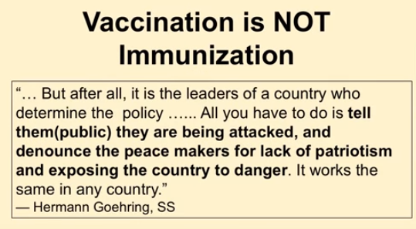
Now I'm using a quote from Herman Goring not because we're in a German beer hall.
But think of this and think of this policy that's going on now the leaders of the country determine the policy. All you have to do is tell the public that they're being attacked. Create a fear and denounce the peacemakers for lack of patriotism. If you don't get shot. What about the kids that can't get shot. You're going to kill them. Oh wait and then expose the country to danger. By God the Zika virus is coming. OK now this pattern has been used for centuries.
Now the tough part is this: we got two things we either have ignorance or evil here.
Now Richard Pan is supposed to be a pediatrician. We're talking Johns Hopkins Harvard. And these are some pretty big well named schools right. So and he is pro vaccine. He passed this bill to force people to be vaccinated.

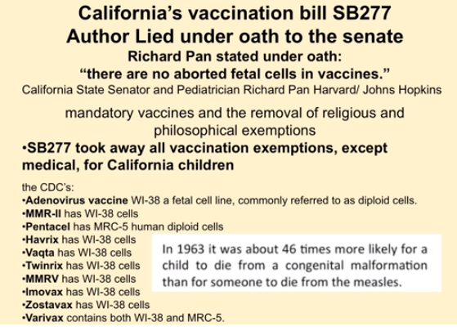

So now you no longer have personal choice. You no longer have religious rights or exemptions. And in fact the amendments of the Constitution have been abolished. I think it's 1, 4 and 7. OK. By passing this law. But when he's in front of this committee under oath and he says no there are no aborted fetal cells in vaccines and he's right unless you read the ingredients of the vaccines.

So is he completely ignorant that the process of vaccinations are injecting foreign animal proteins into human beings?

Well these are the ones that actually have it. They have the aborted human fetal cells in vaccines and you're going to find out that it's also in the flu shot as well. See we're not killing babies to make it out of it's hard to isolate a virus. You can't do it. You'd need to grow it in infected tissue and I'll show you the growth mediums that they're using now. So since you can't isolate a virus you have to grow it in something that's effective. OK. So now this was passed so you now only have a medical exemption in California. What that means is you have to prove that you're toxic or allergic to all the different shots. Now we've got a couple of patients from Arizona that actually got went through the whole legal process to get the courts to agree that the two daughters were caught had autism from the DPT shot they actually won the course the case nine years it took them. So that's not an easy thing to do. Now they're in or Arizona. They come to California for their care if they lived in California. They would be exempt from the DPT shot. They would not be exempt from the flu shot or the polio or the Prevenar or anything else that they're coming up with. So this is insane.

Now it's interesting you're 40 in 1963 you're forty six times more likely for a child to die of a congenital malformation than someone dying at the measles. Look at the Brady Bunch measles episode. OK. So. And I'll show you how to treat it correctly. Now this is a new law that's going to make the movie that you're going to watch pretty soon illegal. It's AB 1671.

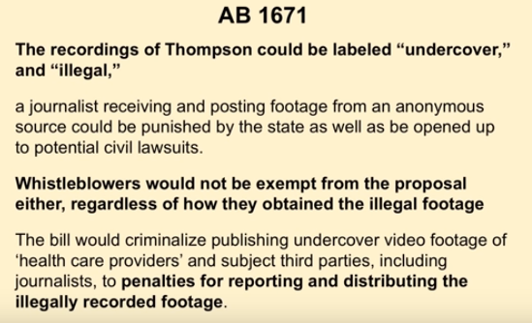

Now it's also going to make me speaking about this illegal and it's going make If you comment on this on Facebook you will also be arrested. OK. So no this is I mean this is bad enough your rights are taken away your kids will be not let in the school you're forced vaccinated. OK. So when people say well yeah they're safe and effective. No they're not. Now Thompson and you're going to see the whole thing in Vaxxed like where he got the information you're going to see the whole back story just understand that this is one of the lead scientist to the definitive study that prove beyond a shadow of a doubt that the measles, mumps, rubella vaccine does not cause autism. This is what all the doctors have been using as their data. This is what the ignorant politicians are saying look the science is in. Shut up. Roll up your sleeves get the shot. OK. This is the data they're using.

He calls up this journalist and says I can't take it anymore, we falsified the data the vaccines actually do cause autism and 400 percent increase nearly. And we falsify the data. So the doctors are using false data a number of cases were thrown out of court using the false data and it was a one sided recording. Now the recording was done in Oregon where it's legal to do one sided recordings. They want this to have the formation that was God from the movie for the movie VAX. The information that was withheld from the public. They're going to make it illegal. No one's arguing about the information. No one's saying holy. OK. These vaccines that are being forced actually caused neurologic damage.

No one's saying anything about that. They're just saying you got the information wrong.

Whistleblowers will not be exempt. That means if you find something going on with your company OK and you record or you take papers you can be arrested. So thank God we won't have those damn whistleblowers, penalties for reporting and distributing illegally footage.
Robin the police will be here soon. Anyone who posts the videos and comments on them online or audio recordings

Welcome to America. OK.

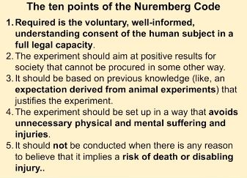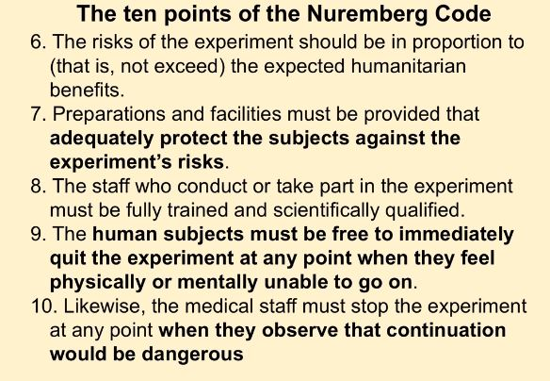

Now the Nuremberg Code 1947.

Now there is a number of doctors that got put before this tribunal and they got in trouble for not experimenting on human beings but for experimenting on human beings without their consent. So they came up with a certain number of points OK. Informed consent was vital absence of coercion. So you can't force people to do this. Okay. Properly formulated scientific experimentation. So there has to be an outcome and there has to be a benefits towards the experiment participants. OK. Now. I'm going to go over the 10 points to the Nuremberg Code.

I want you to correlate it with what's happening now.

But ten points are required:
- is the voluntary and well-informed understanding consent of the human subject in a full legal capacity is that done any more in vaccinations in California. Welcome to 2018.
Adult vaccines the 13 adult vaccines will be forced on you unless we take a stand now.

- Now the experiment should aim at the positive results for society and cannot be produced in some other way. So does that mean if there was a possibility or a study that showed that vitamin C or vitamin A might prevent measles mumps rubella maybe reduced the polio epidemic. OK. That we're also afraid of is right around the corner. Are they testing any of that? No.

- It should be based on previous knowledge like expectation derived from animal experiments that justifies the experiment.
Has there ever been an animal experiment regarding vaccines?
There actually has been one and I'm going to show you about it and how it was published and then pulled. So the public wouldn't see it.
This is the only human animals that would be exposed to the vaccine schedule. The only animals are the human ones. And if you want to see the health of our population and how effective it is look at how healthy our population is as cancer rampant, autoimmune diseases are they are they rampant in our population.
- The experiment should be set up in a way that avoids unnecessary physical and mental suffering and injuries. If everybody in this room took one drug would we all have the same response. If every in this body in this room got 69 doses of the 16 different vaccines that are recommended from birth to 18 years old would we all have the exact same response. No it's like psychotic. OK.
- It should not be conducted when they're in it. Is there any reason to believe that it implies risk of death or disabling injuries if you've ever read the inserts of the vaccines. They do say that death is possible. Has anyone ever seen the TV commercials. Hi. If you have fibromyalgia take this drug and you're going to feel great. Death is a possibility and make sure you don't get exposed to tuberculosis but you'll be just fine. Honest to God we're like the only country in the world that does this. OK.
- Risk of the experiment should be in proportion not as not to exceed the expected humanitarian benefits. So this experiment that we're doing on our children since there's no animal experiments. Oh have you heard that vaccines are based in science. In science. The gold standard is called a randomized controlled trial. This means we take this group OK. You all have voluntary consent. This group is going to get a therapy. This group is going to get a placebo. This group will be the control group. And then we follow you. Does that sound OK. Yes. Then we can compare this group the therapy group to see if there is an actual benefit. This is called a randomized controlled trial. This is what they do with drugs. How long do you want to follow them. A week, month, year, five years, ten years to see if there's maybe an increase. Chronic disease or autoimmune disorders or things like that. That's never done on vaccines. It never has been done on vaccines. Any trial is used to compare one vaccine with another. They're called biologics. They don't require randomized controlled trials
- preparations and facilities must be provided that adequately protect the subjects against the experiments risks makes sense.
- The staff who conducts or takes part in the experiments must be fully trained and scientifically qualified. You can now go through a drive through CBS and get your flu shot. Just roll down the window. But God that's a qualified mental medical health expert. Oh and by the way this was back at the end of World War 2. So I realized the information is really antiquated that we're much smarter now. Yeah. That's legal.
- The human subjects must be free to immediately quit the experiment at any point when they feel physically or mentally unable to go on. No my child had a reaction to the DPT shot. I refuse to go on to the experiment. He had a fever. Thank you no. Except in California.
- Likewise the medical staff must stop the experiment at any point when they observe that continuation would be darn dangerous. Do we have a massive rise in autism in this country. Yes. Yes. Do we have a massive rise in dementia and cancer and autoimmune diseases. Yes. This is not a healthy population. Now

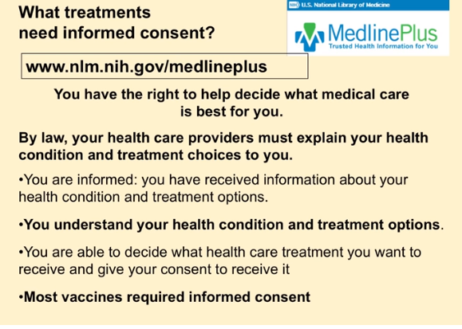

if you go to Medline the National Institute of Health government and ask them when informed consent is. This is what they say.
You have the right to decide what medical care is best for you. Yes you will have to get all 13 adult vaccines on a regular basis. The annual flu shot. It will be forced on you. Okay. But this is what the government says. No you should have the right to say no. By law your health care provider must explain your health condition and the treatment choices to you. Is that done. Treatment Choices you got flu shot.
Did they talk about vitamin D3.
Did they talk about Vitamin C
did they talk about how your body's immune system works how cholesterol drugs can weaken it.
No you understand your health condition and treatment options. Most vaccines require informed consent according to the government unless you're in California. So now. When you look at the zealots if you're talking about religious fanaticism the vaccines zealots are beyond any type of religion. Okay because what do they say. It wipes out smallpox and it wiped out Polio. We're going to break the polio myth right now. We're gonna break it. Okay.

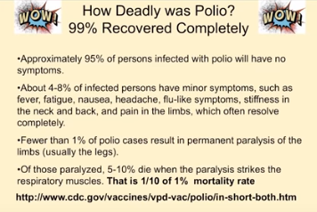

If you're afraid because what a good thing say we just got to create a panic. If you think that polio is just a plane ride away. If we stop. Vaccines that kids are going to start to die. You want to see iron lungs again yeah. According to the CDC dot gov. Ninety five percent of persons infected with polio will have no symptoms. Were you aware of that. That means ninety five percent have no symptoms. Not even a cold. 48 percent of infected persons might have minor symptoms such as fever fatigue nausea headache flu like symptoms which resolve completely. If anyone is good at math. We're looking at about 99 percent now. Okay. Are you scared yet of polio. Okay let's work on it. I'm going to try and build a fear. Fewer than 1 percent of polio cases resulted in permanent paralysis. That means 99 percent of the people recovered fine according to the CDC. Now I'm just thinking if you've got a disease that ninety nine percent of the people are fine and 1 percent get sick. Maybe this doesn't sound scientific but how about we look at what the hell is going on with that 1 percent. OK. You know just thinking of those paralyzed 5 to 10 percent will die. OK. So the death rate is one tenth of one percent in this so one tenth of 1 percent die. Now it's interesting because when you're looking at this

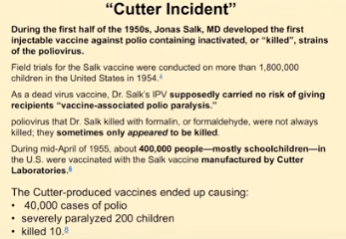
Have you heard of the Cutter incident?
Now the people that make vaccines nowadays say Well that was VAXXED back in the infancy when we were just building vaccines. Okay. However the Cutter incident and I want you to get this timeline right. Okay. In the early 50s. Wait in the early 50s how many people were recovering from polio. Ninety nine percent! OK. So this is that devastating disease that everybody needs to go on during the first half of the 1950s Jonas Salk developed the first injectable vaccine and it was killed or inactivated. Now early 50s developed at first trial started in 1954 one point eight million kids were injected with this experimental vaccine. Now that's 1954. By God it looks like it worked. Now we didn't see a reduction in polio. We didn't see anything. It's just the kids lived. OK. How long was the randomized controlled trial done. About a year. Kind of OK is that. Is that sufficient? Well by God. Nineteen fifty five because this is Dr. salt supposedly carry no risk of giving recipient its vaccine associated polio paralysis. This is this was amazing said one point eight million kids. They got it. They got the shot and they didn't get a lot of polio vaccine induced polio paralysis.
Now it's a bummer because they weren't always killed. Sometimes the virus appeared to be killed but it wasn't really killed. So were injecting live viruses in people during mid-April nineteen fifty five. Four hundred thousand people mostly school children in the U.S. were vaccinated with a song vaccine manufactured by Cutter Laboratories. This caused 40000 cases of polio paralyzed two hundred children and killed 10. Were you aware of this?
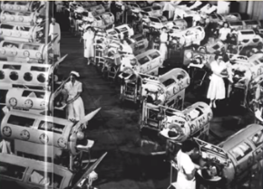
When you see this picture this iconic picture that's been in every fear magazine in the fear based society. I'm looking at this and I'm going. Something's not jiving here. You know you've got you've got this picture of all of these iron lungs and the data I'm aware of is that ninety nine percent recovered. So guess where this was taken nineteen fifty five. This is the Cutter incident. This is vaccine induced paralysis by the shot cutter incident more people develop paralysis from the vaccine in 1955 than would have developed a natural polio. And obviously the Cutter vaccine paralyzed the arms more severe permanent paralysis required breathing assistance and iron lungs. Children died more and quicker than naturally infected with polio.
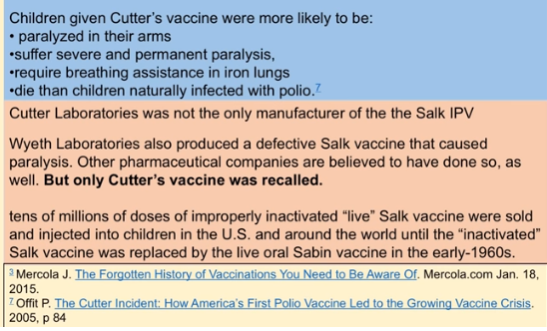
Cutter Laboratories was not the only one. They were the only one put on the chopping block. Now white Laboratories a number of number of other pharmaceuticals did that but only the Cutter was recalled. In fact tens of millions of doses of improperly produced vaccines were injected at that time. Now it's interesting because when you look at this the incidence of polio increased okay after the shot was brought forth. Now cases of polio increased 50 percent from 57 to 58 80 percent 58 to 59. Bernard Greenberg head of the Department of Vital Statistics in the University of North Carolina Public Health. Five New England states cases of polio roughly doubled after the polio vaccine was introduced.
Were you aware of this OK
Robin get the pitchforks because at the end of this talk we're goanna gather and we're goanna storm the fuckin citadel.
Okay we're goanna take back our rights. I'm goanna show you how to do it. Nevertheless in the midst of the polio panic of 1950 Herman Goehring came up with that no actually no I think it was Caesar even. Pressure to find the magic bullet statistics were manipulated by giving the health authorities to quit the opposition.
Now it's interesting they actually had a congressional investigation OK headed by Congressman Percy Priest. Now in 1956 this is when he made the statement in the previous year. Many responsible persons had felt that the public should be spared the ordeal of knowledge about controversy.
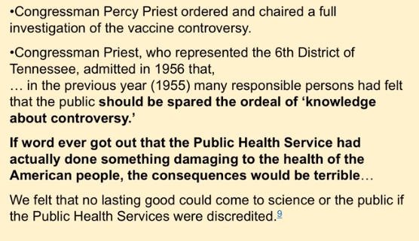
If word ever got out that the public health service had actually done something damaging to the health of the American people. Consequences would be terrible.
So for God's sake don't tell anyone.
We felt that no lasting good could come to science or the public. If the Public Health Service were discredited not being kept.
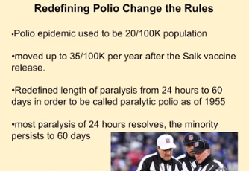
Okay so now what are the stats. Because they always say oh yeah polio went way down after the shot. No they redefined it because remember how many people recovered from polio. Ninety nine. OK okay.
So that when to define an epidemic it used to be 20 per hundred thousand population then it was moved up to thirty five for population and four hundred thousand. So all of a sudden you're changing the rules so you needed a bunch more people to define an epidemic. They redefined the length of paralysis from 24 hours so this means you had cold symptoms with minor paralysis. What happened in 99 percent of the people they recovered. Originally it was: you had to be cold, had cold but flu like symptoms, fatigue and stiffness or paralysis for 24 hours. Then they moved it to 60 days. So what happens instantly the instant and so you're goanna go down. Most paralysis of 24 hours resolved minor persist. Okay now so any polio within 30 days of the vaccination was not logged as vaccine induced they ignored the vaccine failures and vaccine induced cases. Now how many people do we know from just the Cutter incident develop polio. Why did the polio vaccine start to increase the cases. So if you got the vaccine shot and develop polio not only we're going to hide it. We're going to call it wild polio OK.
In 1958 non-polluting paralytic polio my latest with meningitis science was renamed aseptic viral meningitis. So when we look at aseptic meningitis when you hear meningitis now think neurotoxins think neurotoxins meningitis and colleges think of neurotoxins think a weakened immune system. Now even if polio virus was present non paralytic polio was no longer used to as it was reported before 1958. Now did the FDR have polio. Well according to the Journal of Medical Biology he didn't she. He got it in the winter time and it was a disease of the summer is a disease of the summertime and it mainly affected children in
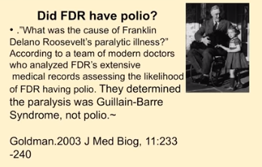

Wait a second.
You know going back to that ninety nine percent and we only had like 1 percent that really got sick and perhaps paralyzed. And it happened to be a disease of the summer time and it happened to affect kids. So can you see the population like if we're really thinking Wouldn't we like go in and say Gee I wonder if they were spraying something like DDT which was very popular back. We've got a bunch of science. DDT is good for me. But do you think that that could have been a contributing factor. Interesting.

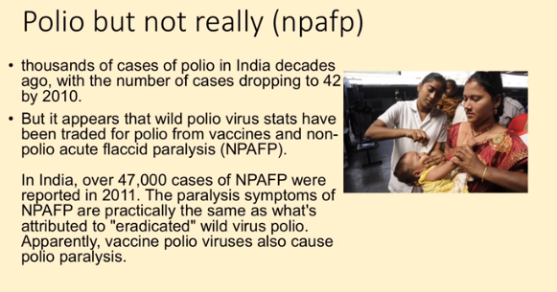
OK. Now polio is alive and well kind of this is non polio acute flaccid paralysis. Now it's alive and well in India kind of not really. They're finding that the number of cases of real polio dropped down to 42. However there are 47000 cases of non-polio acute flaccid paralysis. This is from the vaccine. now.
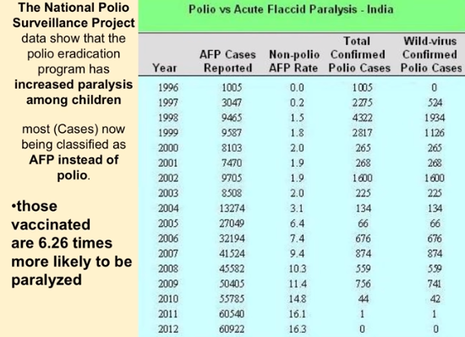
When we look at this we have polio verse acute flaccid paralysis in India. What is the acute flaccid paralysis from the shot. The vaccine. Yes. OK so now we have the link the wild confirmed cases of polio here in India. We have the acute flaccid paralysis cases here caused by the shot. Yes they are now polio free. However there is sixty one thousand kids that are paralyzed from the shot. Now those vaccinated are six point two more likely to be paralyzed. Those vaccinated it's increasing paralysis among it. Now here's that of the Indian Journal of Medical Ethics. OK so this is actually not being hushed up. It's just not being talked about.
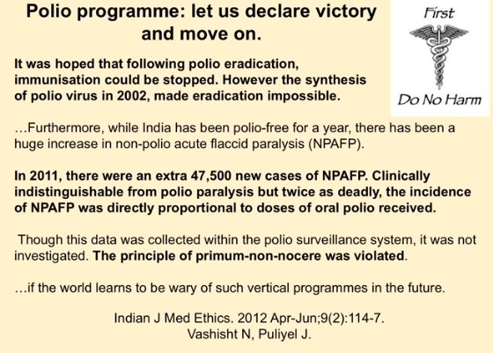
Please. Let's declare victory over polio and move on. OK. It was hope that following the polio eradication immunizations could be stopped. However they came up with a synthesized polio virus in 2002. Now that's a fun one because that means we can manufacture it and use it as a scare tactic because they can put it in water air droplets and we can use it as terrorist activity so we must vaccinate against it. OK.
In 2011 there were an extra. So there's just one year forty seven thousand five hundred cases of non-polio acute flaccid paralysis clinically indistinguishable from polio paralysis but twice as deadly. The incidence of non-polio acute flaccid paralysis is directly proportional to the oral polio received the pre principal premier and known or serum. No sir was violated. That means first do no harm. So that whole old I and I know Hippocrates has been dead a long time but still it was a good idea first do no harm. If the world learns to be wary of such vertical programs in the future your car creating the panic you're causing the disease and it's making a shitload of money OK.
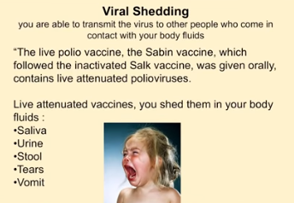
Now viral shedding what they found is not just the cutter incident. The ones that got vaccinated there were people in their household that were affected as well who never got the vaccine. Why. Because the polio vaccine can be shed from the saliva urine stool tears vomit in. So if you're vaccinated you can spread it. So when you get these ignorant zealots that are saying My God you have to get the polio shot because my child just went through chemotherapy. Okay. It's because they can't get vaccinated. Okay.
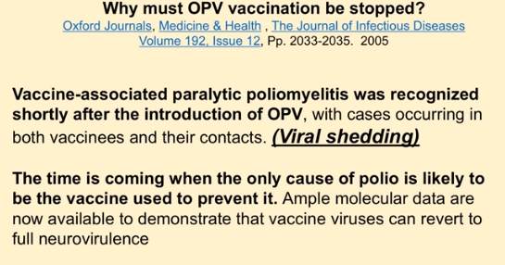
Now this is a brilliant article it was titled Why must the oral polio vaccination be stopped in and out of the Journal of Infectious Disease. And it's interesting because they're saying that it's vaccine associated paralytic. Polio my latest was recognized shortly after the introduction of this vaccine and it's from viral shedding.
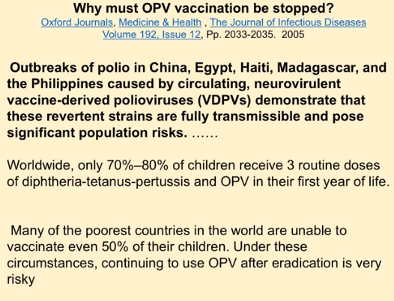
The time is coming when the only cases of polio is likely to be from the vaccine used to prevent it outbreaks and polio in China, Egypt, Haiti, Madagascar, Philippines are all from this neural neuro virulent vaccine derived polio viruses demonstrating that these are reverted strains are fully transmissible and pose significant population health risks.
So we have to keep vaccinating. Otherwise why
see they're calling it to say stop it because we're causing it. Okay. Even the most diehard person now. Now this I want you to be really cautious of because I want you to remember this worldwide only 70 to 80 percent of the children worldwide are receiving three routine doses of DPT. That means diphtheria three doses of that three doses of tetanus three doses of pertussis. OK and three doses of the oral polio virus vaccine. OK so we know that that vaccine spreads disease and spreads it through others. OK. OK. Got that. But look at this. Keep that 70 to 80 percent in mind. OK. Because this is vital when we look at this.
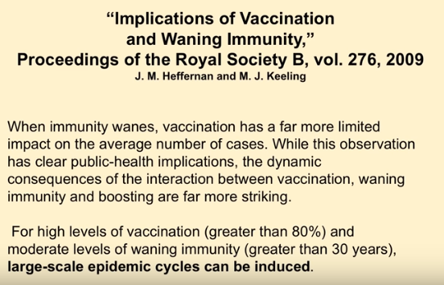
Implications for vaccinating and waning immunity. It turns out if you inject a vaccine in your body your immune system weakens. Now what they're saying is when immunity wanes vaccination is a far more limited impact on average number of cases. Well this observation has clear public health implications the dynamic consequences of the interaction between vaccination and waning immunity and boosting are far more striking now for high levels of vaccination. This means 80 percent. For and moderate levels of waning immunity greater than 30 years. So if you've been vaccinating a population 80 percent has got the shots and it's been going on for 30 years.
Large scale epidemic cycles can be induced.
So welcome to America 2016
not only an epidemic of dementia Alzheimer's cancer autoimmune disorders. OK you are going to see protests? this you are going to see meningitis. You are going to see shingles. OK. Because of this process.
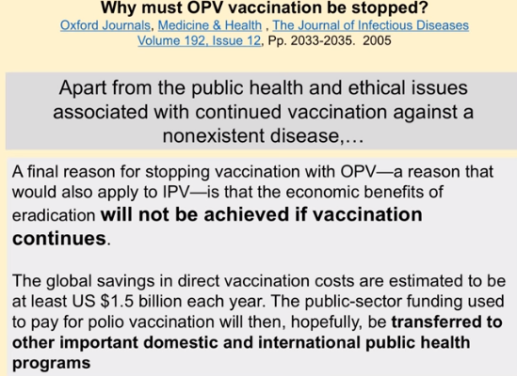
Now again out of this. Why must oral polio vaccines beach stopped. The Journal of Infectious Disease apart from the public health and ethical issues associated with continued vaccination against a non-existent disease isn't that interesting. So if the if you're being forced to vaccinate and you cannot get an exemption please turn your pediatrician or medical health care professional. You've got to use a couple of words with them because these idiots actually think they know what they're talking about okay. They're zealots you use obviously and has you know so Doctor as you know the danger of the polio vaccine is much greater according to the Journal of Infectious Disease. So obviously you must give us an exemption or have you not read your journal. A final reason for stopping the oral polio vaccine a reason that would also apply to the injectable one is the economic benefits will end these will not be achieved if the economic benefits. So wait a second. So. So let's get let's step back. What percentage of the population recovered from polio without any problem whatsoever. OK OK. Ninety nine point nine per girl??. That's just like ninety nine percent recovered. So they would save one point five billion dollars. That can be put on infrastructure like Wells roadways electricity refrigeration all the stuff that actually works to help the immune system. Wow. That would be cool. And that's just a polio program. What if we stop everything else. It'd be really cool.
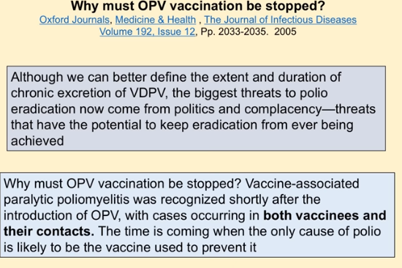
Although we can better define the extent and duration of chronic excretion. Of the vaccine derived polio vac excretion of this this means you got shot in your shedding it. Okay. The biggest threat to polio eradication now comes from politics and complacency. Threats that have the potential to keep the eradication far from ever being achieved. Why must this be stopped. Vaccine associated paralytic polio my lightest was recognized shortly after it both in vaccinees and their contacts. So when they say you have to get the flu shot to protect you do you realize the entire theory of a vaccine was that you're supposed to get a little bit of the bug. OK. And you're supposed to mount a defense against that bug so if you're exposed to that bug you know in wild form you've already had a little bit of exposure to it. So you may not get has? sick or you may be protected from it.
That's the theory does any of that say that you're going to protect those around you.
No it doesn't. It doesn't. So if you're being forced to vaccinate because you have a job at a hospital or a medical professional realize that that's not only not based in science but the viral shedding means that you're spreading disease. And our hospitals are already full

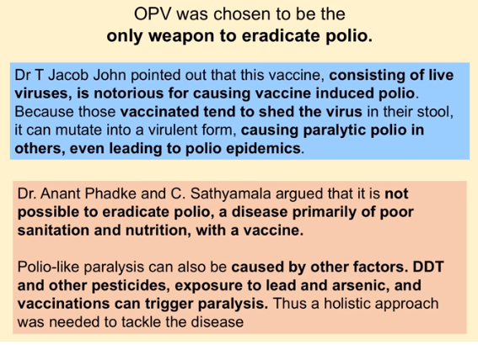
Now it's interesting. These are these are doctors on the field in in India consisting of polio vaccine live viruses notoriously for causing vaccine induced polio. Because vaccinated tends to shed the virus causing paralytic polio in even others leading to polio epidemics. Dr. Anant Phadke and Sathyamala argued is it not pass it that it is not possible to eradicate polio a disease primarily a poor sanitation and nutrition with a vaccine. Did you know that they're coming out with a cholera vaccine. Do you know they have a diarrhea vaccine. OK. Honest to goodness we win ninety nine percent of the people recovered and these guys are saying look it's primarily poor and sanitation nutrition
Polio paralysis can be caused by other factors such as DDT and pesticide exposure or exposure to lead and arsenic and other vaccines can trigger paralysis. So think of this. They're saying that perhaps there's an environmental cause of that 1 percent that actually had it. OK. So now if some zealot says well it wiped out smallpox and wiped out Polio you're going to go like this ban. Cave knock him in the ovaries. Okay. Now I can't hit girls but okay you get it right. Okay.
Now this is interesting. They're talking about a group of people that have a congenital it's called hypo gamma globulin. Anemic patients they're susceptible more susceptible to this polio vaccine associated paralytic polio and it's been found commonly to found long term ?excreeders after developing the paralysis. It turns out that they're excreting this for years. Some of them over 20 years that they're spreading the vaccine induced paralysis. Countries with chronic excrete hours of polio virus will continue to use the inactivated vaccine until these persons die or it's clearly no longer prevent a present a threat. So this article is actually pro vaccine. They're saying yeah we caused this. We're causing the people to excrete this virus. But you know we're still to vaccinate because the excrete is that we created are still excreting until they die. I mean man. OK.
Now this is one of the tough parts. OK. If your doctors using appropriate data. OK if they're if they're based in science OK realized that the science is no longer accurate.
Have you ever heard of a placebo. What's a placebo.
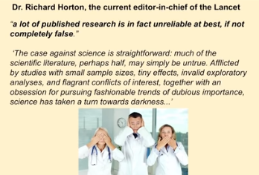
It's an innocuous substance that doesn't have an effect on the body. Right. Since 2008 they've been using active placebos that actually have an effect on the body yeah I'm sure that's good. OK.
So now the current editor in chief of the Lancet a really good medical journal. OK a lot of public research is in fact unreliable at best if not completely false. So this means the data when they say the science is in. I'm explaining how the body works and what the science that these doctors are espousing on it is wrong. The case against science is straightforward. Much of the scientific literature perhaps half may be simply untrue afflicted by the studies of small sample sizes tiny effects invalid exploratory analysis. Flagrant conflicts of interests together with an obsession for pursuing fashionable trends of dubious importance. Science has taken a turn into darkness
Who runs the science now? The pharmaceutical industry!
You've got the guys producing the product and they're goanna make sure it comes out.
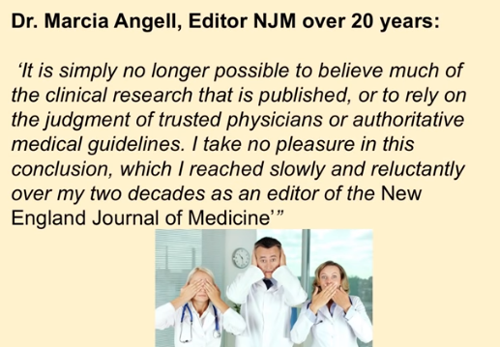
New England Medical Journal. OK so we got the European medical journal Lancet New England Medical Journal. It's simply no longer possible. Leave much of the clinical research that is published or to rely on the judgment of trusted physicians or thought authoritative medical guidelines. I take no pleasure in this conclusion which I read slowly and reluctantly over my two decades as editor in chief of The New England Journal of Medicine Wow.
So if you utilized medical care for health I don't recommend it.
What kills more people in this country doctors or guns. Doctors. Yeah.
Okay so. So what do you do. Imagine if you went to a doctor and they said Oh my God you are so lucky you're human. Your body is self-healing and self-regulating. No shit really. You could cut yourself and it's going to heal. All we're goanna do is give you healthy nutrition we're goanna keep your nervous system healthy. We're goanna take your body and make it healthy. Okay. No no no no. We still have medicine but that's only for trauma. We're not going to use medicine for health. You cannot utilize the medical system for health. They're not done a good track record. OK. Now.
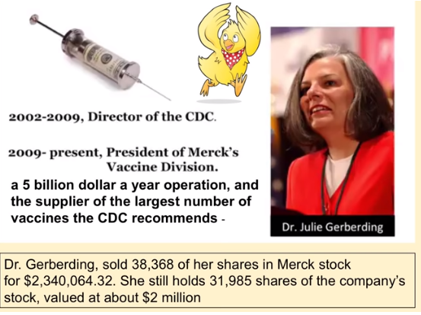
This girl there's a special place in hell for her. OK. Various I'm sure because more and likely you know. Director of the CDC from 2000 to 2009. That's keep in mind those dates. Because you're going to see, she was called the Chicken Little. The flu is coming the flu is coming the flu is coming. OK. Now she promoted vaccines more than any director of the CDC ever. It's interesting that this isn't even hidden. OK. The the prostitution that she did to get this job where she is now president of vaccine division and Merck. 5 billion a year. Course she did have some cool stock options. OK. She sold about thirty eight thousand of her shares. Don't worry don't worry she had like seventy thousand so you know she you don't need to put her on your Christmas list okay. She sold that for about two point three million dollars but she still holds about thirty one thousand but luckily with her at the helm those shares are goanna be worth a lot. OK.
Insider trading in stock markets is bad right. How come this isn't illegal. How come we are going to storm the damn citadel. OK
now realize this is the study or this is. Well you could call it a study because it's not based in science but this is what a child will go through. Now that you have no choice in your vaccines if you want to use utilize the California school system. So at 12 hours old they're given a hepatitis B shot twelve hours just about the only country in the world that does that. And in fact this is the only country that does this experiment. Most countries have less than half of this and they wait longer. OK so this is an experiment. So if you think that we're the most advanced country in the world realize we're not. But oh wait. The thinking person in the back. Yes. OK. Since they have less than a half of our vaccines do they have greater disease rates. No OK
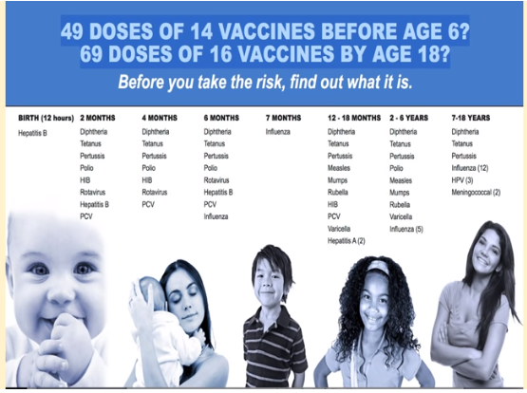
Two month old healthy child goes to the doctor and they're given a deep serious shot a tetanus shot a pertussis shot what shot polio shot. OK we know how effective polio is. You know I can do the whole talk I've done one on tetanus I've done one on hepatitis B. I'm goanna do one dip theory I'm goanna do when I'm pertussis but it's the same psychosis that that you just learned about the polio. All of these have that same viral shedding and neurotoxic effect then the HIB the rotavirus that's brand new. OK. That's for diarrhea. OK. Another Hepatitis B because obviously there are sexually active drug user. And they got their first shot at 12 hours and two months they had better get a booster. OK. And then a PCV. OK now you take that kid that just survived this two month shot take him back at four months then they're goanna get another diphtheria another tetanus another pertussis another what polio another HIB. Another one to prevent. Okay. And I realize if you're up on this the rotavirus is called bowel interception. It killed about 200 kids and some of the trials. I know you're thinking that and that isn't diarrhea response to a toxic environment that your body's trying to get rid of stuff. Kids do die of diarrhea okay. Generally they die because they're malnourished and they're drinking fetid water or something that's toxic in the body. It is a normal body response. Okay so. But don't say anything like that okay. We're not up to six months yet. Then you take that kid who survived these shots at six months old then a six month old infant. Okay. And then they get another diphtheria. Boy these things must work really good. Why do we need three of them by six months another tetanus another pertussis another polio another rotavirus now another Hepatitis B Good three Hepatitis B shots before they're six months old and now at six months old they get an influenza shot. Yes I know influenza is one of the last shots that still contain mercury. I know that but stop bringing that up seven months old they get another influenza shot okay. Or they qualify for it and then 12. DPT then we start in on the measles and the mumps and rubella. Now this is goanna be on the movie vaccine. Okay. Where they're only looking at that. It's like I took an hour or forty five minutes and only looked at polio. You understand OK they're only looking at the MMR. They're not looking at everything else. OK. This is a very sick population two to six years. They get another booster DPT another polio another measles mumps and rubella chicken pox influenza again. And this is cans this is forced on you now. You have no rights. Your child if you're going to use a school they have to get this schedule which is more than double of anywhere in the world. Now this is going to shock you. Anyone in here does everyone in here have common sense. OK. This will not shock you. OK. This this.
This is amazing end of the Journal of Human and experimental toxicology studies have not been conducted to determine the safety or efficacy of administering multiple doses in a variety of combinations is recommended.
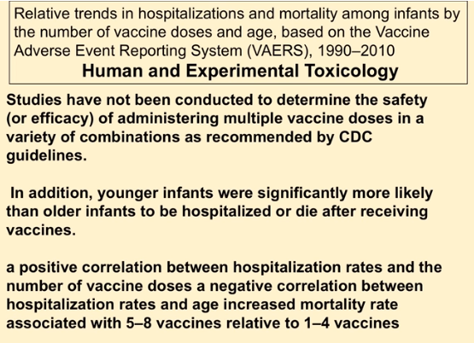
Wait a second. Studies have not been conducted to see if this is safe or effective did that really say that. And here a positive correlation. But this is this is I'm going to read it like regular. Then I'll translate it because this is the kind of crap I got to go through when I'm reading this stuff. A positive correlation between hospitalization rates and the number of vaccine doses. A negative correlation between hospitalization rates and age increased mortality rate associated with five to eight vaccines relative to one to four vaccines. Let me translate that. The more doses and the younger the shittier the outcome the less doses and the older the less negative effects I know. Don't you just want to say duh. You really needed a study to say that this isn't. You know I mean
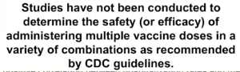
doctor you're going to inject this in my child. Is it safe and effective? Course it is. Really. Are you aware of this journal where they say studies have not been conducted. There's no studies out there. So does that mean your experimenting on my child. You need to sign this exemption form. I'm going to blow up your car. OK.
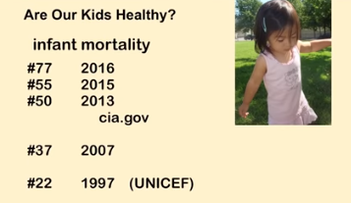
Now the infant mortality rate. Okay. Now in nineteen I think was 1960 where we were like 12. And this is how many killed kids we're killing. Okay. You want a really low infant mortality rate if you want to a population that survives in nineteen ninety seven according to UNICEF we were twenty second in the world. 2007 we're thirty seventh in the world. This means we're there thirty seven countries that have a better survival rate than we do. Now from the CIA. They keep track of this information. By 2013 we were fiftieth in the world. By 2015 we were fifty fifth in the world. By 2016 we're seventy seventh in the world. This means more kids are being killed in this country. And when a third of my practice is under 12 so I'll say Well is your kid born natural at home or in a hospital. And you know what they'll say natural in a hospital I said Not in this country what country you're born. Oh America. OK. Good. Were you given the epidural in ??photos. Yeah. Were you given the flu shot when you're pregnant. Yeah they did. Then they did the ultrasound on YouTube. Yeah. Okay. And your kid has what kind of thing going on now ulcerative colitis and irritable bowel. Yeah. This is America. It's nuts OK.
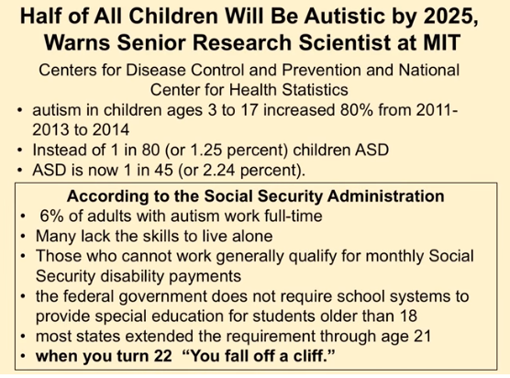
Half of all children by 2025. OK. This is nine years from now. One in two. Now the autistic. That's a pretty big statistic. OK. The autistics are our full blown. You can recognize some of the head bangers there the 9 year old inside of the stroller. OK. You know did you get it used to be unusual to see a 9 year old in a stroller. It used to be unusual to see that kind of wild behavior. Now it's commonplace and it's so common. I think there's an autistic kid on Sesame Street now. OK. But the tough part is if this keeps going like this they now say it's one in forty five some people say it's one in 32 to try and find the actual statistics for autism is very difficult because they're checking 10 year olds. And the symptoms occur at about three years old. OK. So. Now. So security. Ninety six percent. 96 percent of autistic people because there's not a lot of autistic adults now. OK. But ninety six percent of people with autism cannot hold down a job. And you qualify for Social Security benefits until you're 21. This is an economic meltdown. Our population will not be here. That's why that's why I tell parents don't really worry about this forced vaccine stuff because we only have like four or five more years of. Now these are just a hint of the studies that are out there. So when the doctor says these are safe and effective they're safe and effective they're safe and effective. Really. Show me the data because if I look at the Journal of Neurology Hepatitis B there's an increased risk of multiple sclerosis.
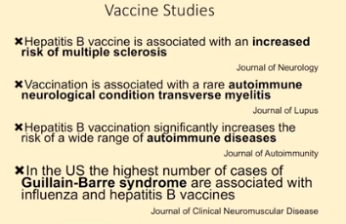

If I look at the Journal of lupus autoimmune diseases and neurologic conditions such as transverse my lightest increase with vaccinations
if I look at the Journal of autoimmunity hepatitis B vaccination significantly increases the risk of a wide range of autoimmune conditions.
If I look at the Journal of neuromuscular disease in the U.S. the highest number is Green Beret syndrome. That's what Roosevelt had are associated with influenza and hepatitis B vaccines. Wow. Isn't that interesting.
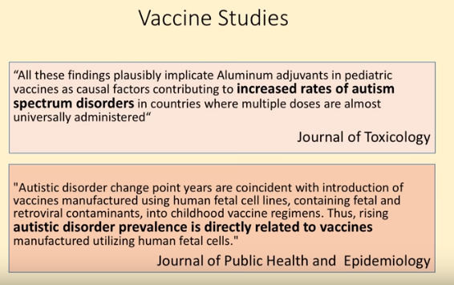
If you read the data. Vaccine studies journal of toxicology you know they say that doesn't cause autism it doesn't cause autism unless you read the actual journal toxicology. These findings plausibly implicate aluminum adjuvants in pediatric vaccines has a causal factor causal factor means it's not contributing to it doesn't weaken the immune system it means it causes it. OK. Yeah I mean I know it is a German beer garden we're speaking in but couldn't you just see that fever kid that speaker with the funny mustache OK. Increased rates of autism spectrum disorder OK in countries where multiple doses are almost universally administered. That's America.
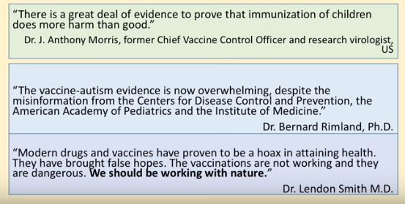
Autistic disorders change point years coincide. This means that when you see the rise in autism that those change points where it like takes off like crazy. OK coincide directly to containing when the vaccine manufacturers using human fetal cell lines containing fetal retinal viral contaminants in childhood vaccines thus rising autistic prevalence directly to the vaccines.
See when you're looking and you're trying to grow a vaccine and we're going to show about the different substrates to it if if you put cancer or toxic cells in a human being you can get a negative effect I know. Really. Okay.
Anthony Morris former chief vaccine control officer. There's a great deal of evidence to prove immunization of children does more harm than good. Vaccine Autism evidence is now overwhelming.
Bernard Ryland modern drugs and vaccines proved to be a hoax.
Lyndon Smith It's true.
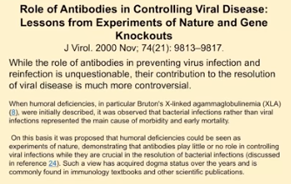
I mean they always see they can't go in and vaccinate and then dump a bucket of virus on your head and say well you're protected. What they do to measure the vaccine is effective as they measure antibodies. Okay now we know antibodies are very poor measurement of your immune system. And in fact Journal of Virology says while the antibody role preventing some viral infections is unquestionable their contribution to the resolution of viral disease is much more controversial.
So this means demonstrating that antibodies play little or no role in controlling viral infections. Wait a second. They're crucial in bacterial infections but little or no Roland Vi. So does that mean like the polio virus the measles virus the mumps virus the chickenpox virus that that that when they're measuring antibodies. That's not based in science. Really doctor.
Okay. Yeah. I mean all debate anybody. I mean I can read here.
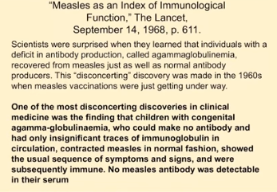
And this is interesting is that a lancet 1968 patients with a congenital malformation a gamma glob? only anemia. They cannot produce antibodies. It turns out it's confusing because they recover from measles with the same quality of the same end result and the same speed. So it turns out that these people can't even produce antibodies. So we know the antibodies really don't have anything to do in the recovery of a disease. And I love this comment.
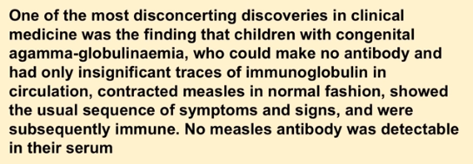
One of the most disconcerting discoveries in clinical medicine was the finding that children with congenital a gamma globulin maybe who could make no antibody and had only insignificant traces of immunoglobulin in circulation contracted measles in the normal fashion showed the usual sequence of symptoms and signs and were subsequently immune. No measles antibody was detected in their serum. So does that mean that the entire thing is based on false science. Yes yes.
Only if you read. OK.
Now when you look at this it's hard to go because remember you can't isolate a virus. So you have to have some type of growth medium. And this is how you make of a viral vaccine you this one and this is out of the MMR contained attenuated lives measles and mumps viruses.
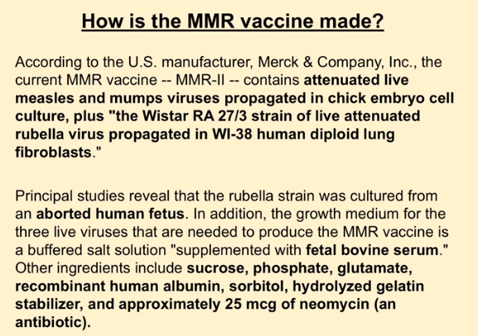
???Propagated in chicken embryo cells cultured in the West are a 0273 strain of live attenuated Rubella virus propagated in human deployed lung fibro blast.
So you grow this in a little bit of chicken you grow it again in human aborted fetal cell tissue and you're going to inject it in people think of what could possibly go wrong too. Sounds good to me. OK.
Then you add it's supplemented with some fetal bovine serum some sucrose phosphate glutamate recumbent human albumin so some more human proteins some sort but all some hydrogen as gelatin. OK and a little bit of antibiotic what could possibly go wrong if you inject this and every child three times.
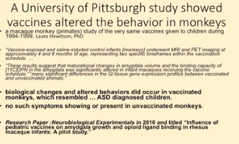
I you know this is what can happen. Now one of our patients actually was involved in this study. He's a pediatrician that got the vaccines or got the vaccines for it. This is the only animal study I've ever seen where they took a monkey little baby monkey at 12 hours old they gave him a hepatitis B shot at two months old they gave him the whole list at four months old they gave him a whole list at six months old gave him a whole list. OK. And you know scale down for their size. The only animal study I've ever seen. No it was published in neuro biologic experimental in 2010. It was also pulled. It was published. Then they pulled it away. They got rid of it because not only did 100 percent of these monkeys have brain damage OK but they also developed autistic like symptoms anti-social behaviors. They couldn't eat regular monkey chow. Their guts world destroyed. I mean we're thinking that ulcerative colitis and Crohn's disease is normal in kids now. Come on. I mean I'm getting more and more kids with these bowel disorders and it's like psychotic.
So this is the only study I've ever seen. Now the reason it was polled the reason it was polled is because Dr. Laura Q. the girl who ran this has an autistic child and she separate she knew there were goanna come down on her big time. She's separated herself completely from the data collection so she couldn't have any influence on it whatsoever because they knew where they were goanna come down on it but she didn't know that they were going to pull it.
OK. Now. The that we already know if you're getting vaccinated you're going to have an increased rate of disease. Well vaccines can suppress certain diseases too. However a career according to the American Journal of Epidemiology. Little is known about how an intensive measles elimination program changes overall immune status of the population. Now this was back in 1984.
Did you know that we don't know what the heck is happening. We can't see higher rates of disease. Now what they're saying they did a computer model to see just on measles if you're goanna vaccinate from them and what happens is that it rises that even in the vaccinated population. Point one percent. Now it's interesting because when this was done in 84 a computer model was created to study the effects of measles elimination program in the United States on a number of susceptible is in the population.
The pre vaccine era it was approximately ten point six percent of the population was susceptible. Okay. Now if anyone is good at math OK if 10 per point six percent of the population was susceptible. What percentage of the population was not susceptible to measles. But 90 percent. OK OK.
So that means 90 percent of the population is not susceptible to having any problem with measles. Okay however by doing this with the institution of the measles immunization program the portion of susceptible is in the population fell to 3 percent. So instead of 19 susceptible is what I mean is if you catch measles from the wild form and you have a normal healthy immune system you're sick for about a week and you're fine and you have lifetime immunity. That's what they're talking about susceptible.
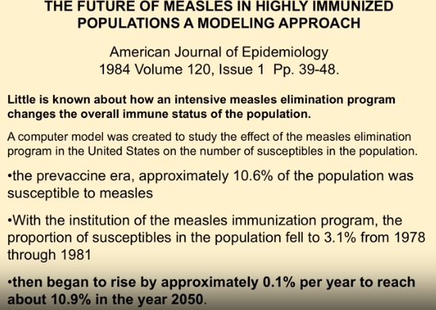
In my area they had chickenpox parties and measles parties because we went over there you got it. You know you eat some ice cream. You were fine. Course I know the ice cream back then didn't have bovine growth hormone. But you know. OK. So by 2050 OK. It's the epidemic is going to start to rise again.
Now future of measles in highly immunized population journalistic demonology the susceptible is that this time would distribute evenly throughout all age groups and effective immunization program aimed at young susceptible is combined with a highly naturalized naturally immunized adult population. Okay. What they're saying is that if we did it back before the measles would start to wane itself out of society. OK. Now.
However despite short term success in eliminating the disease long range projections demonstrate that the portion is susceptible in the year 2050 may be greater than the pre vaccine era present vaccine technology and public health policy must be altered to deal with this eventuality. That was in 84. OK. Back when we had about 12 vaccines we now have 69 doses of 16 vaccines.
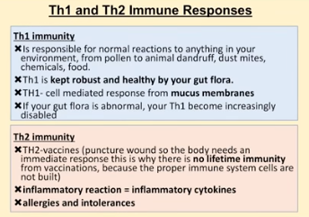
Now this is how the immune system works. You have two responses we're going to boil it down TH1 and TH2 responses to each one requires a healthy gut flora. This means you have healthy bacteria in your and an intestinal tract. You get exposed to a virus fungus or bacteria your body mounts a defense through that and you get exposed to it through the nasally coastal or mucosa. This triggers a huge moral and cellular response. Bam. It's so good in fact you could pass this stuff on to your kids. You can. That's the stuff that you've been exposed to 50 percent of your DNA is viral. I mean so you can pass this on generationally so we get smarter now.
TH2 is an acute inflammatory response. This is something that happens if you get a splinter or you get a shot. OK. This is a temporary thing to respond to with inflammation. OK. Now if you get sense since your body is so familiar with different viruses. If you get a vaccine injected into your skin we got to put something in there to stimulate your immune system otherwise we can't prove what works. Because what are we looking at. Antibodies. I know what you're thinking antibodies don't really denote your protection. I don't worry about that. OK. So what you're doing you're injecting these foreign proteins in your system and then you got to put some toxic stuff in there so the body recognizes it mounts a response. So you're training a body to respond with inflammation you're training it to respond to inflammation.
How many times. Sixty nine doses of 16 different vaccines. By the time you're 18. OK. And so if that's true if we're stimulating this TH2 response then we'd see a ton of inflammatory diseases like inflammatory bowel disorders or about asthma. What about brain inflammation like autism. OK. Have you can you can you see that we're training this so when you look at the TH2 response think about an inflammatory response. Now almost all vaccines contain aluminum. Now I know aluminum is a neurotoxin. But remember we got to put something in the shot to stimulate the immune system. We got to have something in there. Otherwise the body won't even respond to it. OK. Now it's a known neurotoxin according to the Journal of toxicology. It's a causal factor contributing to the increased rates of autism. The aluminum weight causal factor vaccines are safe and effective. You heard that stupid religious thing. OK. Because it's not they've never been associated to cause autism maybe you heard that.
That's true unless you can read.
OK. Can everybody read this or is it just me. OK.
So Journal of Public Health and Epidemiology 2014 the autistic disorder changed point years or coinciding with the introduction of vaccines manufactured with human fetal cells. OK.
And these aren't these aren't just the only ones. OK.
Aluminum can alter DNA and we're injecting it in her body can alter gene expression can all damage cell membranes coagulate proteins in or in increased vascular endothelial adhesive. This it means the blood vessels don't work correctly. I mean this is crazy.
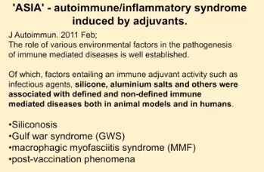
Aluminum and I love this. The current method medicinal chemistry in our opinion the possibility that vaccine benefits may have been overrated and the risk a potential adverse effects underestimated.
Before you came in today would you have agreed with this. Maybe not.
But now do you understand that this is the medical journals are starting to say hey look there's a big friggin white elephant here we got it. We have to say that this is bad.
Asia is the new thing. It's autoimmune inflammatory syndrome induced by the adjuvants. See you can't say anything against vaccines but you can start slamming the adjuvants what they put in there. I mean it's hey at least it's an n you know.
And so what they're saying is that this is part of the problem. The stuff they put in there silicosis go for syndrome macrophage my fast colitis post vaccination phenomenon autoimmune disorders they're all from them.
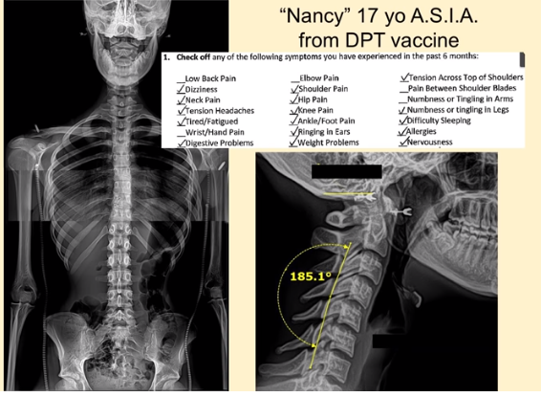
This is a 17 year old girl 17 years old. I mean am I the only one that lived through 17 that thinking that strong young and healthy. Kind of like I am now OK but only 17.
Imagine putting this stuff down dizziness neck pain headache fatigue. I mean the foot pain she was losing weight she was down like 70 pounds. This giant Black area here is her intestinal track. That's what a leaky gut looks like on intent on X-ray. She was dying. Okay. All from the vaccine induced inflammatory response. It's interesting though.
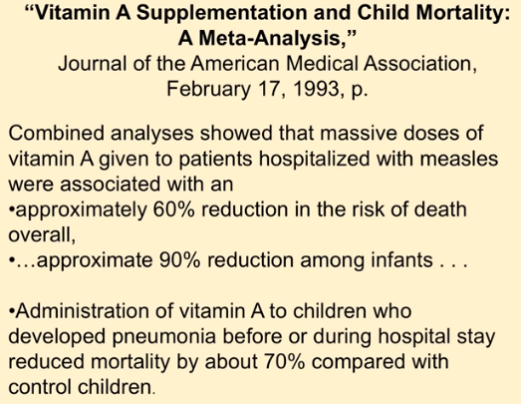
Certainly the American Medical Association shows that if you give a vitamin A supplement and this is a study administered to kids who develop pneumonia before during hospitals say you reduce mortality by 70 percent
risk of death reduced 60 percent you're looking at vitamin A given to patients hospitalized with measles 90 percent recovery with vitamin A. OK.
But no one's studying vitamin A heck no one's even forcing vitamin A on treatment. Polio and vial my lightest with vitamin C. Yeah. What do you do for that 1 percent that gets it that doesn't recover. Give them Vitamin C. This was a great study actually.
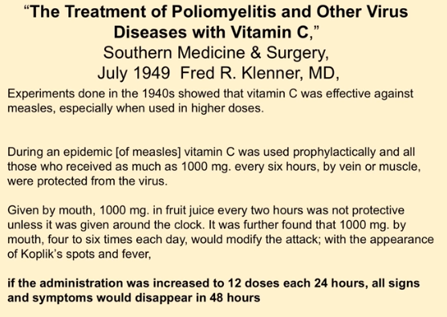
Then they were talking about giving a by mouth by Ivy the administration of vitamin C was increased to 12 doses in 24 hours. All signs and symptoms would disappear within 48 hours of polio.
A polio Yeah. OK. Vitamin A administered reduced opportunistic infections in South Africa 80 percent in acute measles complications. Gone. Falling high dose vitamin A 1932 they found out that well-nourished children rarely died or had serious complications from measles. So these are the plane right away. It's not.
Now this the flu shot. A flu shot. It's mania. OK.

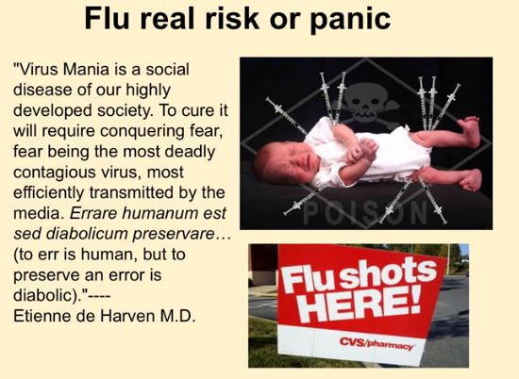

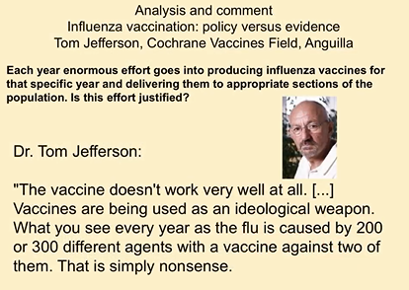
Remember that the Julie Gerberding. OK. Here's the Cochrane Database. And this is one of the independent labs out there the vaccine talking about the flu shot doesn't work well at all. Vaccines are being used as an ideological weapon. What you see every year as the flu is caused by over two to three hundred different agents with a vaccine containing two of them. That's simply nonsense.

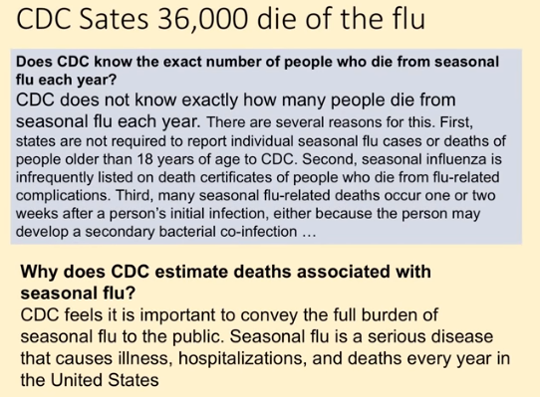
Now the CDC because we're coming up on the flu season they say 36000 people a year die from the flu. Thirty six thousand people a year die 36000 people a year die. When you look on their site the CDC does not know exactly how many people die from the seasonal flu. And I'm thinking anybody remember Sebbal you know like a multiple personality disorder. OK. I'm thinking I must be developing this. OK. The seat why does the CDC estimate deaths associate with the flu. They feel it feels it's important to convey the full burden of seasonal flu to the public seasonal flu is a serious disease that causes serious hospitalizations illness and deaths every year. But we don't know how many people get it. OK.

The British Medical Journal said Dude you guys are inflating the numbers. That not that many people die from it. OK. Do you want to know how many people actually die from the flu.
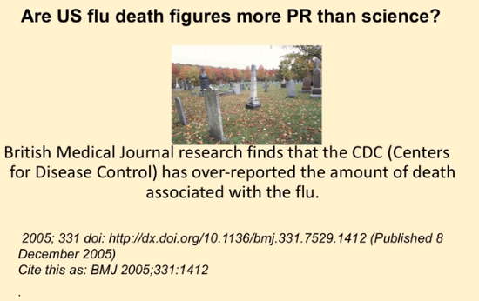
It turns out that the American Lung Association actually keeps stats on this about twelve hundred people a year on average die not twelve hundred people in Huntington Beach. I'm talking entire America 300 million people here about twelve hundred people a year die.
There's about seven hundred ninety eight lightning people struck by lightning in America. So hopefully they'll come out with a vaccine to protect us from lightning strikes cause. OK.
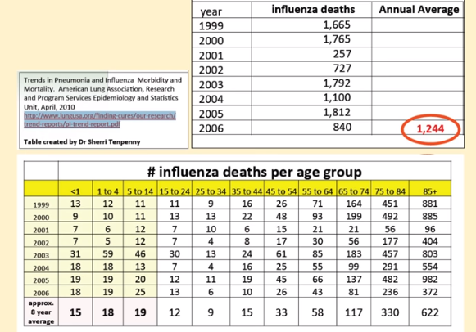

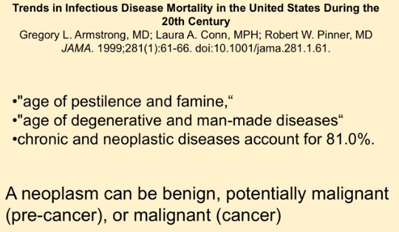

So seriously. OK. So now when you look at this let's look at it. We're entering an age and they're looking at deaths. It used to. People die pestilence and famine. Now it's manmade diseases that we're dying from. And this is in the journal articles. No kidding. KATE ???Now the flu shot. It used to be grown in chicken
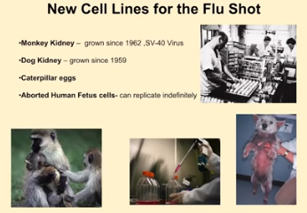
eggs. That's right. Remember you cannot isolate a virus. So you have a living chicken egg. You break a hole in the top. You put some infected tissue in there. You put it on a shelf for about 10 days. You take it off. You open it up you centrifuge out as much of the chicken as you can put in there. I know you're worried about the avian viruses don't think about that OK but you centrifuge it out and you had a little formaldehyde a little mercury gave some antibiotics some sucrose gradient. OK. Then bam you inject into the person. OK.
That's very labor intensive. So what they came up with now is Neil plastic cell growth medium. So now you have a choice in the flu shot of monkey kidney tissue, dog kidney tissue, aborted human fetal cells or Caterpillar larvae to grow that in.
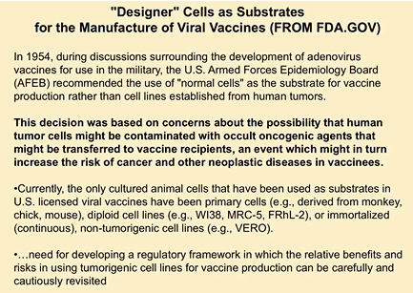
Now it's interesting because these things they're infinite cells they keep reproducing. Now I know if you go to the FDA dot gov site if you type in Neo plastic cell growth medium for vaccines like I do when I'm just relaxing. OK. This site comes up. OK. And it they found in 1954 that that the US Army you could grow vaccines in cancer cells OK they're called neoplastic cell growth meeting they decided not to do it because it was based on concerns about the possibility that human tumor cells might be contaminated with a colt oncogenes or cancer causing agents that might be transferred to the vaccine recipients in the event that it might turn to an increased risk of cancer or other new plastic disease in vaccinees. So they decided not to use the cancer cells to grow the vaccines cause they thought that injecting this into somebody might cause cancer
well don't worry. We decided to start using it. Why. Because it gives a consistent product. You know what's goanna come out and it's cheaper for the vaccination. But don't worry. They're using post marketing surveillance. So you'll be just fine.

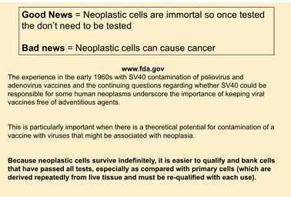
OK. So if there is a massive rise and we kind of associate it with the vaccine then we're going to be OK. OK. So the good news once they're tested. They don't have to be retested. The growth medium bad news is they can cause cancer. OK.
And when you look at that how it causes cancer even know you got two mediums one the cancer cells injected can start growing or the other it suppresses tumor suppressor genes it causes your body to not be able to fight it.
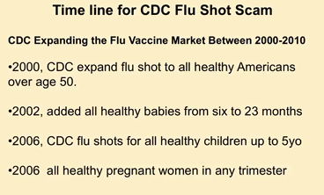
OK let's look at Julie Gerberding. When did she start join. She joined in 2002. OK in 2000 the CDC expanded a flu shot to all healthy Americans over 50. That was the requirement in 2000. OK. You had to be healthy you had to be over 50. That means no kids no pregnant women nothing. Right. OK.
2002 healthy babies from six months. Any studies on that. No.
By 2006 OK. Healthy children up to five then
2006 again pregnant women any trimester it's fine. OK. Now what was that.
Were the public saying good god let's hurry up.
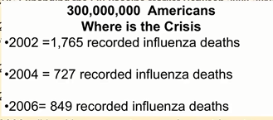
These are the recorded deaths in those years seven hundred, eight hundred and this is out of the 300 million Americans who created the crisis (= 0,0003%).
2007 healthy kids up to eight.
2008 all children up to 18. OK. Just come on come on let's hurry up then Homeland Security gets in it now
2010 every health care professionals got to have it every nurse if you're if you're a secretary in the office of a hospital you got to get it. If you're in accounting in the basement of a hospital you've got to get it. OK. Now
2010 annual flu shots every American healthy or not your birth to the year death. OK. And we're looking at this. There is no.
And it's a liability free product. You understand that this is this is recommended. If you get killed or damaged by the shot or you get the effects on it you cannot sue the manufacturer. You can't sue the guy that gave you the shot. You can't. It's a liability free product with a limitless market.
I know if you have no ethics you're thinking: damn let me invest in that.
But you know if you like humans it's kind of a bummer.
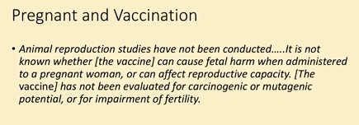
So pregnant women and vaccines, no animal studies have been done that means none. No animal studies. So they're saying get a pregnant person a shot.
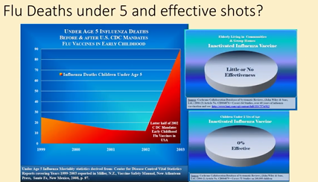
OK. Really Doc these are the death rates of kids under five. From the flu before the shot. This is the death rates after when we look at the Cochrane Database there little or no effective in elderly and zero percent effective in kids under 2. But we're shooting them.
Flu mechanism.
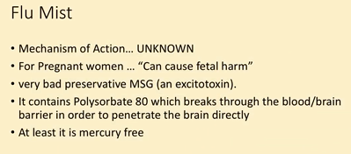
Flu Mist
the mechanism action is unknown we don't know how this works. And there's that spray thing that spreads the living virus.
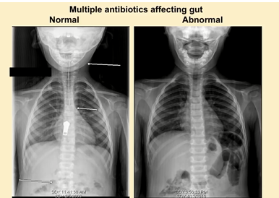
This is a normal healthy child. But there's the typical kid that comes into our office that's what a leaky gut looks like on a child. Yeah. Crohn's disease irritable bowel syndrome. Now this is where serotonin is produced. OK. So do you think that he's going to have anxiety and stress behavioral issues all of that stuff. That's what he came in with. OK he's better now.
Zika virus.
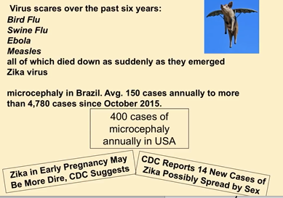
Now I originally called it Zitka virus because I thought we're going to pop this myth but it's really Zika virus. OK so let's go over this now. We've had a number of different scares. OK. Remember the Ebola. Yeah. A few billion dollars of that. No more panic. OK. Remember SAR's, West Nile Virus OK nobody remembers the Spanish flu. But you know we go in there. OK. Now microcephaly in Brazil. They have about 150 cases annually. However they had a huge rise four thousand seven hundred eighty in October last year. Now of course we've got about 400 cases of microcephaly in America every year.
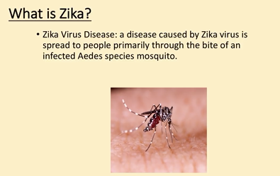
Now what are they from? Are they from the Zika virus or what. Let's look at that. OK. Now when we look at this Zika is a virus primarily from the Andes species of mosquitoes. Now it's infected but the symptoms.
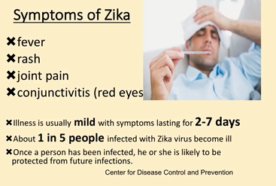
And this again this for the Center for Disease CDC they say the symptoms of Zika are fever, rash, joint pain and red eyes. Illness is usually mild resolves in two to seven days.
About one in five people infected with Zika become ill. Once the person has been infected he or she will be likely be protected from future infections. Wait a second one in five people will get these mild symptoms. OK. So does that mean that 80 percent of the people infected with this have no symptoms whatsoever? and the 20 percent that actually do get infected with this have a mild cold for about seven days, according to the CDC?

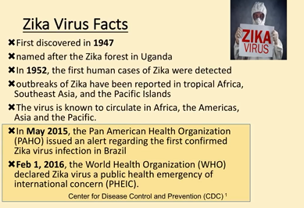
Shit I'm not that scared. OK. Now it was discovered in 1947 in Uganda for us now in 2015 the Pan American Health Organization they issued an alert regarding the first Zika infections. But again 80 percent get it may be protected for life. 20 percent have a mild cold. Nothing. Okay. Now these are the areas where it's always been OK. Now.
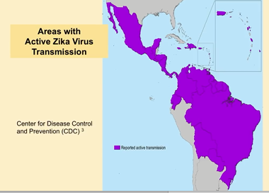

When we look at this what does the CDC recommend if you're infected with
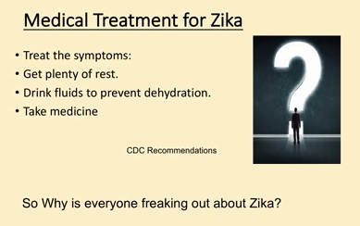
Zika? They recommend plenty of rest. Just like mom would, drink plenty of fluids and take medicine of course. They sell medicine.
Now the causes of microcephaly.

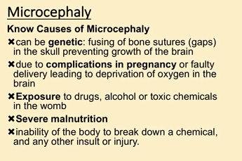

Because this is the big scare small brains small heads. OK. It can be genetic. OK. Where the bones get confused. Complications during pregnancy, exposure to drugs, alcohol, toxic chemicals in the room and severe malnutrition.
Because what I want you to do is look at the area in Brazil where they're coming from. You're talking about a very malnourished indigenous population that actually does have smaller head size.

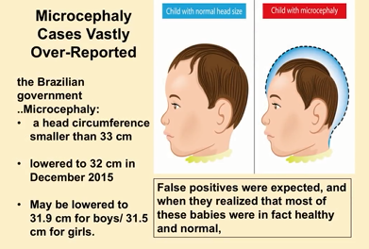

Now when we look at this they started by saying head circumference smaller than 33. OK. And then they had 5000 cases of microcephaly so they thought OK well gee maybe we should change the number. So there was objective. Statistical analysis that shows that a head that's 32 centimeters or thirty one point nine. No this is just numbers made up because they got too many microcephaly cases in an indigenous population or you see what I mean. So the numbers here they're trying to lower the numbers so they lower the number of people that qualify for the for the microcephaly but it's not based in any fact or any science or anything. They're just randomly making up numbers. And they did it because they were getting a heck of a lot of false positives.

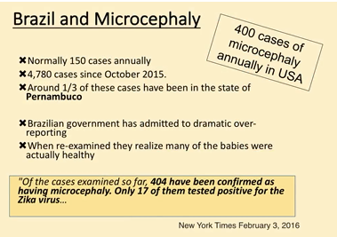

Now Brazil OK. And microcephaly. Hundred fifty cases annually. Generally 4000. About a third of the cases were in this one state Pernambuco. Now one state. OK. No indigenous population malnourished. And are there any toxic exposure. Let's look at the real causes of microcephaly
Brazilian government has admitted to being overdramatic reporting of the cases so far 404 have been confirmed has microcephaly only 17 tested positive. So out of the four thousand seven hundred and eighty microcephaly cases. 17 of them had infected with Zika. Now it's interesting because when we look at this 7 and 9 babies ruled out as not having microcephaly. Thirty six thousand cases are being investigated. You start looking at this and it's like wait a second it's just panic it doesn't make any sense. There is a consensus among medical groups that the current criteria is too broad and drawing too many false positives. And I love New York Times 2016. There is actually very little scientific evidence tying the Zika virus to this particular condition. That's true. There is almost none. OK.
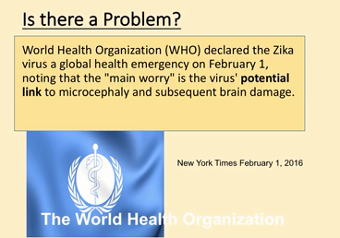

World Health Organization is trying to create a panic because they're going to be selling this vaccine approximately twenty five thousand infants in the U.S. now have microcephaly but 400 a year keeps on adding up. Now I love this one point eight billion dollars funding for it. Where does it go. Where does the one point eight billion dollars go to the largest industry in the world.
Now it's interesting. Argentina's physician organization previous Zika epidemics did not cause birth defects despite infecting 75 percent of the population. In other countries such as Colombia there are no records of microcephaly.
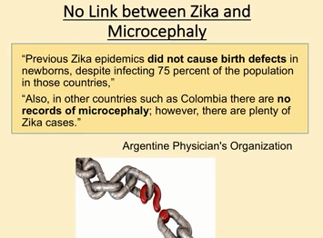
However there are plenty as he cupcakes. So it turns out that you can have a Zika infection in Colombia and be OK but if you're in Pernambuco in Brazil it's not good for you. OK. Same mosquito same virus. Colombian President announced that many of the country's citizens were infected with Zika not as Zika. Not a single case of microcephaly. And you're looking at this three thousand one hundred pregnant women were infected with Zika all the all the women were healthy all the kids were healthy. OK. And these are like actual facts. World Health Organization has been careful not to explicitly link Zika to the microcephaly. I love this. This is totally made up a causal link between zinc infection and pregnancy and microcephaly. So far has not been established but circumstantial evidence unless you're living in Colombia I honest to God. OK
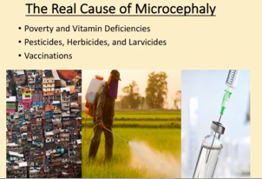
these are the real causes of microcephaly. So now is Pernambuco that small area. Do they have poverty vitamin deficiency are they exposed to pesticides herbicides and do they have vaccinations. Absolutely. Outbreak it's all in the poverty constricted area.
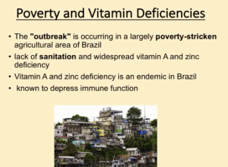
They're all lack of sanitation vitamin A and zinc deficient. We know that vitamin A. Remember how we're talking about vitamin A can wipe out measles infections protects you from vitamin C protects you from polio. I mean all of that is zinc and vitamin A deficiency malnutrition. We know this now the glyphosates. And this is what we're having in most of our food sources we're exporting this toxin but it destroys your mineral absorption destroys your gut flora and it is linked to birth defects.
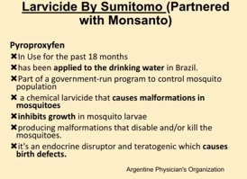
Now the glyphosate absolutely has been linked to birth defects in in laboratory animals. Now this is another one pesticide. It's been useful last 18 months Pyroproxyfen. OK. And this is in the drinking water. Now this actually does cause malformations in mosquitoes and it's actually can cause birth defects when we know that this stuff can cause birth defects we know it can cause malformations and we know it's in one area but still malformations detective and thousands of children from pregnant living malformations detected in thousands of children from pregnant women living in areas of Brazil's state added this to the drinking water are not a coincidence. Even though the Ministry of Health places a direct blame on Zika for this damage.
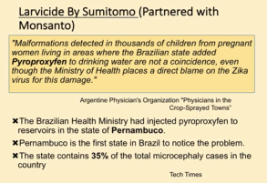
You know we're looking at the actual data of the actual area that Zika is not a problem doesn't never has been.
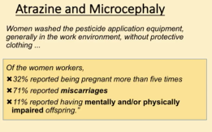
Atrazine.
Now this is another one. This is for an herbicide for weed control. We know this causes microcephaly of the workers the women workers who are cleaning this farm equipment in this area. Thirty two percent reported being pregnant more than five times so they keep losing the kids miscarriages mentally or physically impaired offspring. We know what's causing it. And we're starting to spray in Florida. OK.
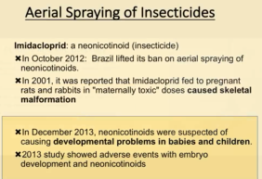
October 2012 Brazil lifted a ban on aerial spraying. OK. And so this. It's almost like the government's trying to cover up the malformations.
Vaccines they actually forced vaccinated the DPT shot in pregnant women. Now remember there's no pregnant animal studies pertussis vaccine has been

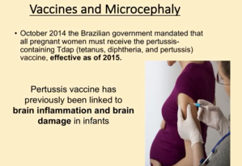l
inked to brain inflammation and damage and they forced this vaccine on the pregnant women mill. It's interesting. A typical vanishing white matter disease with microcephaly and a paddle splinter Magalie provoked after the DPT vaccination. Out of the Journal of Pediatric Neurology. So we know that
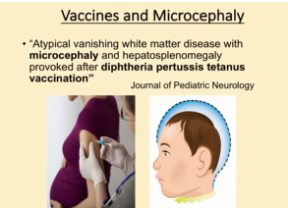
microcephaly can be caused if the mom gets a shot but only if you read all of this stuff is going to be put on our site and that and the tough part for anybody ever know what an internet troll is.
OK. OK. You know we get a lot of OK. They're going to say vaccines are safe and effective vaccine is safe and effective. Yeah yeah OK. Reference reference reference. You know and we got to do our own research OK. Does that make sense. OK.

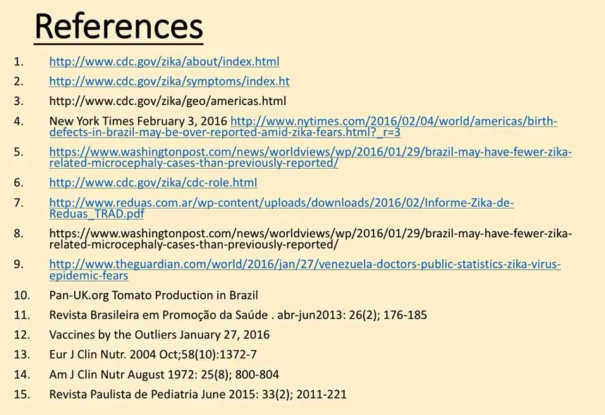
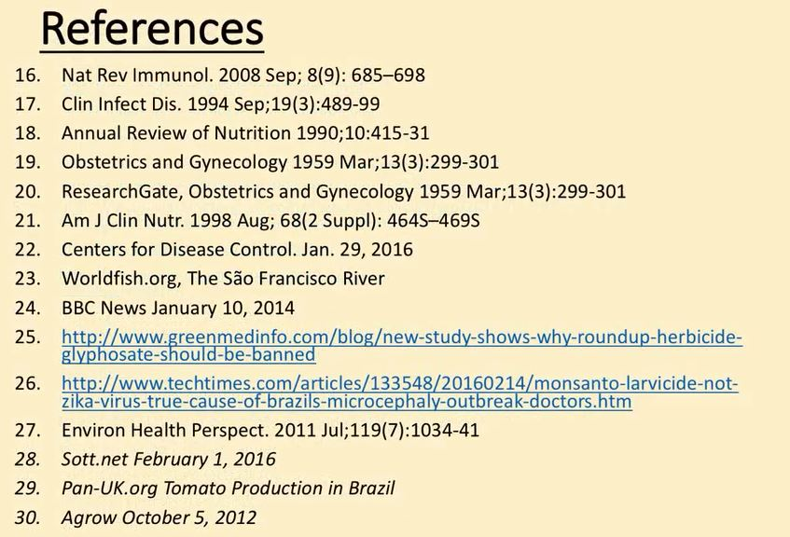

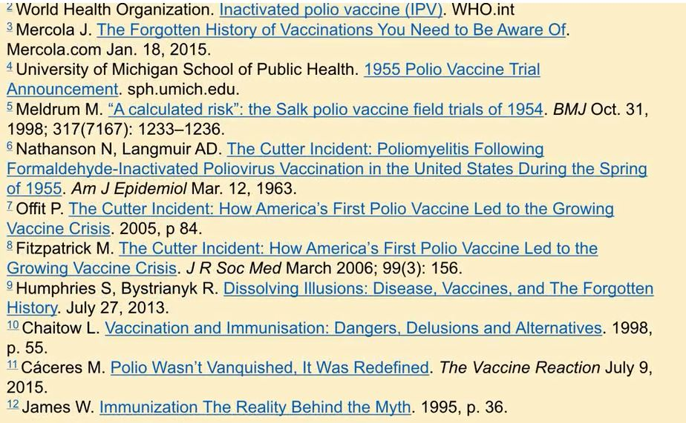
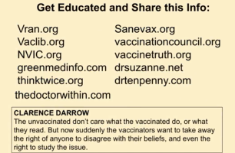

[There were some questions from the audience but they were not registered]
Now any questions. Yeah.
Most where we're the we have the highest vaccinated population and the sickest the most countries don't do this experiment. No. I mean most are half or less and they allow their kid populations to grow a bit
that the reason some people say it's population control. Other people say it's greed or ignorance. So you've got three choices greed, ignorance or population control. It's rate based on science.
Yeah they do. Well they can cross the blood brain barrier in fact they do and it negatively affects the macrophage activity which actually takes care of brain clacking. So they're linking decreasing macrophage activity to flu shots and that's placking in the brain. That's dementia Alzheimer's bad stuff. There are there are a ton of toxicological studies on medications the vaccines the huge experiment is when you get somebody with 69 doses of 16 different vaccines meeting with somebody who had that knowing that it can alter DNA expression and then they produce a child. OK. And then that child is going to get one hundred and twenty one hundred and forty vaccines and then that child mates. This is it's generationally it it's
well I mean luckily they'll be sterile in a few years anyway so don't worry.
Yeah yeah I mean that's why we got fertility things everywhere.
Don't don't shoot him. You keep their immune system healthy kids just realize that it's gonna be a virus. And how do you do it. You give them Vitamin C Vitamin A healthy nutrients.
No. You let them touch them like crazy. Have fun. Yeah. Believe me it's gonna be OK. But the viral shedding is dangerous. But you know your kids are strong and healthy if they're not vaccinated.

pneumokokkenvaccin
https://nl.wikipedia.org/wiki/Code_van_Neurenberg

