The chicken and the egg
Expanded version-2

Introduction

My purpose here is not to answer the question of who was first the chicken or the egg, but to address people's experiential data on issues related to chickens and eggs. To do this, I have three examples that will be elaborated on.
The first example is about the French scientist, Louis Kervran, who discovered
that without the presence of a lot of lime (calcium), his chickens still produced beautiful eggs with a firm shell. He tried to solve this riddle.
The second example is about the Dutch Hendrik ter Beest who raised chickens and was confronted with the fact that his chickens were pecking the feathers out of other chickens, after which he set out to find a solution.
The third example is about the chicken farmer Jos Nelissen from the province Limburg in Holland, who tries to improve the taste and quality of the egg through the nutrition of the chickens and even in such a way that eye problems can also be prevented.

Example 1 on lime, silicon and carbon

We sometimes find that when we take an egg out of an egg carton, it breaks in our hand and makes a mess. My first thought is: not enough calcium. The second thought is: the chickens should be fed more calcium. A kind of logical reasoning.

The Frenchman, Louis Kervran a scientist, made the following observation:

Kervran lived in a part of England where the soil contained virtually no
lime, but on the other hand, there was plenty of silicon, or silica.
He wondered that despite the lack of lime, his chickens could
lay such beautiful eggs with strong shells. Kervran then gave his hens no calcium. Yet they still laid good, firm eggs. When he next decided to omit silicon from the feed, the shells of the eggs did not become hard, but remained soft.

He later formulated a theory to explain this phenomenon. His idea was that Silicon and Carbon, could produce Lime. And he called this transformation a "cold" nuclear fusion. The chicken could deliver this transformation.

Many objections have been raised about this theory.

A problem that often arises with a theory is, that - focused on this case - one undermines the idea of cold fusion and with it the conclusion that silicon provides a solid eggshell. In fact, that view is not correct. The observation of something and the theory of how it comes about are two separate worlds.

Can the observation hold and does the theory need modification? Critics claim that nuclear fusion releases a lot of energy. If in the chicken silicon and carbon fuse to calcium, so much energy would be released that the chicken would be roasted from the inside out. It almost seems like a joke.

I myself was always taught that nuclear division releases energy, doesn't it make more sense that nuclear fusion costs energy?

And is that what Kervran means by "cold" nuclear fusion? But according to current scientific understanding, it cannot be. The observation that good eggs can still be produced without lime still stands, and an explanation of how it can be that chickens lay firm eggs without enough lime is still not there.

Could it be that cold fusion requires another substance that plays a role in the fusion process, but that substance is not yet known? One can think of noble gases as mediating substances. For example, in our air that we breathe and that chickens also breathe, we find the noble gas Argon. At the end of this text, an example of the role of noble gas in fusion and division of substances.

Example 2 about chickens pecking out chicken feathers

A second observation was made by farmer's son and chicken breeder Hendrik ter Beest from Haaksbergen in Holland. He was confronted with chickens pecking each other's feathers out. A common method was to cut off the beak. Chickens were also given blinkers. But Hendrik did not like any of this.

The “New Harvest” magazine denounced the ban on beak clipping in 2007 and suggested that supplemental feeding with oats might be a solution.

Hendrik took that suggestion seriously and experimented with oats, but the oats were poorly absorbed by the chickens. After a combination of hulled oats and ground oats, the chickens ate the oats a little better, although the diet was still not palatable enough. His wife recommended adding sunflower oil to the mixture. It turned out to be "the egg of Columbus," the animals loved it and the feather pecking stopped.
Favorable side effects were faster growth and faster laying maturity of the young hens. The young hens began laying eggs one month earlier.
Eventually Hendrik as well as Kervran came upon silica or silicon as the active ingredient. Silica is also plentiful in chicken feathers and since chickens need silica to produce an egg, it is logical that if they are deficient in silica, they will look for it themselves and find it in the feathers of other chickens. Because of the oats which themselves contain a lot of silica, the silica is replenished and the feather pecking stops.

Nettles, millet, oats and bamboo are examples of products high in silica.

If we throw in Elmer McCollum's research [3] he would not recommend sunflower oil to add to the hulled and ground oats but whole milk or butterfat or buttercream. Why? Because while vegetable oil is a good energy provider, it does not absorb the vitamins A, D, E and K and milk via the fat it contains does absorb vitamines. And probably the silicon is also better absorbed through the addition of good fats and the chickens come out even healthier.
McCollum also probably would not have hulled the oats if they are milled
anyway, because there are many good substances in and under the outer husk of the oats. Palm oil and coconut oil are also better than sunflower oil because they contain saturated fats.

Using McCollum's method or by chemical analysis, it should be further investigated whether that silicon is also better absorbed by milk or butterfat or by palm oil or coconut oil.

Example 3 on chicken nutrition and our eyes

Another development with chicken eggs related to health is of interest: In the Limburg town of Oirle[1] a chicken farmer Nelissen is experimenting with chicken nutrition in cooperation with the university in Wageningen and the UMC+ hospital in Maastricht.

The chickens receive standard chicken food that is supplemented with the flowers of the Marigold plant. The flowers of the Marigold plant contain substances [2] that are good for human eyes for example lutein. And these substances are found in the yolks of eggs. Eggs from chickens fed with the flowers of the marigolds.
McCollum [3] sees the chicken egg as an essential nutrient because the yolk
contains saturated fats that in turn make a variety of substances including vitamins A, D, E and K more accessible for absorption in the body.
Research has shown that eating the eggs given in the diet flowers of Marigolds are tastier and healthier for the eyes and reduce eye diseases in humans. It would be a good thing if we could access this research data [4].
The egg is now marketed under the name "Marigold."

Considerations
There is much of interest to report about chickens and eggs and as we can see, determining something by observation, is very different from explaining the established phenomenon through a theory [5].
What does become clear from Elmer McCollum's work is that one fat is not the other fat. Vitamins, for example, do not dissolve in vegetable margarines. Taking vitamins to supplement the diet only makes sense in conjunction with good fats and good quality water.
When we eat a sandwich with real butter and a boiled egg in the morning,
we are doing our health a good service.
Furthermore, openness of research is important. In the case of Nelissen's
chickens, it is necessary that the investigations that were done, as alleged, also become public. Otherwise, the case does not become credible.

The wisdom of a nursery rhyme shows us the way:
One egg is not an egg
Two egg is half an egg
Three egg is an Easter egg

Converted to research and science, it sounds like this:
1. A single study is not a study, does not say much.
2. Two studies whose results match, that evokes the feeling: it might
be right.
3. Three or more independent studies with the same results confirm
our confidence in what was stated in the first study.

Science, in this way, becomes the building of confidence and thus forms the basis of our health.

References

- Chicken farm of Jos Nelissen
https://marigoldculinair.com/a-family-ffair/
- About Lutein https://nl.wikipedia.org/wiki/Lute%C3%AFne
- Book by Elmer McCollum in English and Dutch translation. https://gezondheid-info.jouwweb.nl/voeding-en- gezondheid/mccollum-boek
- Via Dr. Chris Knobbe referral for eye examination:
https://www.ncbi.nlm.nih.gov/pmc/articles/PMC4785134/
- Publications on nutrition and health
https://gezondheid-info.jouwweb.nl/voeding-en-gezondheid

Glossary

Noble gas
A noble gas is a substance that basically does not bond with other substances because its outer shell contains all the electrons. The role of noble gases is in my opinion not really clear yet but there are indications that noble gases may play a mediating role in the formation and cleavage of compounds. https://nl.wikipedia.org/wiki/Edelgas

Nuclear Fusion
Two substances are combined and a third substance is created.
In physics, nuclear fusion is the fusion of atomic nuclei, forming a heavier
atomic nucleus with a higher atomic number (and thus a different chemical element).

Nuclear Division
In physics it is a process in which a heavy unstable atomic nucleus is divided or
splits into two or more lighter nuclei, releasing significant amounts of
energy.

Silica or Silicium
https://nl.wikipedia.org/wiki/Silicium
What is silica good for?
Silicon or silica is an important nutrient for the human body. For plants
and animals, silicon is essential for building cell walls. In our body, this trace element is an important part of our connective tissue.

Carbon
https://en.wikipedia.org/wiki/Carbon
The free element carbon has many different uses. Among other things, it is a component of diamond decoration and printer ink. Graphite is used as dry-cell and light electrodes, as pencil tips and as lubricating oil, among other things.

Observation
That which is perceived.

Fats
Fats are very diverse. There are animal fats and within an animal again different fat. Then you have fats in what animals produce such as milk. From cow's milk we get cream, butter, buttermilk, whole milk and semi-skimmed milk. Then we have vegetable oils and fats since early last century. The term "plant-based" is a misleading term. The oil comes from the seeds. As many studies now show, vegetable oils and fats or margarines are not that healthy for humans despite all the advertising campaigns.

For example, on the Internet there is said: vitamins A, D, E and K are soluble in fat. And that is very misleading because it does not say in which fat. And we know that the B vitamins are soluble in water, but it doesn't say in which water.
What is the composition of that water?

Researcher Elmer McCollum [2] discovered two mechanisms "Fat-soluble A" and in "Water-soluble B" in his studies with diets.
We now ask the question: in which fats dissolve which substances, which McCollum calls A.
The same with water: in which water do which substances dissolve?

A task for our chemists. Solubility in fat and water is crucial in the absorption of those substances in the body.

Two examples:
- a dietary experiment with rats by McCollum and the
- question of why do we spread butter on our bread?

1. McCollum did the following experiment with two groups of rats. He gave both groups the same diet. Only group A received vegetable oil with the diet and group B received butterfat, or buttercream, with the diet.
What was established?
Group A became half the size of Group B and
Group A lived half as long as Group B.

2. Why do we spread butter on our bread?
McCollum says the grains in bread are not in a high place from a dietary
standpoint. However, besides the wonderful smell and taste of bread, grains possess vitamins and minerals and other good substances.
And we as humans desperately need these substances. However: are these substances absorbed by our body? Fat plays a crucial role, but which fat? If we think of McCollum's experiment, vegetable oil does not come off well. Could it be true that if we spread vegetable margarine on our bread, the good things such as vitamins and minerals are not absorbed, unlike with butter?

And then there are margarine manufacturers who put on the package that they have added various vitamins to the margarine. But what good is that if those vitamins are not absorbed by the margarine and therefore are not absorbed by the body?

Another packet of margarine says: without palm oil! The relatively best thing for our health is taken out because palm oil, politically is in the damned corner?

And so, yet another manufacturer says that their margarine is cholesterol- lowering and that this has been proven by 45 studies.
But whether that is healthy for a human being is not mentioned!
So, it's high time for better overviews about fats, especially about which fats absorb which substances so that they get into our bodies.
The same goes for water.
Swallowing vitamin pills without the right fat or water composition
accomplishes practically nothing.

In short, there is still much to learn in this regard. We have to remember that if we structurally take in too few good substances into our bodies, then the body starts mobilizing good substances from the body itself to do the necessary maintenance. And so, if this goes on long enough, you become sick and ruin your own body. This has been demonstrated in McCollum’s dietary trials. For a mother giving breast milk to her child, it is equally true that the quality of the breast milk is much lower if the mother herself has a poor diet.

Merger and division example

Starting from "Another Math" based on the work of Frans Coppelmans we show what fusion means.
Note this is a theoretical approach.

We assume two elements:

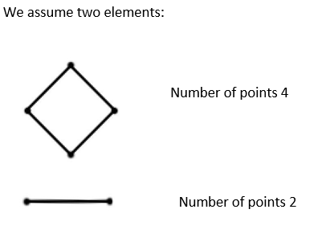

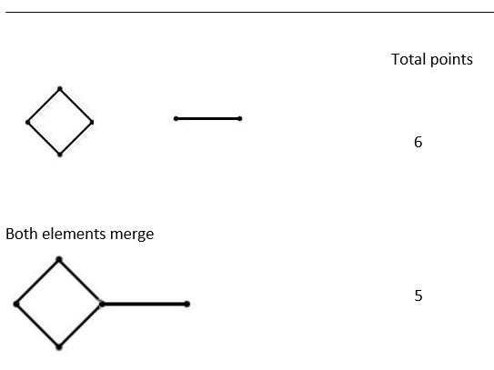

Elements are separated, split, division Total points

After fusion:

Why not like this? Or like this? Or like this?
A B C
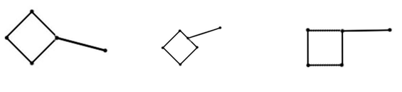

This is where the action of the noble gas or of the final structure is added. The cube consisting of 8 points in the Math.

The noble gas or end structure 8 gives the individual elements a directedness and the directedness allow the elements to be joined. Only the points are connecting points. So, the above B option is impossible. A and C are within the noble gas impossible because of the same directedness of the elements. A and C are possible outside the influence of the noble gas.

In this example, the noble gases are represented two-dimensionally as a dotted square. YouTube shows an example of the fusion in 3-D.

The orientation of loose elements is important when it comes to joining. This is why scars form after surgery because when the wound is sutured, the cells on the cut surface are not oriented and thus the original connection is not restored. A new connection must be created, the healing process.

Now the fusion and division with the noble gas designation. Two elements

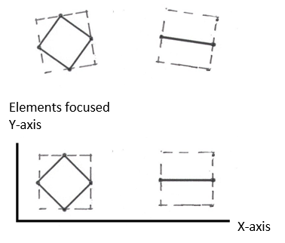
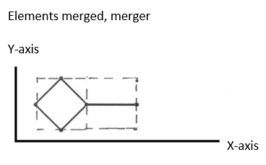

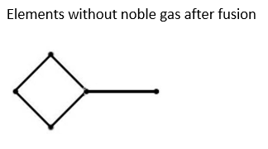

Now what does this element look like when you look at it through a microscope?

Sort of like this:

Through the microscope, you always look against the outside, the contour of an object. The external appearance.
You want to look inside the object but you can't. The inside is only unlocked by
knowing how things are put together.

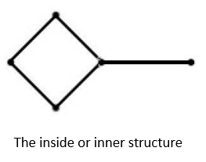

This insight has been brought to us through the work of Frans Coppelmans and is available to all.

Back to practice

The above story is based on theory and the next step now is to see if we can use it in practice. We see in theory that with a merger the number of points decreases. In practice we see this reflected in making connections. If we hang a kitchen cabinet, we have to make connections with the wall, otherwise the cabinet falls to the floor and gets damaged. Demolishing things produces energy because the existing connections are broken and the binding energy is released.
In humans and animals and probably plants there is a constant process of
building up and breaking down and these two movements must remain in balance then it is called healthy, but when the balance is disturbed, then there is disease. Disease can lead to better control of that balance, becoming stronger.
So, wanting to prevent or even eradicate disease with all one's might is not desirable. For people who believe in eliminating disease, the question has probably never occurred to them: what will come in return? Perhaps something much worse? In nature, there is a balance, if you take something away, something will automatically come in return. Similarly, there are people who think there are too many people and that we need to clean up a lot of people. These people do not realize that there is a balance in this area as well, those people are there for a reason and if you take away large groups of people, the very idea, something will come in return and that is usually even more people.
The big simple solutions are often not the best solutions, so let's humbly work
for a better future for us all.

https://frans-coppelmans.jouwweb.nl/wiskunde
https://youtu.be/fqaCHrjj_co

