Vaccination and Homoeoprophylaxis 7th edition
A review of Risk and Alternatives

Dr. Isaac Golden
OCR version 2.1

PART 1: GENERAL DISCUSSION
Overview of the argument, and some issues

Before we commence our detailed study of each of the 6 questions asked (remembering that Sections do not need to be read in order), I would like to present a few pages summarizing the book. I know that some readers will always begin at the beginning, and at times don’t get to the homeopathic Sections until after the information is needed. For others, the volume of material may be challenging, or time is not available, so a simple summary will be useful.

We all want the best for our children. We want them to be safe and healthy. We would like to protect them from any suffering - mental, emotional or physical. However life is not like that. It is inevitable that we will suffer at times, but it is sensible to try to minimize the frequency and severity of this. At the same time we don’t want prevention methods to come at too great a cost, especially hidden long-term costs in terms of debilitating chronic diseases.

There are many infectious diseases circulating in our communities. In Australia, leaving aside seasonal influenza, we are generally free of epidemics. However some potentially lethal diseases are still present such as meningococcal diseases, Hib, and even whooping cough in infants. So it does make sense to prevent, provided the means of prevention does not cause more long-term problems than the condition itself. And this is where the debate commences.

Question 1 looks at the potential severity of the different diseases for which vaccines are available. Most people accept that it is worth preventing at least some diseases, but some are concerned that the most commonly used form of prevention - vaccination - may cause problems.

Question 2 looks at whether general prevention or disease-specific prevention is most appropriate, and concludes that maximum prevention comes from targeting specific diseases with disease-specific remedies. There are two types of disease-specific prevention, and the remainder of the book compares these options.

Question 3 outlines some concerns with vaccines. However the recommendation is not that you should never vaccinate. That is your decision alone, and will be influenced by a variety of facts including family pressures, work requirements, school issues and so on. My position is that you do have a choice between the two methods of disease prevention, neither of which are
100% effective but which are comparably effective, but with very different
levels of potential toxicity.

The point of this work is to say to parents that you can actually provide comparably effective prevention against the diseases of greatest concern without risking toxic damage that may result from vaccination.

Much of Question 4 is devoted to providing evidence of the safety and the effectiveness of the homoeopathic option. There is very little disagreement regarding safety, because homoeopathic medicines are prepared past the point where there are toxic materials present - the main debate quite properly relates to effectiveness.

Your job will be to assess the evidence provided, and there is now a considerable body of evidence quantifying the effectiveness of homoeoprophylaxis. It is both interesting and disappointing to see how many people in orthodox science claim that there is no evidence, whilst at (he same time admitting they have never read the existing materials. OF COURSE, if you never examine what is available then you can say that you are not aware of any evidence. But that is a world away from having examined evidence and concluded that it is inadequate.

This is all I ask:- that parents are given the opportunity to freely examine both sides of the argument, to examine all the evidence available, and then be supported in the decision they make.

In practice, some individuals and groups want to suppress free speech for a variety of motives. Some because they genuinely believe that their option is the best (even if others don’t realize it); others for simple vested interest (and it is not necessary to speculate about the massive profits big pharma makes from vaccines - this is common knowledge), and others because of some pseudo- scientific herd mentality.

For example, in 2009 I appeared on a local TV channel to debate the immunization issue with a Professor who was a vaccine manufacturer. I introduced the Cuban material which the Professor was not aware of.

Some members of the Skeptics Society saw the debate and viciously attacked the TV Channel and the two presenters, criticizing both for allowing any air time to discuss the issue. They wanted the public to be prevented from knowing that 2.4 million people had been successfully immunized using homoeoprophylaxis - not an opinion but a fact.

But the suppression of free speech is the first sign of a lie - if a person is speaking truth then they have no need to suppress discussion. So we often hear it said that anyone who opposes vaccination is threatening the wellbeing of the whole community because they are reducing the herd immunity effect which vaccines bring. But homoeoprophylaxis also brings with it a herd immunity effect. This is not realized simply because people have not studied evidence.

So we are dealing with an issue where emotions and deception often hold more currency than truth. It is the task of each parent to try to see past deception to the facts, and thus make informed decisions.

Question 5 of the book compares the two immunization options - vaccination and homoeoprophylaxis, and Question 6 asks - which option is best for my child? It is totally appropriate to begin with these Sections if you wish, and in fact I recommend this for readers who think they might struggle with the volume of material contained in the earlier Sections.

So start by reading Section 5 and then Section 6, and then return to the remainder of the material if you prefer.

The progression of logical reasoning asks:

QUESTION 1: Should we attempt to prevent infectious diseases?
QUESTION 2: What is the best overall approach to infectious disease
prevention?
QUESTION 3: What are the risks and benefits of the vaccination option? QUESTION 4: What are the risks and benefits of the homoeoprophylaxis
option?
QUESTION 5: What are the comparative risks and benefits of the two
disease-prevention options?
QUESTION 6: Which option is best for my child?

But you can pick up the book at any point.

What I have done in the 7th edition is to put the bulk of the writing relating
to specific diseases and specific vaccines into Appendices, so even if you start at the beginning, you will gain a comprehensive overview by the time you have read about a third of the book, then you can delve deeper if you so wish.
Chapter I
QUESTION 1: Should we attempt to prevent infectious diseases?

To some readers it may seem a silly question - after all, why would we NOT want to prevent possible suffering in our children. However, there is serious debate within both the orthodox and complementary (or natural, or traditional) medical circles concerning the desirability of preventing all infectious diseases.

We shall begin our examination of this question by considering how potentially serious the common infectious diseases really are (individual diseases are now examined in Appendix 9.1). It is always worthwhile remembering that what may be a simple and harmless disease in a healthy person may become lethal in a person whose immune system is seriously compromised. The example of measles in a child suffering from malnutrition is
a good example of this. So in a country like Australia, measles is potentially less
serious than in a country where a majority of people are starving.

We shall then consider something called the hygiene hypothesis, which, stated simply, says that the acquisition of some childhood infectious diseases assists in the normal maturation of a child’s immune system. This hypothesis has supporters from all fields of healing.

Finally, we shall consider some of the options that parents have when they come to make their first basic decision - should we attempt to prevent a particular infectious disease in our children?

1.1 The characteristics of common infectious diseases

The focus of this book is on the standard childhood diseases in Australia. This list typically applies in most developed countries. However overseas travel is always a possibility and so some diseases commonly of concern in overseas travel will be considered. Of course, the recommendations made in the book can apply for adults as well as children.

Table 1-1 lists the infectious diseases which shall be examined, as well as summarizing some relevant information about incubation and spread of the diseases

Refer to “Definitions” (page xii above) for descriptions of the differences
between an epidemic, an endemic, and a pandemic outbreak of disease.

READER’S NOTE: Table 1-1 summarizes some of the material now presented in Appendix 9.1. This Section can be skipped if you already have a good idea of the diseases you want prevented, or if you prefer to come back later and study the disease information more carefully. However, a careful look at Table 1-4 at the end of this Section is recommended.

Table 1-1 Infectious Diseases with Summary of Characteristics

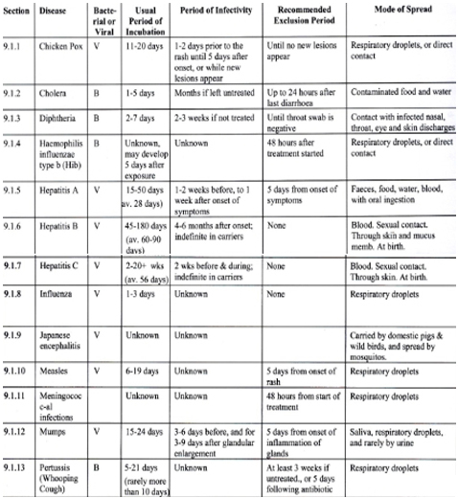

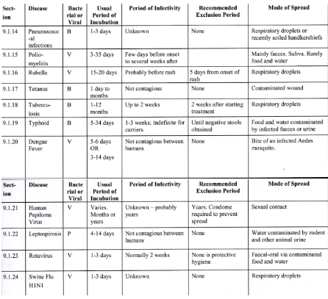

The major references used to develop the following material are:

The National Health & Medical Research Council. The Australian Immunisation
Handbook, 9th edition, 2008.
The handbook contains a wealth of “scientific” information about diseases and vaccines, and is very thoroughly referenced for those who wish to examine back-up evidence in medical journals and medical texts. Unfortunately I was not able to obtain permission to directly quote from the Handbook when preparing the final draft, so readers who want additional information (all of which is also available publicly elsewhere) may obtain their own copy. The handbook is accessible for free online at www.immunise.health.gov.au.
Davies E G, et al., Manual of Childhood Infections, 2nd edition, 2001.
W.B. Saunders, London.
A very thorough handbook of many infectious diseases, and how they manifest in children.
Neustaedter R. Vaccine Guide - Risks and Benefits for Children and Adults.
Revised Edition, 2002. North Atlantic Books, Berkeley, California.
A well-known publication among natural therapists interested in the vaccination issue. Very well researched, informative and readable.
Lessell C B. The World Travellers Manual of Homoeopathy. 1993. C W
Daniel, London.
An excellent reference for the world traveller. He discusses homoeopathic treatment and prevention, as well as giving some great common sense suggestions concerning prevention.

NOTE: The following general structure is used when examining each disease in
Appendix 9.1:

1. The Organism
2. Clinical Symptoms
3. Orthodox and Homoeopathic Treatment
4. Summary

PLEASE NOTE: Because point 3 refers to possible treatment options for the
diseases examined, I am obliged to repeat the Disclaimer given at the front of the book. Some of these diseases are potentially life threatening, and professional help should be sought to ensure that appropriate treatment is undertaken.
Disclaimer: This book is not intended to replace the services of a qualified
practitioner. Any application of the recommendations set forth in the
following pages is at the reader’s discretion and sole risk.
1.2 The hygiene hypothesis in orthodox and complementary medicine

There is some agreement within both orthodox and traditional medicine that acquiring some infectious diseases may be beneficial to the normal maturation of a child's immune system. For example, Morgan referred to epidemiological studies showing that a typical measles illness "may actually confer non-specific health benefits leading to reduced childhood mortality rates” (Morgan, 2004). Martinez reported that “infants exposed to infections in early life appeared to have fewer allergies later - his study of 1,000 children showed infections might be protective, allowing the immune system to ‘develop batteries’ against infection” (Herald Sun, 1996). Cookson and Moffatt concluded that “childhood infections may, therefore, paradoxically protect against asthma” (Cookson W O & Moffatt M E, 1997).
Traditional Chinese Medicine practitioners certainly believe that a typical measles infection can be very beneficial in maturing the immune system.
The so-called “hygiene hypothesis ” states that a lower level of exposure to bacteria and viruses, and fewer infectious diseases in childhood, results in an increase in asthma, eczema and allergic diseases in later years. The term was first coined by David P. Strachan in 1989 (Strachan, 1989). The hypothesis is controversial within orthodox medicine, with supporters (Von Mutius E (2007); Matricardi et al, 2002; Braun-Fahrlander et al, 2002; Pawankar R et.al., 2008), and those who question its validity (Dahl ct al, 2004).
However, there is little if any evidence that demonstrates that every child needs to acquire every disease in order to be healthy. In fact, there is ample evidence that infectious diseases at times create ’’layers” of distress in otherwise apparently healthy persons, for example, those patients ’’never well since” measles, glandular fever, pertussis, etc., who are regularly seen in homoeopathic practice.
Further, it can be argued that if the stimulation caused by an infectious disease is
beneficial, then the similar stimulation on the subtle level provided by homoeoprophylaxis (HP) remedies will be similarly beneficial, but without the risks sometimes associated with either the natural disease, or the vaccine.
Section 4.4 presents the evidence I collected during my doctoral studies which examined the long-term health of children who were vaccinated, who used
homoeoprophylaxis, who used constitutional prevention, and who used no method of
prevention at all. This showed that those who used HP were generally healthier than all other groups, and that the vaccinated group were clearly the least healthy of all.
This reinforces the beliefs of those who support the hygiene hypothesis in
regards to the negative effects of vaccination, but suggests that the appropriate use of
HP appears to have similar effects as the natural disease when it comes to gently stimulating the immune system and maintaining long-term health.
Further research is of course needed, but if this finding is true, it provides a significant additional reason to support the use of HP.

1.2.1 Some implications of the hygiene hypothesis

Let’s make some assumptions in order to explore possible implications of the hygiene hypothesis as it may relate to the link between asthma and vaccination:

Assumption 1. Vaccination against measles reduces the annual deaths from measles by 11-20 per year.

We estimate this by examining in Table 1-2 the trend in deaths prior to the introduction of measles vaccination in Australia in 1970, and by the fact that there has been only 1 death recorded from 1995 to 2008.

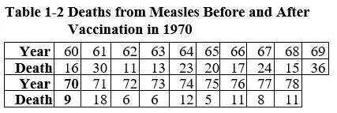

Average 1960 to 1969 = 20.5; Average 1970 to 1978 = 9.6

Assumption 2. Vaccination causes a fivefold increase in the incidence of asthma
in vaccinated children.

This assumption is supported by the data collected by myself and others (see Sections 3.6.13.4 and 4.2.3.3 below). There is also research in the orthodox literature demonstrating there is a case to answer regarding the asthma-vaccination link (Enriquez R et.al., 2005).
There were 447 deaths from asthma in Australia in 2008 (NACA, 2010). Seven deaths were in the youngest age groups (0-9 years). Figures from the Asthma Foundation of Victoria show that over 2 million people nationwide have the condition, and that asthma is one of the most common reasons for childhood admissions to hospital.
Economically, the annual cost to the Australian community is estimated to be in excess of $720 million, the cost to companies through absenteeism of those with asthma is $110 million per year, the cost of career absence is in excess of $120 million per year, and the cost of asthma medication over $110 million per year (Asthma Foundation of Australia, 2004).

So we can compare a saving of at the most 20 deaths a year from fewer measles deaths as a result of vaccination, with a causation of say 320 deaths a year from an increase in asthma as a result of vaccination (assumed to contribute 4/5 of the total deaths).

Comment: This analysis is by no means complete. It does not take into account the many additional variables that would need to be considered to make the analysis complete (such as the costs of measles infections, the costs of other vaccine reactions and long-term side-effects). However, it shows that this type of analysis needs to be done. Whilst the simple comparison of 320 deaths to 20 deaths is “academic”, it shows that there is clearly a case to answer, an examination which the orthodox
health authorities have neglected and the pharmaceutical industry rigorously avoided.

1.3 Options

Should a particular disease be prevented and if so, how? are major questions that responsible parents will eventually have to face.
There is no one single answer that will fit every possible situation - the severity
of diseases varies considerably, as does the general health of the children who may be infected. What may be a potentially serious disease for some people may be generally benign for others. We are all different, with a unique level of individual susceptibility.

It seems to me, when looking at the diseases examined above, that for an
Australian child we can break the diseases into three groups, as shown below in Table1-3.

I emphasize that this list is totally subjective. It is my own opinion. You have every right to hold a different opinion and you should act on your opinion.

It is recommended that parents and other readers prepare their own list. It
is of course quite appropriate to have a fourth column -“uncertain”. This exercise is part of the required decision making process for any person with a
young child.

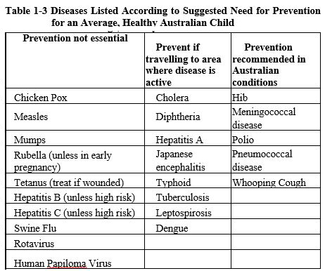

It certainly is reasonable to conclude that the material presented in Section 1 indicates that the prevention of some of the diseases examined is preferable to having to treat the diseases. We shall therefore now examine which approach to the prevention of specific diseases yields the most certain result.

Chapter 5
QUESTION 5: What are the comparative risks and benefits of the disease
prevention options?

5.1 The comparative effectiveness of vaccination and
homoeoprophylaxis

Because the vaccination debate has at times been both emotive and irrational, with fear employed as often as facts, many people are left with the impression that there are no areas of agreement between practitioners who use homceoprophylaxis and the orthodox medical community. This, however, is not the case.

Approaching the issue logically, there are four important points to consider, and there is substantial agreement on the first three.
- Some infectious diseases should be prevented: It is generally agreed that it is preferable to prevent certain severe diseases rather than have to treat a very distressed patient. There is, however, some disagreement about the need to prevent milder diseases, and some natural therapists (including some homoeopaths) believe that it does no harm to allow healthy people to acquire at least some infectious diseases and then be treated for the disease.
- Disease-specific prevention is the most effective method: There is substantial agreement on this point, although some natural therapists believe that the most effective form of disease prevention is to strengthen the general constitutional health of patients. While optimum health does have a significant bearing on disease prevention, there are numerous examples of healthy, stress-free people acquiring, infectious diseases (e.g. south-sea islanders exposed to Europeans for the first time in the 1800's). Furthermore, statistics show that disease specific protection is more effective than general protection.
- Vaccines are more toxic than homoeopathic medicines: This point is generally accepted; in fact, many doctors criticise homoeopathic substances because they do not contain any molecules of the original substance used. They say that "nothing" is there, and "nothing" cannot be toxic. Vaccines, however, contain a number of toxic substances. For example, the triple antigen vaccine contains molecules of diseased material modified with formaldehyde, together with an adjuvant (usually aluminium phosphate) and a preservative (previously thimerosal, a mercury-based chemical, and now another chemical).
- Vaccine efficacy is comparable with that offered by the homoeopathic option: While there is considerable disagreement on this point, if debate could focus on this critical issue, parents would be better able to make informed decisions. We shall now examine this point in more detail.
An analysis of the material drawn from the medical journals clearly demonstrates that the medical community itself acknowledges that vaccination is not completely effective. The best measures of vaccine efficacy range from about 75-98%, depending on which vaccine is being examined (the whooping cough vaccine is generally regarded as the least effective common vaccine, the measles vaccine as one of the most effective).

Some of these measures of efficacy have been obtained through controlled clinical trials (which are the scientific community's own standard); some, through field trials. We saw in the material presented in Section 3 that the difference between the efficacy of vaccines in clinical trials and the efficacy experienced in the field can vary considerably.

Other measures of efficacy have been obtained through large epidemiological studies which analyse communities of vaccine recipients. When conducted without bias, epidemiological trials provide information about the short-term toxicity of vaccines because they show how many children were vaccinated and how many of these had short-term reactions. They are, however, not reliable measures of effectiveness because although we know how many children were vaccinated, we do not know how many children were exposed to the disease being examined.

For example, if 100,000 children were vaccinated and 5,000 of these children acquired the disease, it would appear that the effectiveness of the vaccine is 95%. However, if only 50,000 of the 100,000 vaccinated children were exposed to the disease, the effectiveness is actually 90%; if 25,000 of the 100,000 vaccinated children were exposed, the effectiveness is 80%; if 10,000 of the 100,000 children vaccinated were exposed, effectiveness is only 50%. Since the epidemiological studies do not (and in fact cannot) include data for how many children were exposed to the disease in question, these studies are poor measures of effectiveness.

In the statistical studies of the homoeopathic method reported in Section 4, the key measure of effectiveness is arrived at only after attempting to eliminate children whose parents believed the children were not exposed to the target diseases, leaving only children who appeared to have been definitely exposed to a disease covered by the homoeopathic program in the analysis. While the analysis has weaknesses, it does attempt to eliminate the major bias affecting all 'after-the-event’ analyses, such as epidemiological studies and questionnaires.

So the vaccine efficacy of 75-98% benchmark against which to compare the homoeopathic alternative is almost certainly an overstatement of the actually efficacy in the community.

The single measure of effectiveness of the homoeopathic method derived from my 2004 analysis was 90.4%. This figure not only gives a general indication of efficacy, but, more importantly, supports the historical experience with the homoeopathic method over the last 200 years. Nearly all other research attempting to quantify the efficacy of HP has produced a figure of around 90%. When we add to this the latest experience from Cuba involving millions of people and conducted by orthodox scientists employed by the Government’s vaccine manufacturing facility, we see that the effectiveness of HP is now established beyond reasonable doubt.

Clearly, both history and current research support the conclusion that, while no method of disease prevention is completely effective, vaccination and homoeopathy offer similar levels of protection against infectious disease.

5.2 The comparative safety of vaccination and homoeoprophylaxis

Vaccines contain a variety of toxins, and therefore are clearly potentially toxic. Homoeoprophylaxis remedies do not contain toxic materials and are not toxic.

The analysis of my doctoral research presented in Section 4 has provided material on which to make a more direct comparison between the safety of vaccines and homoeoprophylaxis. The relevant data presented in Tables 4-17 and 4-18 is summarised in Table 5-1.

Table 5-0-1 Comparative Safety of Vaccination and
Homoeoprophylaxis

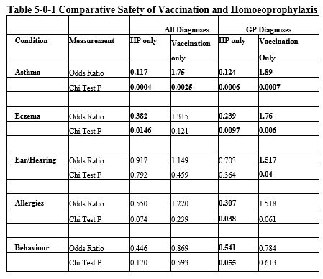

In every case, Odds Ratio measures show that there is less chance of a child who uses homoeoprophylaxis acquiring the chronic conditions listed than a child who is vaccinated. Many of the figures are statistically significant (shown in bold type). In some cases the ratio difference is significant (for example, the 15 times greater chance of acquiring asthma if vaccinated rather than using HP).

5.3 A general summary of comparative risks and benefits

Homoeoprophylaxis and vaccination are comparably effective, but homoeoprophylaxis is by every measure much safer both in the short and long term.

5.4 The economics of immunisation options

Not only is HP a comparably effective and non-toxic option to vaccination, but it is a very inexpensive one.

We now have data from Cuba on which to base some useful analysis. In 2007 the Cubans immunised 2.4 million people with 2 doses of medicine each for around $400,000US. On these figures, the Australian Government could immunise the entire country at a base cost of $4,500,000A - let’s double it and say $10m. In 2009 the Government paid $200m for sufficient Swine Flu vaccine to vaccinate the country (they have still a lot of unused stock on hand).

America could have been homoeopathically immunised against Swine Flu for under $100m instead of paying $3billion dollars in R&D and production costs. The pharmaceutical industry and offshoots benefited by $2,900,000,000 which the country could have saved by using a comparably effective and safer option. And these figures do not include delivery costs, which would further widen the gap, and they do not include the costs of repairing vaccine damage.

The Australian government has identified the potential blowout in future Federal budgets from the aging population - a problem common to most western developed countries. It can be seen that hundreds of millions of dollars can be saved simply through using a different immunisation option. Even more could be saved through an appropriate integration of complementary and conventional medicine in treatment and preventative health care.

The economics are simple to see, as are the reasons why they have been resisted. One day politicians will break free from their pharmaceutical/medical minders and see what savings are possible. That will be a great day for us all for many reasons, only one of which is economic. In September 2010 Australia’s leading economic analysts, Access Economics, released a report showing that the Government could save hundreds of millions of dollars annually by using natural medicine in treating just 5 different conditions. If we looked at all health conditions, plus vaccination, the potential savings to Government would reach billions in just one small country (Access Economics, 2010).

As discussed in Section 4.2.3 above, in 2009/10 the Cubans homeopathically immunised over 9,800,000 people against Swine Flu. This and other massive interventions will allow us to even more closely map cost of vaccines compared to HP.

Chapter 6
QUESTION 6: Which option is best for my child?

We now have arrived at the point where it is necessary to try and bring all the above information together, and answer this most difficult, yet most important of all the questions asked so far - which is the best option for my child?
Some of the possible options are:
- Vaccinate as suggested by orthodox health authorities.
- Vaccinate only against diseases which you feel are potentially very dangerous. For some parents this would mean omitting the MMR vaccine, and Hep B (unless in n high risk category).
- Vaccinate against some diseases, and use HP against the rest.
- Use HP only against diseases which you feel are potentially very dangerous.
- Use HP against all the diseases suggested by orthodox authorities.
- Only use general methods to constitutionally strengthen your child in order to provide disease specific immunity
Note:
(a) Options 1-5 may all be used with constitutional treatment us well.
(b) Options 1-3 may be used together either with treatment in advance to attempt
to lessen vaccine damage, or treatment afterwards to address any identified
vaccine damage.
(c) A 7th option of doing nothing at all exists, but if you have taken the trouble to read this book it is unlikely that you will fall into this category.

It is your right to choose the option that you think is best. I am often asked what I do for my own children and my grandchildren. I prefer option 4 together with constitutional treatment. But this is only my personal preference, my own opinion. At this point, my opinion doesn’t matter; neither does that of your GP. The decision must be yours. I hope that Table 6-1 below may assist you in considering further relevant points in the debate.

I have tried to keep my own biases out of the Table, but no doubt some intrude. For example, 1 don’t regard saying that “HP is effective” as a bias, I regard it as a statement of fact. But you may disagree with my view. Therefore I suggest that you start with a blank sheet of paper, and fill in the Table as you believe is appropriate. If you like, this is the one bit of "homework” I recommend that you complete before you finish your research. Once you do this, then hopefully you can answer the question - which is the best option for my child?

Take all factors into account. The effects of criticisms by others that I have put into Table 6-1 are very very real for some parents. If the approach you choose leads to bitter family disputes, and considerable stress, then that factor alone is capable of lowering your level of immunity and that of your children. I know some parents who have felt unable to deal with such a stress, and have chosen to vaccinate as a result. I don’t believe that such a decision should be criticised as a “cop-out” - we all live with different pressures, and to ignore them is foolish.

In an ideal world there would be no such pressures because both viewpoints would be understood and respected, and a decision to use HP would be just as supported by orthodox authorities as a decision to vaccinate. This is the health system that I am calling for, and I hope you will too, whatever your personal preferences. But now it is time to put your ideas down on paper and prepare your own comparison of the 6 options listed above , and make a decision!

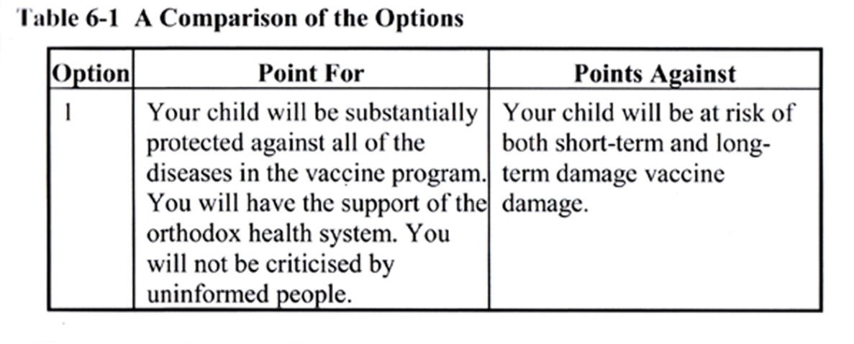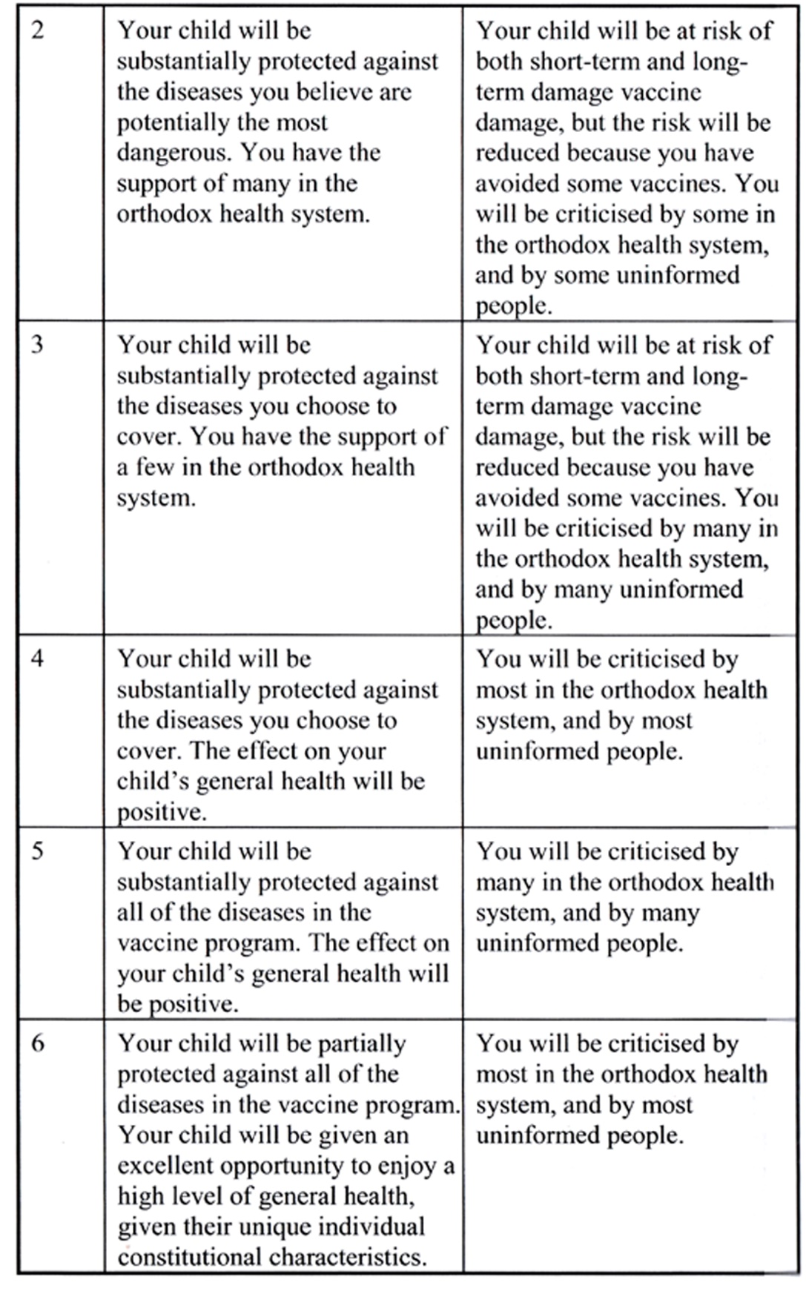

Chapter 7
CONCLUDING COMMENTS

Official statistics showed in 1994 that over 2,216,000 Americans were seriously damaged by toxic reactions to correctly prescribed pharmaceutical medications and as a result 106,000 died in hospital in that year (JAMA, 15/4/1998, and JAMA 26/7/2000). Over 200,000 people a year die from "adverse reactions" from drugs, and another 80,000 die from medical malpractice, according to the pharmacy industry magazine Drug Topics (October 23, 1995, pp. 14-16). In 2010 it was estimated that 48,000 patients die in US hospitals each year from health care associated sepsis and pneumonia alone (Eber MR et.al. 2010).

In the UK, an estimated rate of adverse events of 5-10% of admissions in UK hospitals has been made (BMJ Editorial, 2001b). further, 2-4% of all hospital admissions are medication related, and most are preventable (Runciman WB et al, 2003). Despite these deaths and injuries, the pharmaceutical dominance of politicians and therefore governments continues.

In Australia the figures are just as bad - over 60,000 serious adverse events, and over 15,000 deaths annually from prescription drugs.

The people advising public health authorities in developed countries are almost entirely advocates of pharmaceutical medicine (doctors and medical scientists). Thus our politicians only ever get to hear one side of most medical debates. The number of drug company lobbyists continues to increase, along with the amount spent on lobbying activities. In the US alone in 2002, the drug industry spent $30 billion in advertising, including close to $13.2 billion lobbying doctors and hospitals, and $15.7 billion on drug promotions (Deya RA, Patrick DL, 2005, pages 71, 78).

All this expenditure comes despite the fact that in 2003, Dr Allen Roses, worldwide Vice President of Genetics at GlaxoSmithKline and a pre-eminent figure in the field, stated that more than 90 percent of drugs only work in 30-50 percent of people
(http://icfda.drugawareness.org/Archives/4thQtr_2003/record0012.html).

His comments were supported by estimates the British Medical Journal Clinical Evidence centre which showed the following outcomes of all medical interventions, only a third of which provide definite benefits (http://clinicalevidence.bmi.com/ceweb/about/knowledge.isp)

7-1 BMJ Effectiveness of Clinical Interventions

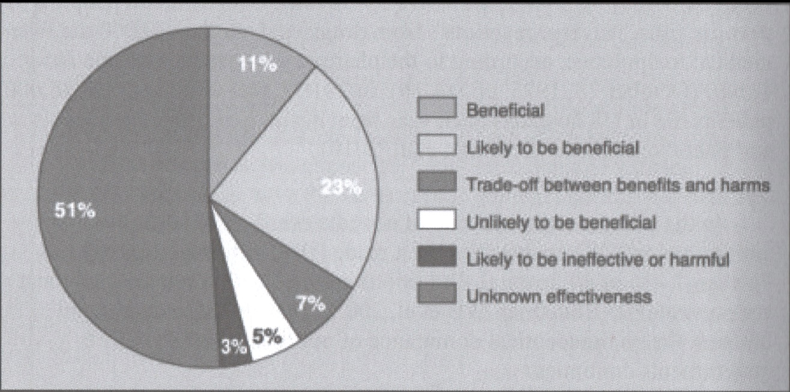

Only individuals with a capacity and a willingness to think independently are prepared to look beyond the officially supported reaches of the pharmaceutical media machine. Orthodox researchers have found repeatedly that the main users of natural medicine are generally better educated and from higher socio-economic groups than those who rely totally on drugs (Eisenberg DM et al, 2001). This doesn’t mean that those with higher education or a higher income are the only people who can think for themselves, but that they often have more access to information, and more economic opportunity to act on their choices. I know from 25 years experience that the parents who use my homoeoprophylaxis program come from a broad range of socio-economic groups, but the factor they all have in common is that they have searched out information on which to make their decisions. They have chosen to take responsibility for their own health, and the health of their children.

Pharmaceutical medicine does have a place. At times it offers the best treatment (especially emergency medicine and surgery in some conditions). However, it is often generally ineffective in curing long-term health conditions as it relies on the chemical suppression of symptoms which may move the results of the illness to a deeper and more serious level.

The ideal health system is surely one where people are free (both by preference and economically) to use the best of both pharmaceutical and natural medicine. We have a LOT to learn from the Cuban medical system which has developed free from multinational pharmaceutical influence due to the USA embargo against that country.

When we come to immunization, most people want to prevent certain infectious diseases. Nothing can guarantee prevention, but vaccines have been shown to provide a significant level of protection. However, there are risks of possible short-term and long-term damage with vaccines. Mild short-term reactions are common; severe short-term adverse events don’t happen all that often, and we don’t really know the true incidence of long-term damage from vaccines because it has not been sufficiently studied.

However we are assured by most doctors that the potential risks of the diseases we want to prevent definitely outweigh the potential dangers of the vaccines. Such a statement is unscientific simply because all the facts including long-term health impacts have not yet been assembled which permit such a claim to be made.

A growing number of people are not satisfied with their doctor’s reassurance, and are not convinced that the risks of vaccination really are as infrequent as the doctors suggest, so they choose to investigate for themselves.

They find that there is an option to vaccination. It certainly appears to be safe. It has been used successfully for over 200 years. Recent research supports the historical evidence that it provides a significant level of protection against the diseases they are worried about.

So they decide: if there is such a viable alternative, then why take the risk of vaccine damage, let’s use the safer alternative.

If you are, or intend to be one of those who thinks and acts independently, you will probably then find that many people begin criticizing you - your doctor, the infant welfare nurse, some members of your family, some parents at play group, etc. They say that what you are doing is not proven, and doesn’t make sense. None of them have actually examined the evidence which exists about the alternative you have chosen, but the doctor was told by his professor, and the nurse was told by the doctor, and the family and friends and acquaintances were told by the doctor, the nurse and the government department (who were told by the professor and the pharmaceutical companies).

All this conflict may put you under great stress - what should you do?

My suggestion - look at the evidence for yourself, make up your own mind about what is best for your child, taking everything into account (including stress and pressure from others), make a decision, act on it, and know that you are doing the very best you can for your child.

Whether you vaccinate, use homoeoprophylaxis, use constitutional treatment, or do nothing specific, if you have made such an effort to become informed, then no one can do better than that.

Know that you have done more, out of care and concern and love for your child, than any of your critics have done. Be proud that you have done your best, whatever may happen.

We don’t live in a perfect, risk free world. Uncertainty is part of life. At least you have not avoided your responsibilities as so many do. You deserve support, and you deserve congratulations!

A FINAL NOTE FOR POLITICIANS

My doctoral research, supervised as it was by a Professor of Medicine and a medical epidemiologist, and examined by Doctors of Medicine who also had PhD’s, as well as training in homoeopathic medicine, has shown the following:

- Use of appropriate homoeoprophylaxis programs has the potential to improve the national coverage against potentially serious infectious diseases due to increased coverage for children who will not otherwise be vaccinated.
- At the same time, use of appropriate homoeoprophylaxis programs has the potential to reduce the incidence of chronic debilitating illnesses in our community.
This is a win-win situation for both individuals and the community. It also provides these benefits at significantly less cost than vaccination.

We need politicians who are not bound by advice from people who are locked into pharmaceutical medicine, who will investigate and think for themselves, and act for the good of our entire community.

Economically, practically and morally, a dual system of immunization where parents are supported to choose between vaccination and homoeoprophylaxis makes complete sense.

Its time has come. Let’s make it happen.

