Cholesterol by dr. John Bergman
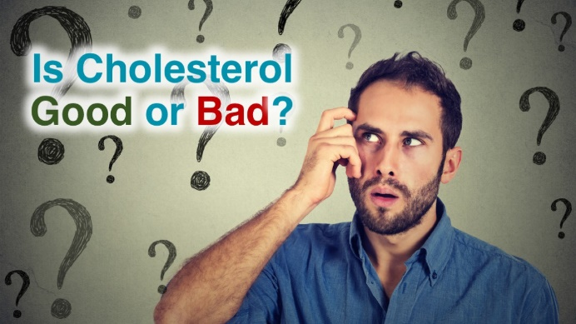
This is a question that has baffled most people and unfortunately the majority of doctors for decades. There has been so much conflicting advice over the past 50 years about cholesterol and the types of fats that are "Heart Healthy". This video course is designed to clear up all this confusion and give you the facts and the knowledge you need to keep your heart healthy for your entire life.
The Problem
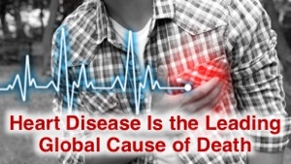

The major issue right now is that Cardiovascular disease is the Leading Global Cause of Death. In fact, 1 out every 3 deaths in America is from some form of Cardiovascular Disease. This is the reason why doctors always check your blood pressure at every annual physical or checkup. However, blood pressure is not necessarily the reason why people are dying and most doctors are pointing to Cholesterol as the "Bad Guy".
The Theory
Here's a quote from the Mayo Clinic to give you an idea of the Theory/Myth about Cardiovascular disease:
"While cardiovascular disease can refer to different heart or blood vessel problems, the term is often used to mean damage to your heart or blood vessels by atherosclerosis, a buildup of fatty plaques in your arteries.
Plaque buildup thickens and stiffens artery walls, which can inhibit blood flow through your arteries to your organs and tissues."

Scientists and Doctors have believed and operated on this theory for decades which is why almost all doctors recommend lowering your cholesterol with dietary changes or medications.
The problem with this theory about cholesterol and fatty plaques building up in the arteries is that this isn't actually the cause of cardiovascular death.

The Facts
Cholesterol is not the cause of Cardiovascular death in fact it's incredibly important:
•Cholesterol is vital to proper neurological function.
•It plays a key role in the formation of memory and the uptake of hormones in the brain, including serotonin, the body's feel-good chemical.
•When cholesterol levels drop too low, the serotonin receptors cannot work.
•Cholesterol is the main organic molecule in the brain, constituting over half the dry weight of the cerebral cortex.
•Cholesterol is the precursor to all the hormones produced in the adrenal cortex including glucocorticoids, which regulate blood sugar levels, and mineralocorticoids, which regulate mineral balance.
•Corticoids are the cholesterol-based adrenal hormones that the body uses in response to stress of various types;
•It promotes healing and balances the tendency to inflammation
•The adrenal cortex also produces sex hormones, including testosterone, estrogen and progesterone, out of cholesterol.
Do You Really Want to Take a Medication to Lower Cholesterol?
Now What?
Now that you have an appreciation for the importance of Cholesterol, it's time to learn what actually causes cardiovascular disease so you can have a healthy heart for your entire life!

Your Instructor

Dr. John Bergman

Class Curriculum

Introduction

Preview
Get Ready to Learn about Cholesterol! (2:02)
What Medical Doctors Know about Heart Disease

Start
Is Heart Disease a Problem? (1:24)

Start
What is Heart Disease? (1:37)

Start
Risk Factors for Heart Disease (2:01)

Start
High Cholesterol is Dangerous (2:48)
The Medical Treatments for Cardiovascular Disease

Start
The Typical Recommendations (3:14)

Start
Start Looking at Medications Differently (0:58)

Start
The Effects of Cholesterol Lowering Drugs (3:14)

Start
The Risks of Taking Statins (3:17)

Start
Do Statins Actually Help? (4:06)

Start
Why are Statins so Dangerous? (1:27)

Start
Why is Drugging the Heart a Bad Idea? (1:59)

Frequently Asked Questions

When does the course start and finish?
The course starts now and never ends! It is a completely self-paced online course - you decide when you start and when you finish.
How long do I have access to the course?
How does lifetime access sound? After enrolling, you have unlimited access to this course for as long as you like - across any and all devices you own.
What if I am unhappy with the course?
We would never want you to be unhappy! If you are unsatisfied with your purchase, contact us in the first 30 days and we will give you a full refund.
Get started now!
© Dr. John Bergman
• Terms of Use
• Privacy Policy
Enroll in Course for $108.90
https://drjohnbergman.teachable.com/p/cholesterol

