Dr. John Bergman and Polio
https://www.youtube.com/watch?v=25I3rxiAg5A&t=3s
Polio Vaccines Exposed
Transcription version 1.0

…this is the biggest dogmatic pillar that could possibly be and I say dogmatic because there's no science behind this. If you ask somebody are vaccines beneficial? They'll hold up the cross and they'll go:

it wiped out smallpox and wiped out polio. It must be good!

What are you supposed to say. Gee I don't know, I never really thought about it and never looked into it. You know where's the facts the research behind it. Well tonight we're going to go over the research and the facts and you're going to find out that it did not wipe out smallpox it did not wipe out polio.

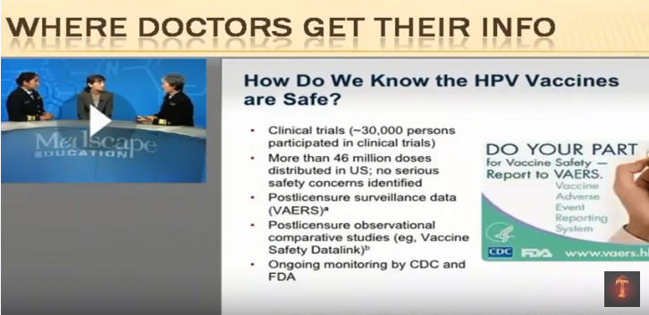

First off where do doctors get their information?

I see doctors just like you know everybody in any kind of trade school because a medical doctor is a trade school to get their information from school and then they get out into the field and there's a continuing education. Well Medscape is one of the one of my favorite jokes. I mean my favorite continue in education things because they do they have very poor information on here. Now this one happened to be on the human papillomavirus HPV shot. Now what's interesting about this the HPV it's human papilloma virus. The HPV shot. It's associated with some types of cervical cancer. What it's billed as is the cervical cancer vaccine the first anti-cancer vaccine and it's only one hundred fifty dollars a shot. You get three shots in a row and you're. Supposed to be protected. So I started looking at this and this is what they're saying on this Medscape. So this is where doctors should get their information. They're saying Oh thirty thousand people 46 million doses and I'm thinking wow you know this sounds really good.

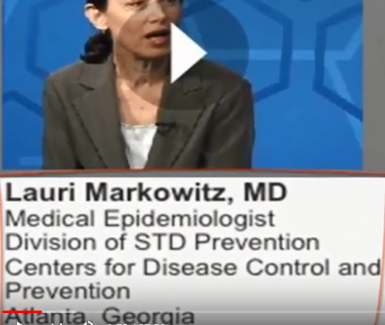

Now this Lori Markowitz. Just her title alone makes me impressed. Because here she is a medical epidemiologist from the sexually transmitted disease prevention center for disease control. I mean so that's she should really know shouldn't she. Well it's interesting.

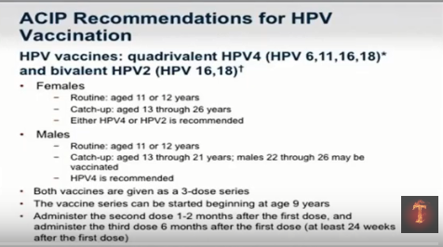

She starts saying you know ages 11 and 12 routine vaccinations and then catch up 13 to 26. So where'd you come up with these numbers. Where's the science that they had behind it, where the long term independent studies since the people that make the vaccine actually make the studies. I'm looking for the independents. Where's the long term prevalence. What's the prevalence of disease. What's the risk of the shot. So let's do a double blind study to compare a placebo with the shot and long term does the shot cause cancer in 15 years. We don't know it hasn't been out that long. So I go in there and then she says something that shocks me.

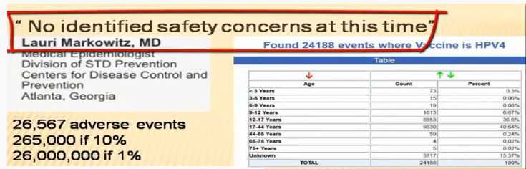

She says so far there's no identified safety concerns at this time.

And I'm going What?!

Because I'm aware of a few safety concerns. In fact. When we look at this there's over 27 of nearly twenty seven thousand adverse events reported to the federal government agency that gave the vaccine adverse events agency. That report says now what they say is there's less than 10 percent. Are reported. So if there's over to almost twenty seven thousand adverse events reported and this is only 10 percent anyone good at math. That means nearly three hundred thousand to 30 million.

So this is this is very, very dangerous. And she makes a bold statement like no identified safety concerns at this time.

There is no science behind it.

So these doctors there is doing this dogmatic approach and they're and they're bastion is when you look at this.

It wiped out smallpox it wiped out Polio.

That is not true.

When we look at the flu shot alone that red line is death rates of children,

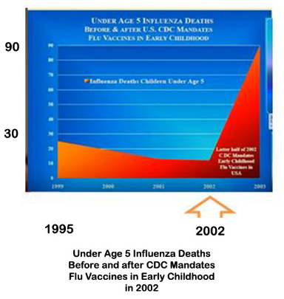

five years old from the flu. Why was it going down and why did it shoot up? Because right in 2002 that's when it was approved can give flu shots to a five year old. And we know that Cochrane Database independent research they say that it's zero percent effective in kids.

But this: wiped out smallpox, wiped out Polio.
Remember that's dogma. It's not science!

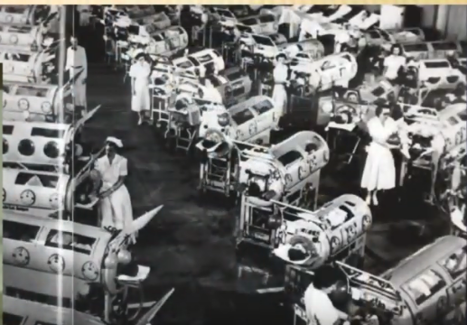

But you've seen this film are you seen this picture iron lungs because what do they say. Well we wiped out smallpox we wiped out polio. And you don't see any iron lungs around do you. Well you do see iron lungs OK. We have positive airflow ventilation.

This is the modern version of the iron lung.

Dr. Susan Humphrey she's an apologist kidney expert. She did the most brilliant presentation on polio, she is a medical doctor she's in the mold you know not really studying about vaccinations just being taught what she was taught. She brings a patient to the hospital in 2009 they shoot him with a flu shot. Right when it gets in there and he develops some damage from it and she says:
- Why are you guys doing this medical procedure?
- Where's the science behind shooting people with flu shots?
- Where does it show that that it's good for chronic conditions or that it helps protect them. Where's this?

And they say: look it up. So she does. She finds out there's no scientific data behind it that isn’t beneficial. And then they say what do they say?

Look vaccines wiped out polio, wiped out smallpox.

So they keep throwing in that data and she looks it up. And I encourage you. She did this whole thing what is called: Smoke, Mirrors the “Disappearance” of Polio.

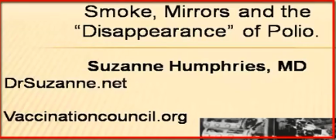

Her Website is DrSuzanne.net . You absolutely got to look her up. She is brilliant and absolutely my new heroine.

Now when you go to the CDC Website OK we don't see a new iron lungs. What was the disease prevalence. What does the CDC say about polio. Everybody that got it died or what?

Well first off you'd be surprised because when you go to the CDC Website:
Ninety five percent of everybody that caught polio had absolutely no symptoms.

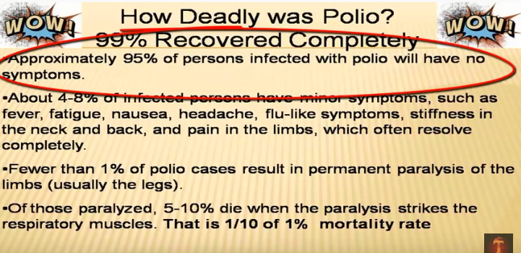

Absolutely no symptoms between 4 and 8 percent of the people that got polio had like mild cold symptoms you know a little stiffness in the joints and then it went away they recovered with absolutely no symptoms or side effects.

So you're talking ninety nine percent of the people that got this deadly disease recovered with no residual long term effects.

Only 1 percent had paralysis.

And less than 10 percent of that one percent or one tenth of one percent actually had paralysis of the lungs where they ended up dying.

So what disease on the planet affects 1 percent of the population and one tenth of that 1 percent so we're talking ninety nine percent of the population recover without any incidents.

And this is going to be a panic?
So we're going to we're going to drive the population?

Would it make more sense to find out what that 1 percent was doing, why that 1 percent would be weak. Why was it affecting that 1 percent? Would that make more sense? Yes or yes?

So in actual fact polio was not a deadly disease.

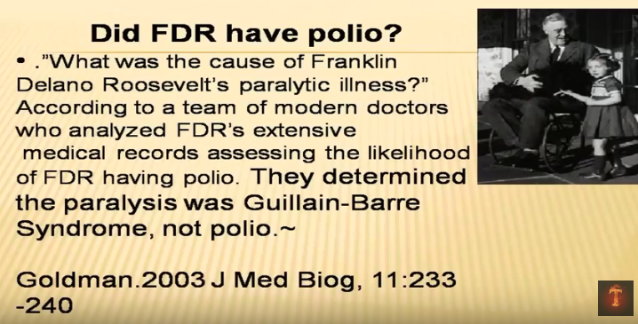

No Did FDR had polio? Well it's interesting when you look at the journal of Medical Biology they actually go in there and they found out that according to his symptoms and his record FDR did not have polio but the Guillain-Barre syndrome which is a common side effect of vaccines. Isn't that interesting?

Anybody understand football? You carry this ball. If you cross the opposing teams goal line. You get how many points? Seven? No you actually get six points but then you have to kick it through these hoops. In order to get the seventh.

But then now I'm not a sports nut. I know something that if you tackle somebody and it's their own side you get like two or three points or you need there's like another thing but there's certain rules to the game right.

What if I said OK if you scored a touchdown you get 15 points and if you scored it you get three points would that be fair?

No because I'm changing the rules. It doesn't make sense.

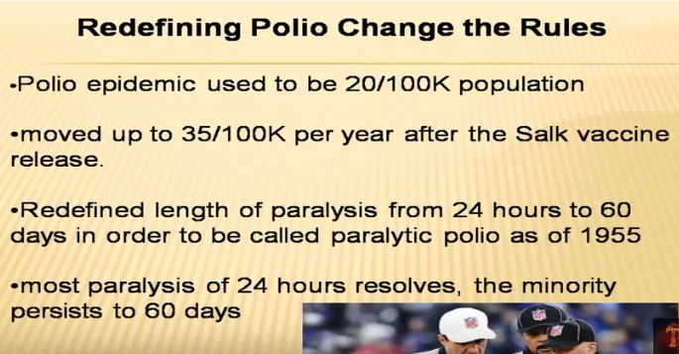

That's exactly what they did because when they say what's the dogmatic and wiped out smallpox to wipe out polio…

Well what they did is they changed it see a polio epidemic used to be 20 cases for every hundred thousand population. So what they did is that would be considered an epidemic as soon as the vaccine came out. They made it thirty five.

They almost doubled the number required to be a polio epidemic.

So would the epidemic go down immediately. Yes it would. And then. The old remember. Ninety nine percent of the people are ninety five percent had absolutely no symptoms. Forty eight percent of the population had risen. You know little bit of cold like symptoms that would resolve. How long would a cold take to resolve? 48 hours, a week maybe something like that. OK good. Well before the polio shot you had to have stiffness and joint problems for about 24 hours after the polio shot. They changed the rules where you had to have it for 60 days. Do you think a cold something would. OK. So that instantly drops some of the polio cases. So I mean it's just crazy.

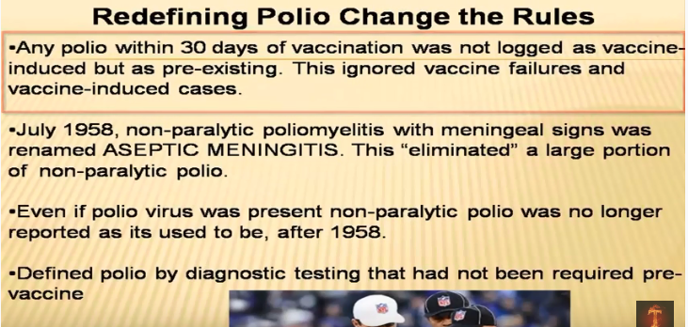

And then they also redefined it. Any polio that develop 30 days within the vaccination and you're going to see the documentation shows that when you vaccinate and I mean any vaccination you increase the risk of polio. Has to do with the neurotoxins.

So that if you've got a shot and you develop polio within 30 days. Well it wasn't from the shot it wasn't the fault of the shot you just had it.

And then they renamed it.

They used it they started to call polio aseptic viral meningitis because they had very similar symptoms. So you know it was the same thing if you ever look at the history of smallpox if you got smallpox. And Lord Byron actually did a study back then. He was hired by the ministry or the government to look at it.

If you got smallpox but you also got the shot they renamed it multiple vestigial lesions syndrome you know because it couldn't be smallpox because you were protected obviously you got the shot.

So when you start looking at this the totally changed the rules of the game. I mean that's just foolish.

Now we've known since 1949 that that polio and this is out of the Lancet.

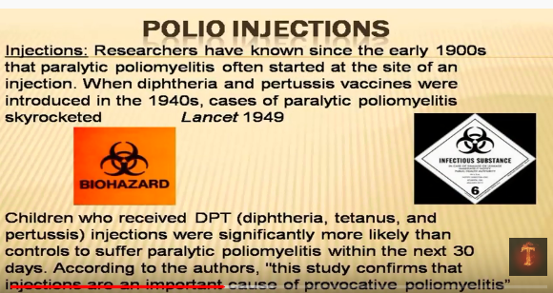

It started at the side of a shot. So this means the multiple vaccines that they were giving for some reason injecting neurotoxins and animal proteins in a muscle is bad for you.

I know these videos are going to be shown in 100 years and this will be where the laugh track is put in.
Yes injecting foreign animal proteins and neurotoxins in a muscle is not good.

So when you look at this and this is out of the journal infectious disease nineteen ninety two turns out kids with DPT shots had significant Paralytic Polio.

They're even saying you know you shouldn't be shooting people if they have endemic polio myelitis. In the area. Now at the time. You know my son laughs because he pulls up cigarette ads from the 60s that he used to prescribe cigarettes for digestion and cigarettes for asthma.

Did you know they used to use a lot of arsenic.

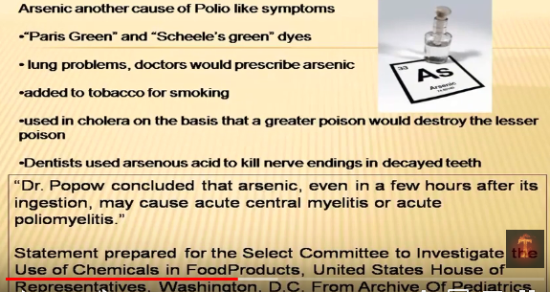

Because why did that was polio if it only affected one percent. What was affecting that 1 percent since it's neurotoxins or since it's a neurologic disease.

Do you think neurotoxins may have something to do with it?

Well at the time arsenic was really popular. In fact it was used in cholera and cholera was from poor water and they felt that a little bit of arsenic would actually help prevent the big bad cholera.

They also used it to deaden tooth endings if the tooth was hurting so they put a little poison in there so it would kill the nerve ending in that way your tooth pain would go away.

They used it in color. OK. They would use it because it had a beautiful brilliant green color. Arsenic.

And what's interesting when you look at it arsenic they see the advertising it's safer kids, safer pets. Arsenic.

It's just what your doctor ordered. So and it was added to tobacco smoke because it was actually considered beneficial.

What's interesting in 1952 according to in front of the House of Representatives. Dr. Powell. He said that that if you took this arsenic which was a common medical treatment that you could develop polio, polio like symptoms.
Remember only 1 percent of the population had serious neurologic damage from it. Should we look at that one percent. What they were doing. OK.

Arsenic is one of them.

Then DDT, DDT is good for me.

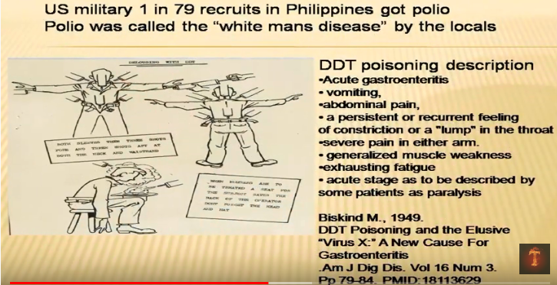

This is a military pamphlet. This is showing them to squirt DDT underneath the arms in the hat around the hair down the back to kill all the past.

Now in the Philippines our polio was considered a white man's disease.

Now defected to the people on the base about a one in 79 ratio. And it didn't really affect the surrounding communities. So why would the white people the Americans have a weakened immune system would it. Could it be from the neurotoxins?

Could it be. I don't know.

Well when you look at it DDT poisoning acute stages described as paralysis It's a neurotoxin. OK with this weaken the immune system leading to polio like symptoms. Yes or Yes?

Well here's a chart. The solid line is The Rise and Fall of polio. The dotted line is The Rise and Fall of DDT production. OK. Actually pesticides. So this is DDT, arsenic, lead. Can you see that the two lines match up pretty similarly?
Yes or yes?

So now we know that it happened to be neurotoxins that was affecting that 1 percent but then the organic cause was never thought to be looked at because why do you want to look in order gain a cause without that negatively effects industry. It would and it would negatively affect how we view it. I like this.

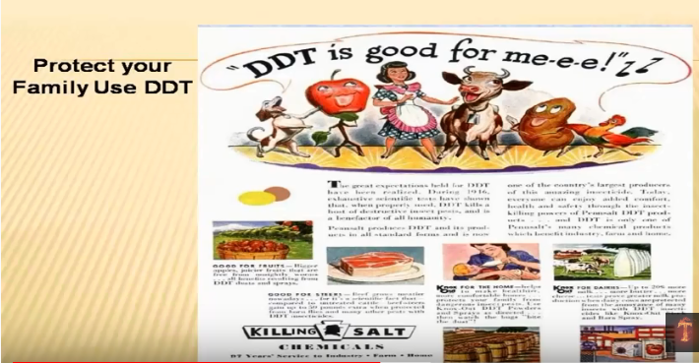

DDT is good for me. It's actually safe to put on food and fruits and vegetables. You can spray it on a sandwich for goodness sake. Okay I'm not kidding because they show that you could spray it on a sandwich.

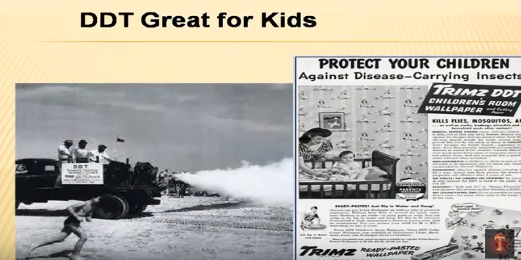

These are kids running around in Dr. Humphries video the smoke and mirrors. She actually shows a video an excerpt from a Canadian documentary where they're spraying children while they're eating food. This was considered normal OK. DDT was a fantastic thing.

Now what we're seeing here. Is an also an unusual rise in acute flaccid paralysis. And you might say Well gosh that sounds like that one percent of polio that had the flaccid paralysis where they couldn't move and you'd be right.

Except the problem is. This line down here this flap that's not moving is the wild polio that's an India in the global. Right line that's rising is polluted that's being caused. By neurotoxins and the shot. So in and. In India when you when you read some of this stuff you start thinking wait a second this can't be true.

Because they have non polio acute flaccid paralysis. Now it's not polio. But it has all the symptoms of polio.

They say that I mean they've been polio free for about a year. That means no wild polio. But in 2011 over forty seven thousand cases. That means forty seven. Kids are permanently damaged. In 2012. I think going up to like sixty two thousand. And when we look at why. Because though wild polio was eradicated so I'm sitting around and looking at all the reports around the area. Of you know 60.000 kids. I mean how many kids would that be. That would be like a lot. And I like kids. You know if one of them is harmed it would piss me off. But sixty thousand. Come on.

So I look at it and then so I look at one of the papers around the area and the Hindustan Times I know how many people subscribe to that. It's a little far you know but I mean you look at this and some of that some of the comments in there were thank goodness we've wiped out while polio. Thank goodness we've wiped out while polio. You know our modern science is

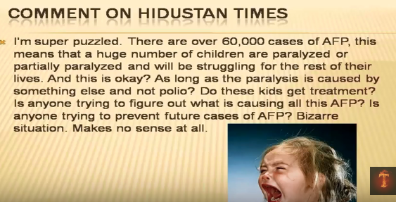

amazing and this girl writes. I'm super puzzled there sixty thousand cases of acute flaccid paralysis. This means a huge number of children are paralyzed or partially paralyzed. We'll be struggling in the rest of their lives and this is okay as long as the paralysis is caused by something else not polio. Do these kids get treatment. Is anyone trying to figure out what's causing this paralysis. Is anyone trying to prevent future cases.

Bizarre situation it makes no sense at all. I'm in total agreement.

So now. I don't know if you know the premier asylum its first do no harm. This is supposed to be like part of the Hippocratic oath. So I read this article and this is brilliant. Do you think only the Hindustan Times is aware that that thousands and thousands and thousands of kids are being damaged by the shot. Or do you think that maybe some medical doctors are actually smart. OK. That they are aware of this. This one's out of the Indian Journal of Medical Ethics. And this is it's kind of tongue in cheek.

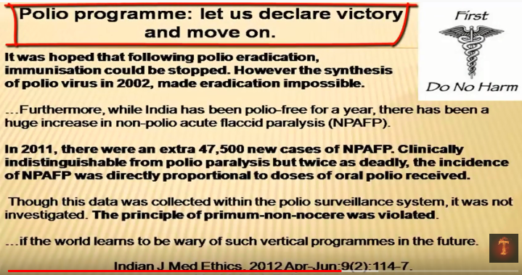

They said let's declare victory on polio and move on. That means let's stop the vaccination. Well we don't have the wild disease. Does that make more sense particularly since the vaccination is causing so much death and destruction. But now when I was reading this I read the first line and I didn't it didn't make sense to me. OK it was hoped the appalling polio eradication that imminent immunization could be stopped. However the synthesis of the polio virus in 2002 made eradication impossible. Now is anybody. Would you like to look into this and find out what the heck the synthesis of the polio virus was. I was because I like doing this stuff. I'd like to find out why. But then you look down at it they talk about the forty seven thousand new cases. And it was directly proportional to the doses of the vaccine. This means that if you got more doses of the vaccine you had more risk of getting the non-polio a flaccid or acute flaccid paralysis. And they know this. They're seeing it. And what I like.

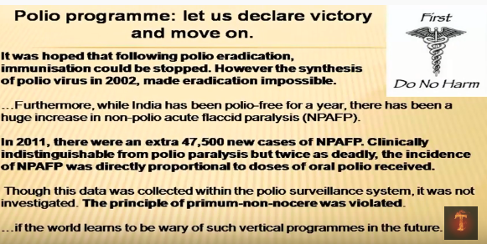

The standard was collected with a polio survey of system it was not investigated. They say the principle of first do no harm was violated. These doctors are saying we're more messed up. It's not appropriate. And I love this. If the world learns to be wary of such vertical programs in the future. Do you know what a vertical program is. You take an area where there's not really a problem. You start creating a problem and then you use that problem to create more panic so that you can keep continuing to treat the problem that you just created. Okay now this is called a vertical problem. So now we have sixty thousand kids that are dying but also remember the top line. The polio virus was synthesized. Wouldn't you like to know what that means.

Scientists create a live polio virus!

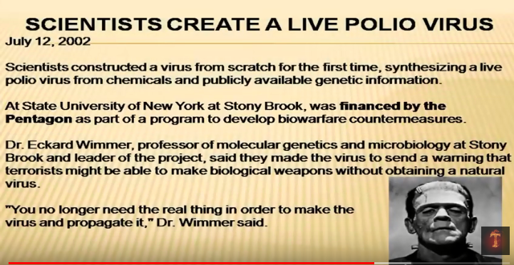

Well it turns out that the Pentagon. To develop bio well warfare measures. They hired this lab up in New York. To create a polio virus. Now what they did is they said guys we want you to make it OK. We want you to make this virus. Now I don't want you to synthesize it from any wild polio. I want you to make it from scratch. So they took some DNA and some RNA and I like what they said.

They decide to make it from scratch a scratch from chemicals and publicly available genetic information. So they assemble this. Now it turns out that by building this it's twice as deadly as the wild polio virus. OK. And you know I don't know if it's half that half the calories but it's twice as deadly. OK. And they were able to make it so by making this. You no longer need the real thing in order to make the virus and propagate it. This means that now since we can create a virus we have to continue to vaccinate against polio because it can be used as a bioterrorist weapon. However did the vaccination every stop the virus. No not according to the history.

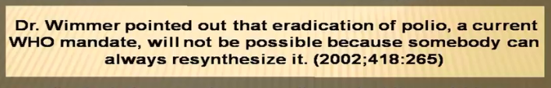

And I love this pointed out the eradication of the polio a current WHO World Health Organization mandate will not be possible because somebody can always re synthesize it.

So the entire idea of growing or assembling this polio virus made it impossible to stop vaccinating. But the vaccine never showed that it helped. Correct it. You begin to see this. I mean I don't know how many drugs you gotta take to have this make sense, but this is just insane.

Now on the good thing it's hard to make smallpox is a complex virus but they can actually make Ebola. That's a pretty simple one. Yeah OK. I mean I don't know. It's not to keep you sick. The reason that they're making this is because for industry. If you have a polio vaccine industry and that's going to be paying lots and lots and lots of people you want to keep the fear going. And so if the fear is you've got a country of about a billion people India and there's about 100 cases of polio and there's a billion people it's hard to stimulate fear. But if there's forty seven thousand cases of non-polio flaccid paralysis we just want to slide those underneath the rug. But this way if we could create something we can create a long term panic which will panic the world for just about ever as long as you're ignorant, unless you watch this video.

Now epigenetic control. This is huge. Because people are going to say well you're genetically predisposed to this you're genetically predisposed to that. That's not true.

There's a control above the genes.

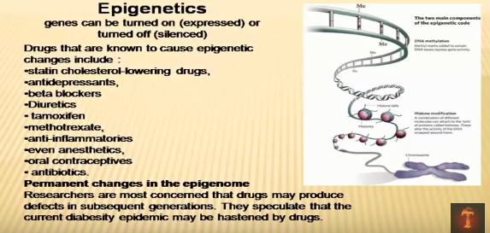

However. If you're looking at the things that control above the genes we're talking blood pressure drugs anti-depressants and acids anti-inflammatory entries. So oral contraceptives. So these things have control above the genes. What that means it controls genetic expression.

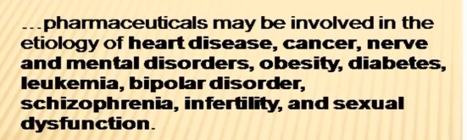

So when we look at this those drugs are linked to heart disease cancer or mental disorders. OK. Diabetes bipolar disorder schizophrenia infertility. So all of these drugs virtually every drug and I'm talking Tylenol I'm talking naproxen I'm talking you know you know the birth control pills every drug out there can have a negative effect because remember every drug poisons and enzymes or blocks of receptor site.

What was the cause of that 1 percent of the population that got polio. OK. We're talking neurotoxins or some type of poisoning. Can you see this now.

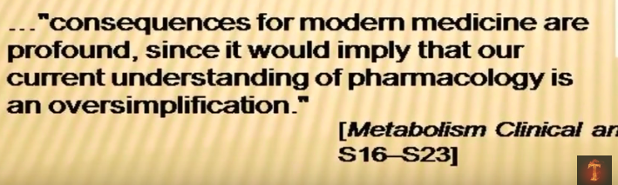

Consequences for modern medicine are profound sense would imply our current understanding of the pharmacology is an oversimplification. That is brilliant. It's true. You can't give somebody a drug that poisons an enzyme or blocks of receptor site. You can't inject foreign animal and viral proteins and neurotoxins into a muscle and expect to get a positive effect.

This means that absolutely no vaccines are beneficial. They're not beneficial they're not good they're not good for you. They don't work.

And if anyone wants to prove it then great let's do a long term beneficial study. Let's compare vaccinated population with unvaccinated population. Let's see the disease rates. Why does 50 percent of our population have cancer. 50 percent of diabetes. Polio is alive and well. OK. Polio like symptoms.

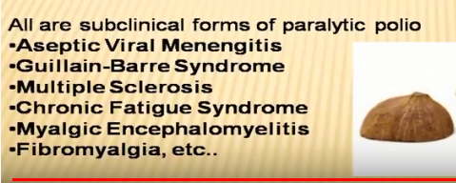

If you see a septic viral meningitis if you see young brain syndrome multiple sclerosis chronic fatigue. These are all similar to the old polio virus. The inactivated polio virus or the oral polio virus. I like this. They did not prevent any type of polio myelitis or paralytic polio from happening it didn't prevent it. But it slowed it down it changed it.

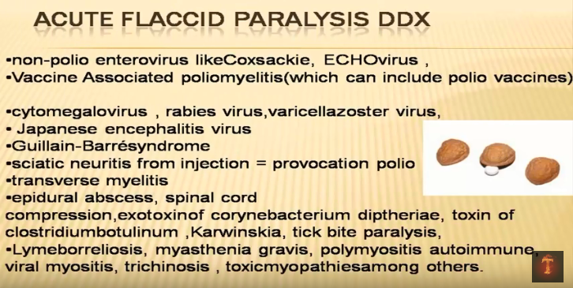

OK now we need look at this again a huge flaccid paralysis. And this is the. Epidemiological review we're in studying this stuff. You do what's called the DDX or differential diagnosis. So if you have flaccid paralysis you could say it could be oh kicked by paralysis, Lyme disease beyond beret. These are all the same thing that back in 1950 would also be considered polio. But after the shot it couldn't be polio because you got the shot can you see the psychosis.

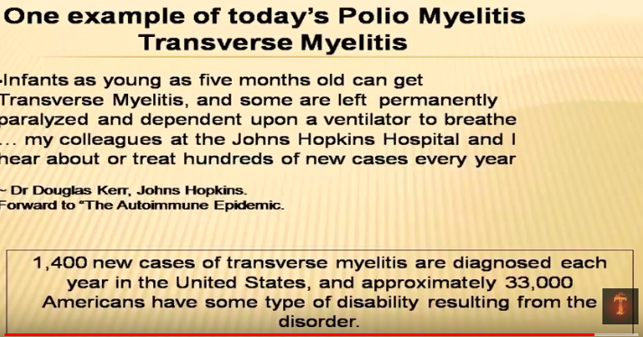

Now transverse my right. OK. Remember polio. What was polio. Full name. Polio myelitis has to do with inflammation of the spinal cord. Transverse myelitis. This is again it's inflammation of the spinal cord. Now there's about fourteen hundred new cases a year. There's about thirty three thousand cases of transverse myelitis in this country about thirty three thousand cases about fourteen hundred new cases a year.

It has the exact same symptoms as polio. OK.

Without the stool or fecal sample. When we look at this and I got to do is do transverse myelitis under legal stuff. OK. And there there's a number of law firms that are jumping on the bandwagon because they know that this is the latest thing that we would use to call polio. But remember I showed you that that article that says polio has been seen at the site of vaccines. OK for nineteen forty nine and nineteen ninety two I showed you that article.

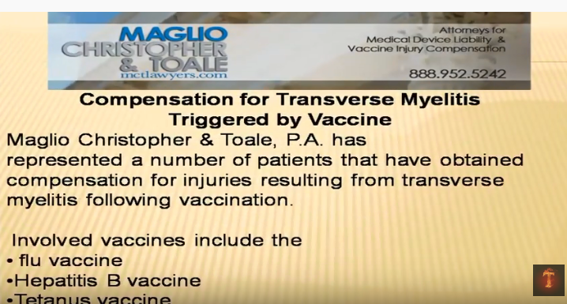

Well let's look at this transverse my alliance they successfully sued these companies. That found out that this this mimic or of polio was started by the flu shot. Hepatitis B shot. Tetanus shot, measles, mumps and rubella shot. That this also called cause the same thing similar to polio. OK. Now it's only been 2010 that flu shots have been approved for every human being from six months old to the end of their life every year. Do you think we're going to see a rise in transverse myelitis. That's going to keep these attorneys busy.

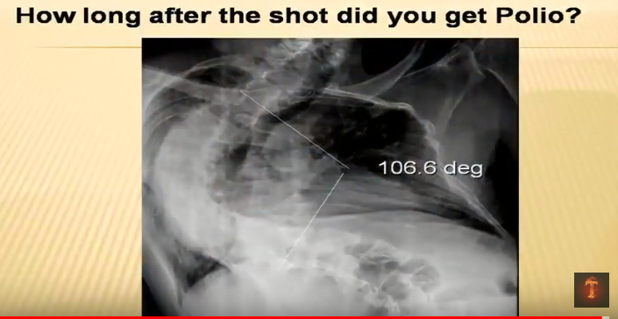

This right here is this is an X-ray of a patient standing up straight. He has polio now since we haven't had a wild case of polio and I was aware of this OK. I said how long after the polio shot did you get the polio symptoms. He looked at me and he said three weeks. Sir how did you know. With this information you would know too.

Not 30 million but 3 million 27.000 times 100 = 2.700.000

