Dr. John Bergman Vaccine Court - $1 trillion Death & Injury Claims in 2015 - Criminal Operation (1)

https://153news.net/watch_video.php?v=10614

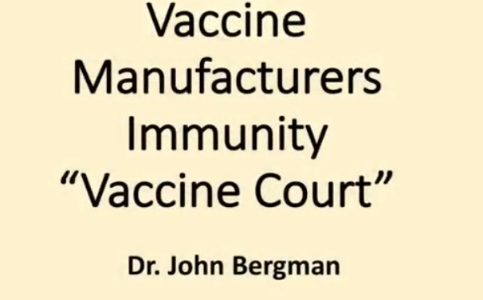

Welcome to True Health Tuesdays. Okay, this is, you know, on most of the health talks we do, we go through medical conditions, then we go through stupid medical stuff, then we go through solutions, and then how the body works. Okay, you know, just like a general pattern.

This is a crime, okay, that most people aren't aware of, okay, that your rights not only been taken away, but this is really negatively affecting our population. There's a thing called vaccine court, and we're going to go through the mindset of how it was created, but most people don't know that in this country, you don't really have a lot of rights. And the only thing I can correlate it is with the Nuremberg trials.

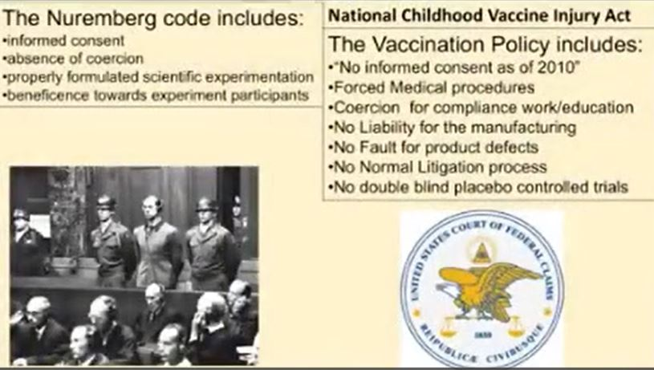

So in World War II, you had this group of Nazis that were accused of doing human experimentation, and they felt, well, you know, this just isn't right, that informed consent actually came out of the Nuremberg trials, that any medical procedure done on a human being, that the human being has rights to their own body, okay, that you should be able to say, yes, I want the procedure or no. So informed consent in the Nuremberg, absence of coercion, so you're not going to be operated on or experimented on for work or for school or for education or for financial gain, okay, so you're not going to be coerced into it. Properly formulated scientific experiment, which typically would mean the gold standard, okay, where you do the placebo-controlled trial.

One group gets a therapy, one group gets a placebo, one group doesn't have anything, and you follow them for a period of time, that way you know that the therapy was effective. You know, everyone's aware of the double-blind placebo-controlled trial. Now there's a benefit towards the experiment participants.

Now this is all what the Nuremberg trial came from, okay, or the ideas that they put forth that should be just basic human rights so that Nazis don't go in there and force certain political parties or political motivations, like different companies couldn't just take over your own rights and you have no way to sue them. Well 1986 rolls around, the National Childhood Vaccination Act. Now there's no informed consent as of 2010.

If you want, in 2010 they started to force doctors and nurses, whether you wanted to or not, as a requirement for your employment to get a job. In California, as well as in 14 other states now, they're passing laws or have laws on the books to say if you want an education, you have to submit your body for the vaccines. There's no exemption except for medical exemptions.

Now the medical exemptions have to be specific for a specific time, so you will submit in order to get that. So we're looking at forced medical procedures, coercion for compliance, no liability for the manufacturing. Now this is a shocker to people because if you were to get in a car that had faulty brakes, it damaged the car, you could sue the manufacturer if there was a faulty design.

Does that make sense? It's called a litigation process. It's the right to do process that if a company has done something that damaged you, you have the right in our court system to follow through so that they're liable. Now what this tort system does, or this legal system, it makes the companies liable for their product.

So if they screw up, they got to pay for it so they have the financial incentive to not screw up. Now the vaccine policy is no fault on the product defects. So if they screw up and you're going to find out they still do, you can't sue them, there's no recourse.

No normal litigation process. It goes before the federal claims court, you submit it, there's no judge, there's no jury, there's a special master, and he decides. And no double-blind placebo-controlled trials.

This means that no vaccine ever on this planet has ever been subjugated to a double-blind placebo-controlled trial. I don't know if you knew that. They're not based in science.

They're called a public health measure. So since they're automatically sanctioned because of psychosis. So where did this massive rights being taken away, where did the mindset of this start? So we have to go in, and when I'm looking at this, I'm looking at all these different doctors debating this, and they're all saying, look, you have to force people.

You can't give people the personal choice of saying, yes, I want a vaccine, or no, I don't want a vaccine. You cannot have that personal choice because you're not that f****** smart. Michael, edit that out, will you? Okay.

The word smart. Honest to God. Yeah, the word smart, you're going to edit out.

No, because when you look at this, they're saying that you not getting vaccinated can negatively affect the health of those around you. We need to have everybody force vaccinated because we have to have this herd immunity, and it's those damn unvaccinated people that can spread disease. Okay.

Now I realized that in the world of science, that can't happen. So let's go back into this. So I go to the CDC website and I look up the history of polio because what did the zealots say? Vaccines are safe and effective.

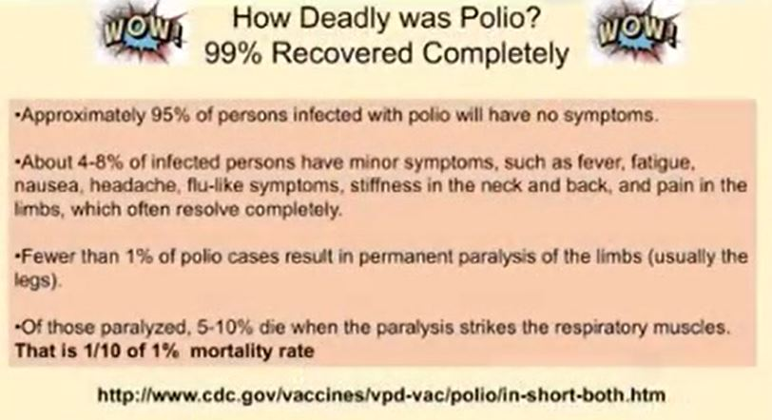

Shut up and submit. Okay. On the CDC site, they say, this is the height of the polio epidemic, before anybody ever developed a vaccine, 95% of the people that got polio recovered with no symptoms whatsoever.

Okay. No symptoms whatsoever. 4-8% had a little bit of a cold.

Less than, they recovered within two weeks with partial paralysis. Less than 1% of the polio cases developed in permanent paralysis. So you got a disease and of that 1%, okay, 1 10th of that 1% died.

So you're talking 99.9% of the population recovered without death. 99% recovered with no symptoms whatsoever. And I'm going, well, that doesn't really correlate with those pictures of the auditoriums with all the, you know, iron lungs in it.

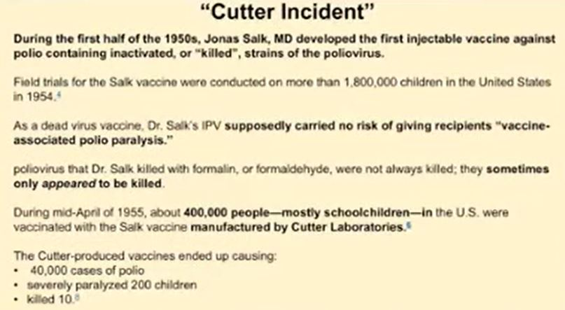

So I look up, do some research, find the cutter incident. Now the cutter incident in 1950, Jonas Salk developed this process because if you inject a polio virus into the side of a human being, you're going to cause that disease. So he found a way to kill it.

Okay. So this way, the person that's getting injected isn't going to develop that. So it was no risk rate.

It's going to be fantastic. Brand new, brand new 1950 technology. You're going to love this.

Okay. We're going to inject all the kids. So they do.

So they inject, oh, about 1.8 million kids and they lived. Okay. The problem is, okay, a few years after that, because they started the trials in 1954, 1955, they started to manufacture this and a couple of the plants kind of screwed up.

The attenuation process or killing the virus didn't work right. So about 1955, 400,000 people or kids, mostly school children was injected with this vaccine by cutter laboratories. It caused 40,000 cases of polio, paralyzed 200 and killed 10.

So now I'm thinking this makes sense. This picture was from 1955. Okay.

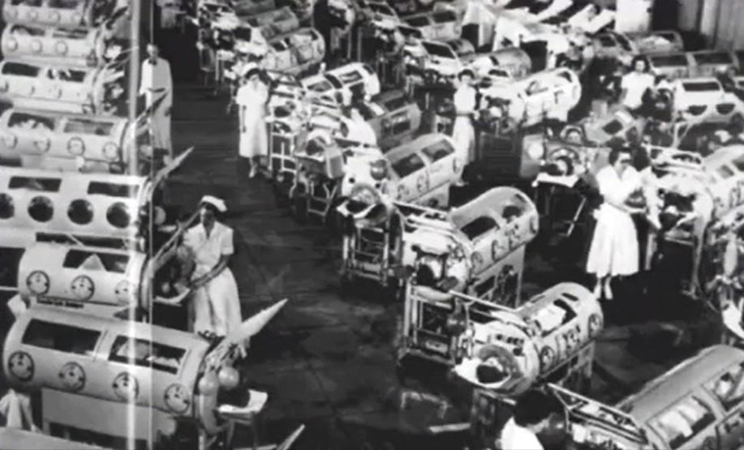

So now it makes sense. It's not like, you know, one 10th of 1% is going to be in an iron lung. It makes sense that it would be.

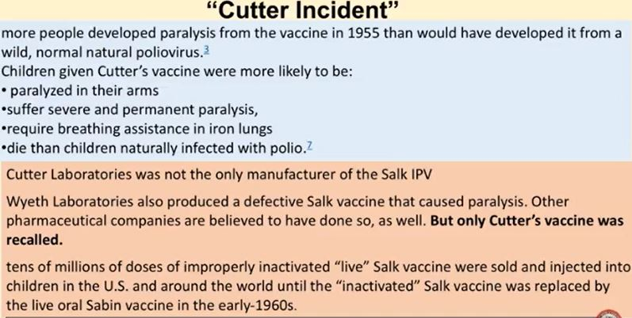

So then you start looking at it. And this cutter laboratory was only one of a number of labs that were also producing defective salt vaccines. And in fact, people given this vaccine were more likely to be paralyzed, more likely to suffer permanent paralysis.

So they were beyond that one-10th of 1%, more likely to die. Okay. And the Wyeth laboratory, you're going to hear about these guys in a little bit, also produced a defective salt vaccine, and a lot of other vaccine companies were also suspected in this, but only the cutter was put on the line.

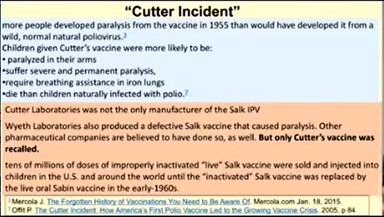

Why? Because you don't want to accuse everybody. Okay. Because you don't want people to be afraid of the vaccine.

Okay. So, I mean, literally tens of millions of kids were injected with this faulty vaccine. Now it's called the Cutter incident.

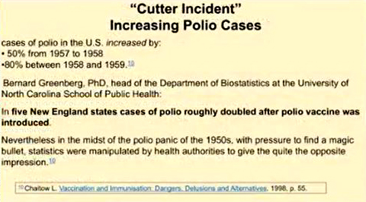

Now the cases of polio since the introduction of this, because remember before the introduction, 99% of the population was getting polio, recovering fine, no symptoms. Okay. After this, from 1957 to 58, 50% increase.

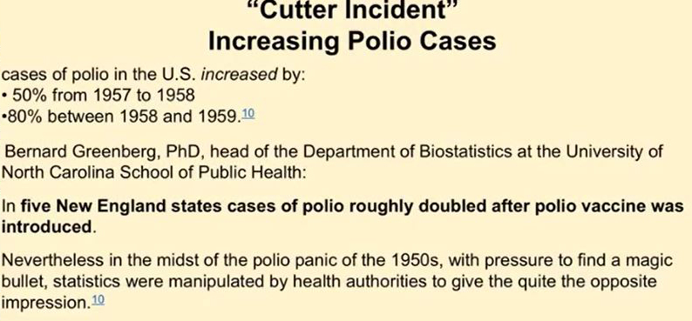

After that, 58 to 59, 80% increase. Okay. Now, and you're talking New England's state's polio roughly doubled after the polio vaccine was introduced.

Now, they knew about this in Congress, and in fact, Congressman Percy, he chaired a full investigation on this. Okay. And so they wanted to find out, okay, what actually happened.

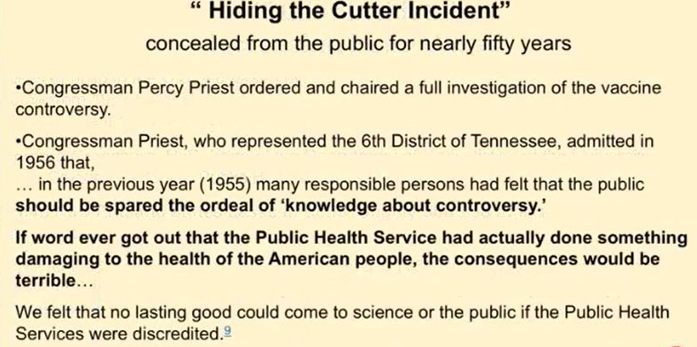

So they realized that the laboratories were producing a faulty vaccine that infected and caused the epidemic. However, they felt that the public should be spared the ordeal of the knowledge about the controversy. That if the word ever got out that the public health services actually done something damaging to the healthy American people, the consequences would be terrible, terrible.

The vaccine industry might suffer. Okay. So now, again, I'm just giving you the mindset to where your rights were happily given away, happily given away.

In fact, in fact, it was voted for. And if you go down the block and say, you know, you can't sue a vaccine company and that some people walk around unvaccinated, they'll say, you're a plague, you're going to spread disease. Okay.

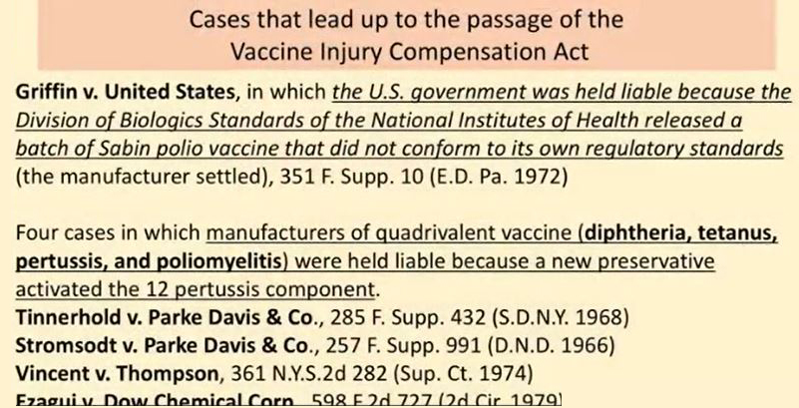

So where did this stupid fear factor come from? Well, here's some of the cases, Griffin versus United States, 1972. So we've got the 1950 epidemic caused by the vaccine, and the United States was held liable because the Division of Biologic Standards and the National Institute of Health released a batch of Sabin polio vaccine that didn't conform to the regulatory standards, also spreading disease. So we've got the Salk vaccine in the fifties that had a problem, Sabin vaccine in the seventies.

Then there are four cases of the diphtheria, tetanus, pertussis, and polio. There are quadrivalent, there are four different things in there. Four different cases, 1966, 1968, 1974, 1975, that a new preservative put in the vaccine actually activated the pertussis component.

Okay. So now this was back before the liability suit, okay, before they were protected. So you're looking at this and you're thinking, wait a second, this is really dangerous.

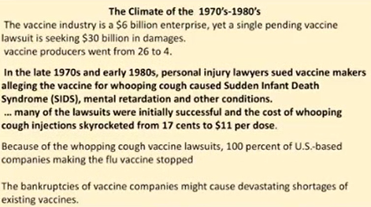

We got a $6 billion a year industry at the time, the vaccines, and people were getting hurt, damaged, infected, spread. This was building up to lawsuits, possibly 30, $40 billion. Okay.

So, so it was going to negatively affect the production of the vaccines. And in the seventies and eighties, they found out that the whooping cough vaccine caused sudden infant death, mental retardations, other conditions. So the cost of the vaccine went from 17 cents to 11 bucks.

Okay. In this timeframe. Now, and a lot of the companies started to go bankrupt.

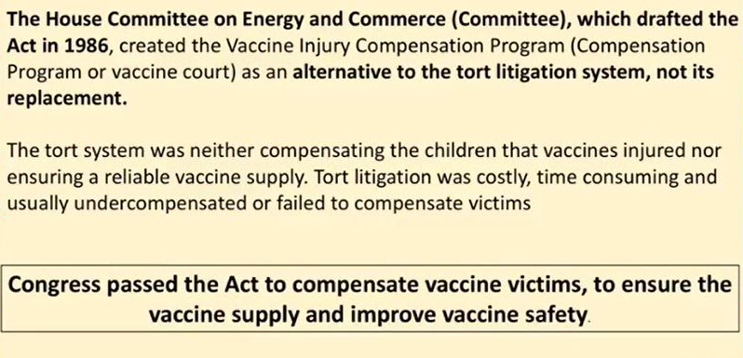

So the house committee on energy and commerce, not the health committee, not the public health Institute, not the national Institute of health, the house energy committee and commerce, okay, drafted the 1986 act as an alternative to tort litigation. Tort litigation is the standard litigation process. Not its replacement.

See, the tort system wasn't really compensating the vaccine injured kids and they weren't really protecting the companies because you got to protect the companies because they're funding the government. Okay. So Congress actually passed the act.

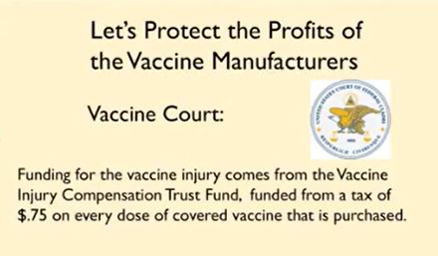

Now, so, so the whole thing here, it's, there's a tax on each vaccine that goes into this fund. So it's mainly to give immunity to the vaccine companies. Because for God's sake, man, if you're, if you're producing a vaccine, that's harming people and the people have the right to sue the company because of their faulty product, then the company's going to go out of business.

And frankly, this is America, the public. Okay. It's time to have the industry, you know, be really be protected.

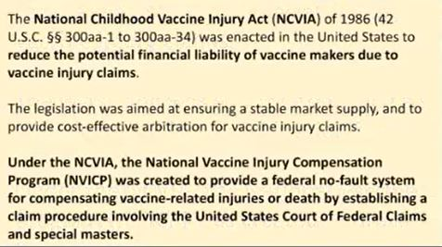

So now, and I got to read some of this cause it's just, it's mind boggling to think that our representatives would do this. Okay. Now the national Childhood event reduced the potential for financial liability of the vaccine makers due to vaccine injury claims.

This is a quote out of the, out of the, the, the act, the legislation was aimed at ensuring a stable market supply and to provide cost-effective arbitration for vaccine injury claims, a stable market supply, not a safe market supply under the national vaccine injury compensation program created a no fault system for compensating vaccine related injuries or death established in a can't claim procedure involved in the United States court of federal claims and special masters, not a jury of our peers likes laid down on the constitution. That's no longer part of this. Goodbye 14th amendment now. So they put safety features in there. Cause in 86, remember 1986, when all this stuff was going on, there were no forced vaccines.

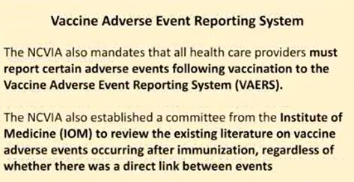

You, you didn't, there was personal beliefs that are religious beliefs. There were medical beliefs in virtually every state. Nothing was forced to get in for unemployment.

So, so this was a totally different environment than what we have now, but they were still smart enough to put in, um, uh, adverse event reporting system. And sure enough, they said that the, um, national compensation or vaccine injury act also mandates that all healthcare providers must report certain adverse events following vaccination to the vaccine adverse event reporting system VAERS. Now the Institute of medicine was also going to review the existing literature on vaccines, adverse events after immunization, regardless, or whether there was a direct link between the events.

Now I'm looking at this regardless of whether there was a direct link between events and I'm hearing all of these, these vaccine pundits and, and they're saying, well, just because somebody got a shot and developed a disease doesn't mean the shot gave it. Um, correlation is not causation. Well, here laid down in the, in the VAERS reporting system is correlation is important that you should at least look at it.

And if enough correlates exists that let's say there's a massive rise in autism or sudden infant death or something that correlates with this, that would be of significance. Does that, does that make sense? Okay. So now, now look at this.

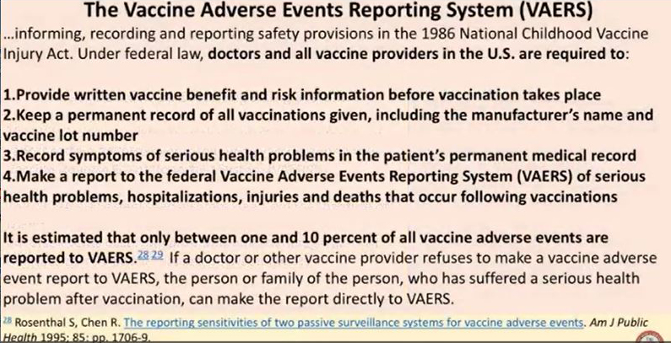

This is the safety net they put in place in 1986. The doctors and all vaccine providers in the U S required to provide written vaccine benefits and risk information before the vaccine takes place. Number one, that's what you got to do.

Okay. So you're going to get a pamphlet. Here's the benefit of the vaccine and the risk of the vaccine.

Now roll up your sleeve. Cause you don't have a choice. Take the shot.

If you want the job, give the kid your shot. If you want the child to go to school. Okay.

Remember this was before mandatory vaccines. Second, you got to keep a permanent record of all vaccine manufacturers name lot record the symptoms of serious health problems in the permanent medical record. Also make a report to the VAERS site of serious health problems, hospitalizations, injuries, and death.

Now they say currently between 1% and 10% of all the vaccine injuries are reported. So when you see numbers like a thousand or 2000 or 10,000, you can multiply that times 10 and still be in a safe number of the number of events out there that are occurring. Now it's interesting.

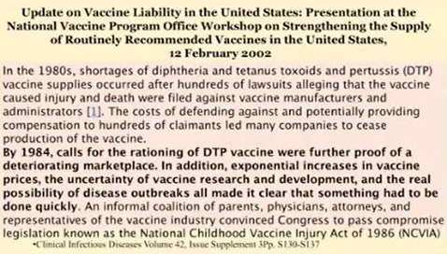

I'm looking through this and I found this article written in 2002. So you're talking about 20 years after the, um, the vaccine injury compensation program, but 20 years after, and I'm, I'm reading it. And I'm getting more and more pissed because it, this was out of the clinical infectious disease volume.

And I got to apologize for, for reading this, but this was a review of what was happening before the vaccine injury compensation program was, was enacted. Okay. Where, where the vaccine companies weren't liable.

And I thought it was a really cool thing to like a snippet to go back in time. In the 1980s shortages of diphtheria and tetanus and pertussis vaccine supplies occurred after hundreds of lawsuits alleging that vaccines cause injury and death were filed against the vaccine manufacturers and administrators, the cost of defending and potentially providing compensation to hundreds of claimants led to many companies to cease production of the vaccine. By 1984 calls for rationing the DPT vaccine were further proof of a deteriorating marketplace.

In addition, exponential increase in vaccine prices, the uncertainty of vaccine research and development, and the real possibility of disease outbreaks made it clear that something had to be done quickly. So they were rationing the vaccine. Was there an increase in disease? No, just a fear of increasing disease.

Okay. And the supply may be getting down. So we have to protect the industry right away because of the hundreds of lawsuits.

No one's talking about the lives here. And so now the parents, physicians, attorneys, representatives, they went in this wholeheartedly thinking that it was going to be better for the patients, better for the supply because we need vaccines to cover everything else. Well, I want to tell you a story.

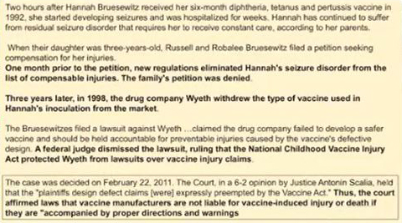

And this is a story took 19 years to come to the end. And this goes back right after the Vaccine Act was passed. Now, I got to apologize for the writing on this here.

But understand, parents take their six-month-old child in for their standard shots. Now, the Vaccine Act has been passed. Hannah Brusewitz, okay, after receiving her six-month DPT shot, she went into seizures two hours afterwards.

Now she's convulsing. She's seizures. They rush her to the hospital, residual seizure disorder that caused her to see constant care.

When the daughter was three years old, they filed a petition for injury for compensation. Okay, kid gets a shot. Two hours later, they go into seizures.

Daughter goes there. Okay, it took them three years to say, hey, look, we just got to file for this because this is crazy. However, one month prior to the petition, new regulations eliminated Hannah's seizure disorder from the list of compensable injuries and the family's petition was denied.

This means so they go in and my daughter got a shot. She developed this disease. However, when they look at the table of injuries, seizure disorders is no longer.

It was there last month. It's not there now. They removed it.

Now, three years later in 1998, the drug company Wyeth withdrew the type of vaccine used in Hannah's inoculation from the market. There must have been other problems, but we don't know and we never will know. Okay, the lawsuit, Bruceowitz filed the lawsuit against Wyeth, claimed the drug company failed to develop a safer vaccine that should be held accountable for preventing the injuries caused by the vaccine's defective design.

Federal judge dismissed the lawsuit, ruled the Childhood National Vaccine Injury Act protected the drug company Wyeth from lawsuits over vaccine injury claims. Now, this goes up to the Supreme Court. So everything happened in 1992.

19 years later, does that sound like it's a really efficient, fast, going for the public, really helping the little guy? Okay, here's Anthony Scalia. February 22nd, 2012, held that the plaintiff's designed effect claims were expressly preempted by the Vaccine Act. Thus, the court affirms laws that vaccine manufacturers are not liable for vaccine-induced injury or death if they are accompanied by proper directions and warnings.

Proper directions and warnings. Yes, you may die if you get this vaccine, but you must get this vaccine in order to get employment. Yes, you could have seizures if you get this vaccine, but without this vaccine, you can't get an education.

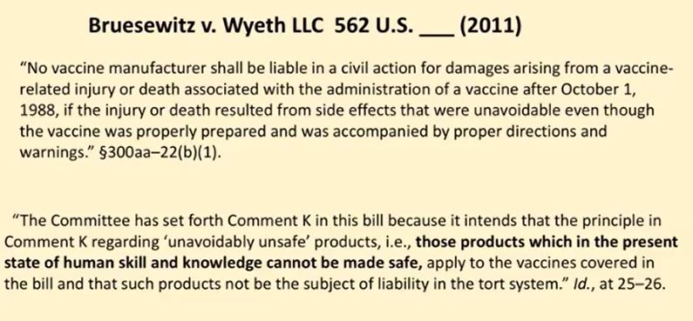

Two of the judges on the Supreme Court decided to not go along with it. And I tried to shorten the slide, but it's so important that you understand that there are some honorable people on the Supreme Court. They're not just idiots like Scalia.

Justice Sotomayor and Justice Ginsburg. And they heard the case, and they had to come up with this. And they said, no, we can't go along with this.

Vaccine manufacturers have long been subject to legal duty rooted in basic principles of product liability law to improve the design of their vaccines in light of advances in science and technology. Until the day that duty was enforceable through the traditional state law, tort action for defective design. Okay, so when you read this first paragraph, and I know it's small, but when you read that, you say, look, man, just like every other industry, they've got a responsibility and if they hurt somebody, by God, you can go after them.

So that legal threat will keep them honest and keep them developing something safe. However, they go on. The National Childhood Vaccination Act of 1986 preempts all design defect claims for injuries stemming from vaccines covered under the act.

The court imposes its own bar policy preference over the considered judgment of Congress. In doing so, the court excises 13 words from the statutory text, misconstrues the acts legislative history and disturbs the careful balance between Congress struck between compensating vaccine injured children and stabilizing the childhood vaccine market. Careful balance, careful balance between compensating vaccine injured children and stabilizing the vaccine market.

Did they do that? No, it's all been gone haywire. Okay, the vaccines are now forced on you with no liability whatsoever. The decision leaves a regulatory vacuum in which no one ensures that vaccine manufacturers adequately take account of the science and technological advancements when designing or distributing their products because nothing in the text structure or legislative history of the Vaccine Act remotely suggests that Congress intended such a result.

I respectfully dissent. So there's no liability. Now, these are part of the acts.

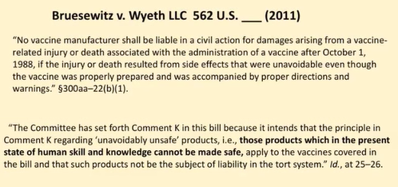

Okay, when you look at this, no vaccine manufacturer shall be liable in a civil action for damaging arising from a vaccine-related injury or death associated with the administration of a vaccine after October 1st, 1988. If the injury or death resulted from side effects that were unavoidable, even though the vaccine was properly prepared and accompanied by proper directions and warnings, you're getting the proper directions, you're getting the warnings, but it's forced on you, something that wasn't even thought of back then. The committee has set forth Comment K in this bill because it intends that the principle in Comment K regarding unavoidably unsafe products, those products which in the present state of human skill and knowledge cannot be made safe.

They're thinking that, my God, maybe we will advance someday to where vaccines could be safe and effective. But right now, currently, we don't have that. Can you understand why they would dissent over this? Now, these people were happier than heck for this.

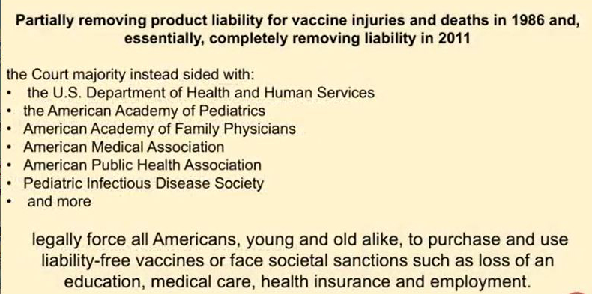

The partially removing product liability from vaccine injuries and deaths and completely removing liability in 2011. The industries that inject people are happier than heck. So now, as of 2018, in a couple more years, the American government will legally force all Americans, young and old alike, to purchase and use liability-free vaccines or face societal sanctions.

Such a loss of education, medical care, health insurance, or employment. Is that happening currently today? Yes, it is. So I'm looking at this, and I'm a little pissed.

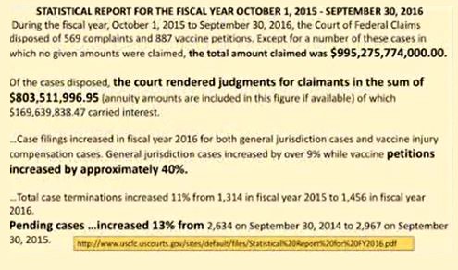

And I'm feeling like, damn, I can't beat up anyone because it's kind of my fault that it went through. It went down on my watch in 1986. I was 26 years old.

I should have been aware. Okay, so I go in there, and I go to the U.S. courts. And I think, well, let me check out to see how many court cases are being applied.

Even through this absolute horrible court system. Okay, let's see how many cases are being filed. So I go to the statistical report of the fiscal year, October 1st, 2015 to September 30th, 2016.

And I'm thinking, okay, let's say we had 1,000 people get injured by faulty brakes on a car. They all decide to sue for a million dollars. What's 1,000 million? Billion dollars.

Okay, that's a lot of money, right? Tough for an industry. Multiply it by 1,000 times. That's the number.

Total amount claimed in that year was $995 billion. If that industry actually had to go through a real court system, and those claimants were paid, in that one year, they would have paid $1 trillion out, nearly a trillion dollars out in damages for what they did. But because the government is protecting them, they're not there.

They're not going to be paying for it. They only paid about 800 million. Now, however, petitions, vaccine petitions increased 40% in that year.

So more kids are getting injured. Pending cases increased 13% in that year. So we're seeing it rise.

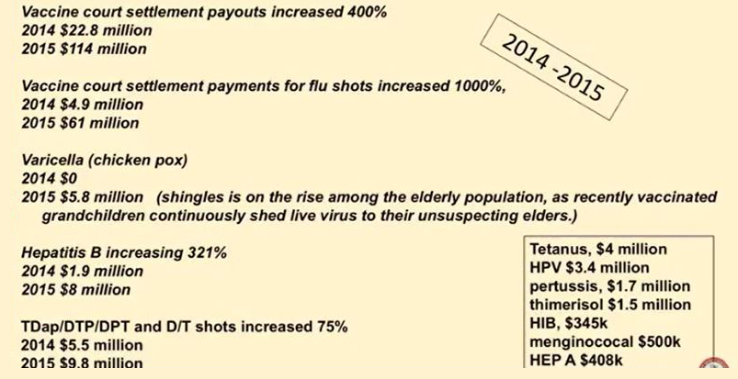

Now let's look at more of the payouts. Vaccine court settlements increased 400% between 2014 and 2015. Vaccine court settlement payouts for flu shots increased 1,000% for nearly 5 million to 61 million.

61 million payouts for vaccine damage for the flu shots. Could it be because they're more required for the jobs now, possibly. Chickenpox increased to 6 million. Hepatitis B vaccine increased 300 percent.

TDap increased 75 percent. And this is just the 2014-2015 year. We don't have the total stats for 2016.

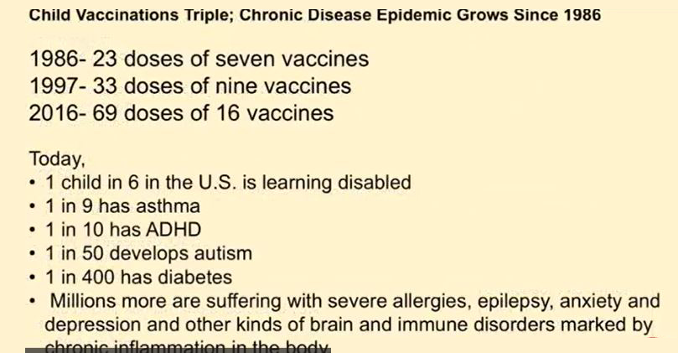

I imagine it's going to be on the rise as well. So let's look back in time, okay? 1986, when this was done, 23 doses of 7 vaccines were recommended. 23 doses of 7 vaccines.

Okay, 1997, massive increase, 33 doses of 9. But there was no outcry from the public saying, hey, wait a second, these are liability-free. There was no cry from the public saying, hey, look, we need more protection. There's more infectious diseases.

It was just a liability-free industry gone wild. Now, 69 doses of 16 different vaccines. We vaccinate more than any other country on the planet.

And earlier, we had the sickest population. Sickest population. One in six has learning disabilities.

One in nine has asthma. One in 10 has attention deficit disorder. One in 50 has autism.

It's really about one in 32. Okay, so what about the cost from 1986? Per child in 1986 cost about $80 to get all of those 23 vaccines. Per cost per child, today it's over $3,000.

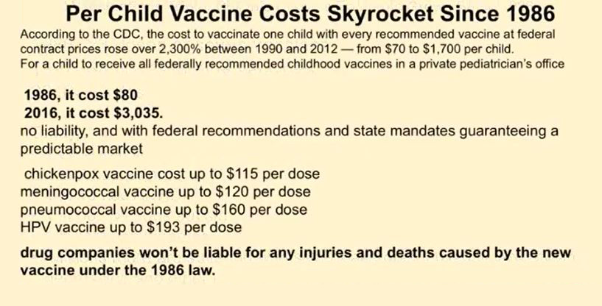

And they're forced. They're forced on you. You must pay.

Okay, otherwise your child cannot go to school. Okay, now, drug companies won't be liable for any injuries or death for any new vaccine under the law. So all these laws, the 69 doses, the 16 vaccines are already covered.

Okay, now the global market. I'm looking at the global market. Now, this was an article out of 2009.

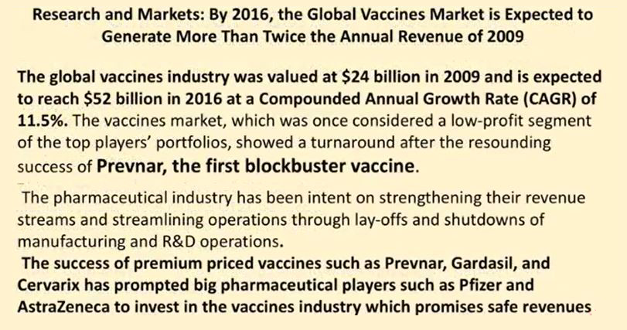

They said it was expected to reach $52 billion about this year. And then I looked at this and I thought, well, wait a second. In 2009, what were they talking about? What was the big push? Prevnar, the first blockbuster vaccine.

And I thought, wow, blockbuster vaccine. Now, why was the pharmaceutical industry rapidly improving or increasing? Pharmaceutical industry has been intent on strengthening their revenue streams by streamlining operations through layoffs and shutdowns of manufacturing and research and development operations. Why do you need research and development? To produce a safer product? No, man, we don't have any liability.

Okay, so blockbuster vaccine. And then I looked at the other one, Gardasil, Cervarix. Okay, so I look up Prevnar and I see this.

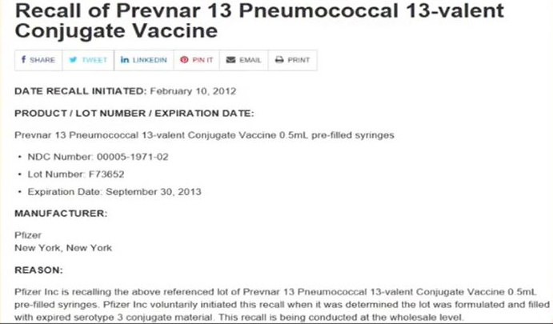

This is interesting. Prevnar, a 13 pneumococcal vaccine was recalled. They had some batches recalled.

And I thought, wow, recalled, why? Because oh, some of the serotypes in there, some of the materials inside the vaccine were dangerous. And then I think, well, let me look at the Food and Drug Administration. And sure enough, I look on their vaccines, blood and biologic recalls.

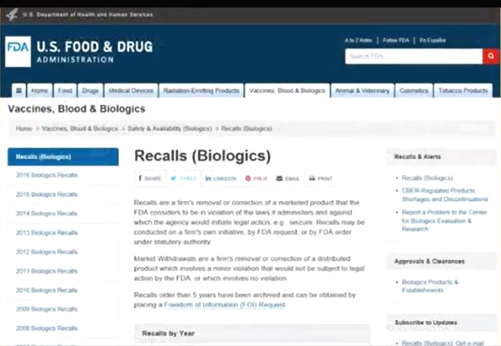

And I go, oh my God. So here's a product that's liability free, but it's killing people. So there's voluntary recalls from the manufacturer.

So I start looking into it. And I think, wait a second, here we go. We're looking at Sanoviv's Pasteur, Fluzone.



We're looking at FluViral. So we've got a couple of flu vaccines there that are recalled. Hepatitis B vaccine was recalled.

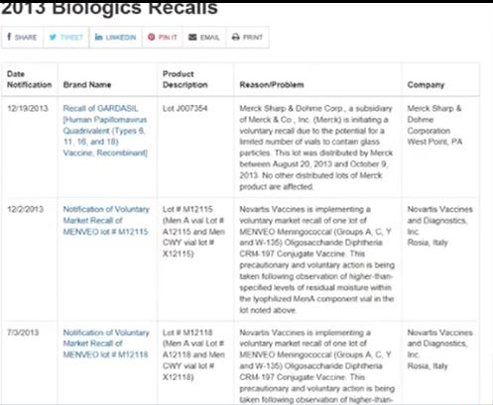

Gardasil was recalled. Oh, by the way, if, and this Gardasil was back in 2013. So if your child was injured by this recalled vaccine, the hepatitis, the Fluzone or the Gardasil, do you have any legal recourse? No, because it's designed defects are protected.

Can you see this? Can you see this? I mean, it's like, good God, the public doesn't know. Okay. Infant mortality rates.

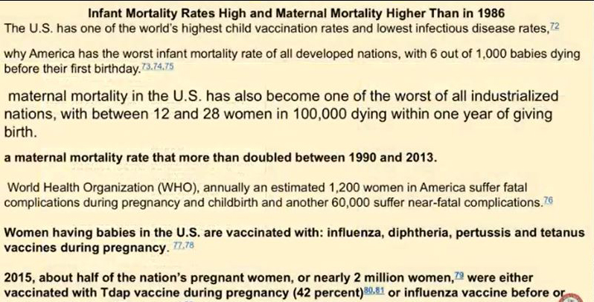

What is it like now as opposed to at 86? Do we have healthier kids? No. We have the highest vaccination rate, lowest infectious disease rate, and the sickest kids rate. Our infant mortality is the worst of all developing nations.

Six out of a thousand kids die. Maternal mortality. This is moms dying.

Okay. Worst of all industrialized countries between 12 and 28 women per a hundred thousand die within a year giving birth. Why? Because we're looking at the highest vaccinated.

US women are now vaccinated with influenza, diphtheria, pertussis, and tetanus during pregnancy, even though it says on the sheet, they're not tested on pregnant animals even. So when we look at this, sure enough, we're getting more and more vaccines. Now here's a chart.

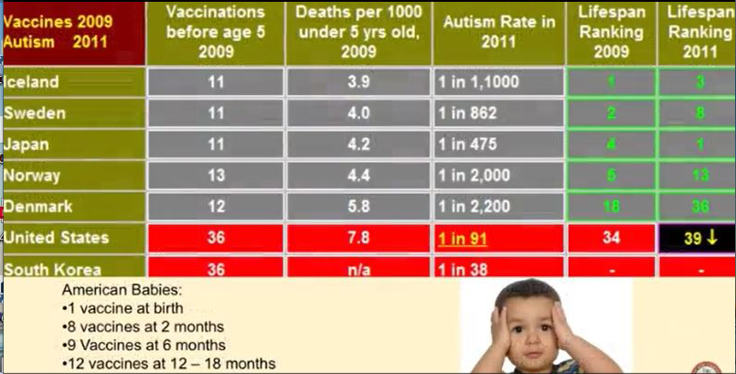

And again, if vaccines were scientific based, if those pundits for vaccines were based and we're forcing more vaccines on our kids, we should have healthier kids than Iceland, Sweden, Finland, and Japan, and Norway. In fact, they should have way higher diseases than we do, right? Because vaccines protect us, of course, if you're in that religion. But what happens when somebody has a third of the vaccines and they have less disease rates? Should we look into this? Should we call our representatives? Possibly.

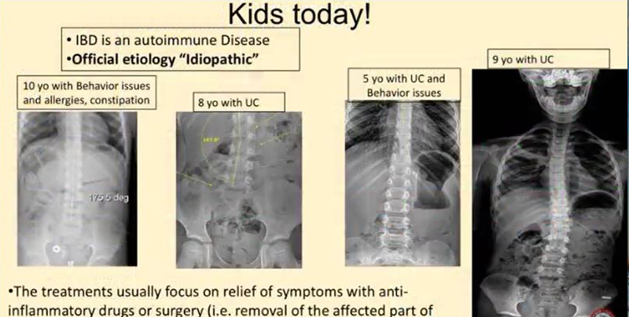

This is what I deal with. I'm getting kids with, I mean, eight and 10 year olds kids, forget behavior issues, autism, we're talking ulcerative colitis and eight years old. I mean, so many depression and anxiety in a 10 year old.

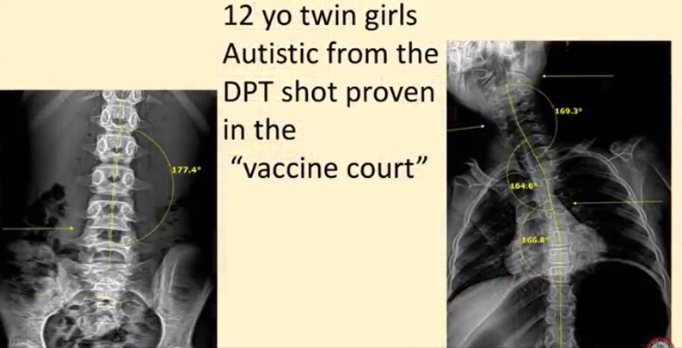

I mean, this is insane. These guys actually made it through the court battle, through the court system, twin girls absolutely proved that the DPT shot caused their autism. So when they say vaccines don't cause autism, that's not what they found in this case.

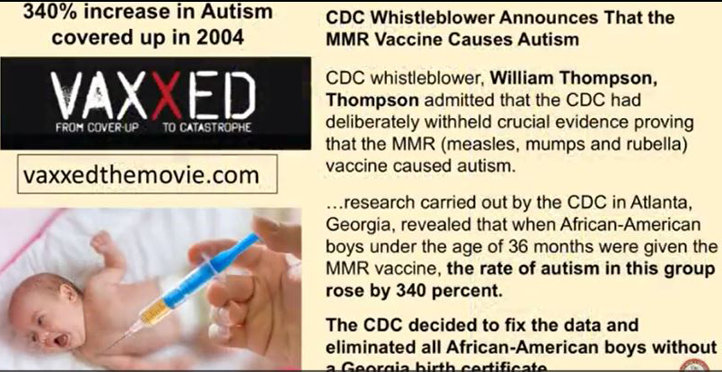

I would recommend that you look at this movie Vaxxed. The CDC did a study in 2004 and they lied on the study. They found out that the MMR, measles, mumps, and rubella shot actually did increase autism rates.

So they changed the data, reworked the data, and so that they can tell people that it doesn't cause increases in autism, even though they approved it. Dr. William Thompson was one of the lead scientists and they, it does, it does. They proved it.

But see, they couldn't say it because when they ran the study, 5,000 cases were thrown out immediately. So if you had each one of those 5,000 cases, suing the US government for, I don't know, $10 million for the autism, do you understand it would have crashed the economy. So they had to lie to protect the industry.

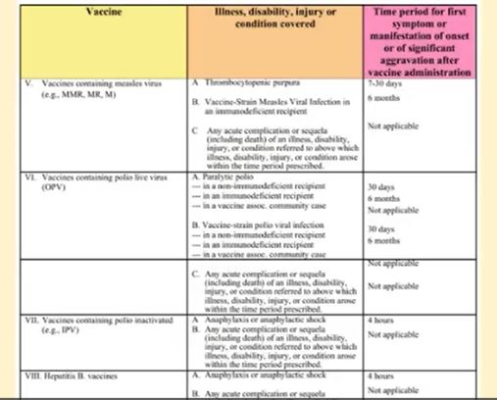

Now let's say you go through this. Now this is the vaccine table that they're talking about for compensation. If you get a DPT shot and you get anaphylactic shock, you have three hours to report it.

If you get brachial neuritis, you have two to 28 days to report it. If you have any other disability, it's not associated with the shot. It can't be.

It's not on the chart. If you have measles, mumps, and rubella and you get anaphylaxis shock, it has to have occurred within four hours. If it occurs within five hours, sorry, it doesn't qualify.

Can you see this? Okay, this is the chart. Vaccines contain, again, measles, mumps, and rubella. When you look at this, it's so inane and insane to think everybody you have a certain number of hours or days to come up with a symptom.

And if you don't do that, it's not on the chart. You don't qualify. We know the data now.

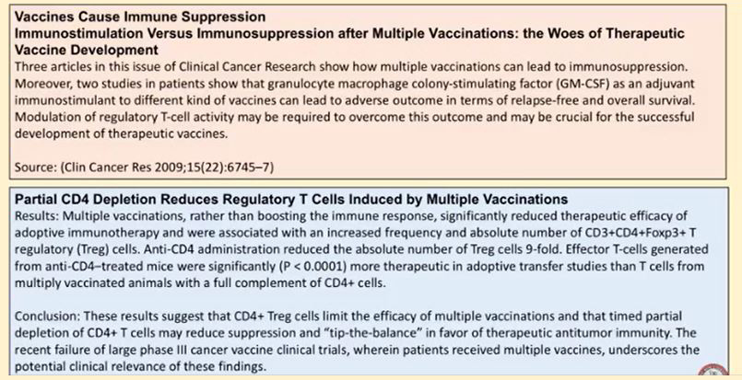

This is clinical cancer research. Vaccines cause immune suppressant. Multiple vaccinations, woes of therapeutic vaccine development.

Turns out the more vaccines you get, the sicker kids are and the higher disease rates there are. Multiple vaccines reduces regulatory T-cells. This means the entire immune system is weakened.

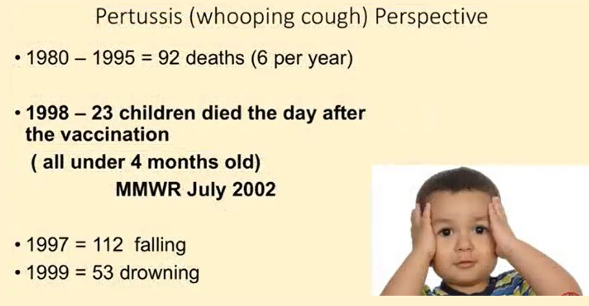

We know that whooping cough actually caused an average of six deaths per year in the country. In 1998, 23 kids died, died the day after the vaccine in one year. And to put that in perspective, how many people die from falling or drowning? You know, a study done by the FDA shows that if you get the whooping cough vaccine, you spread whooping cough.

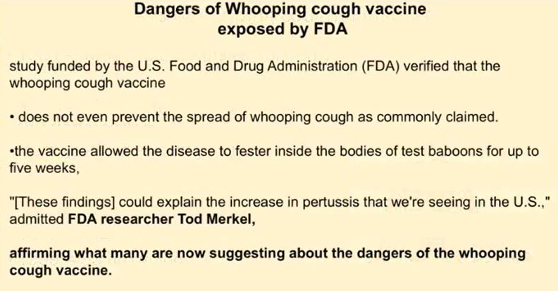

Okay, you spread it, and it doesn't even prevent. When you look at this, you're seeing study after study after study after study that obviously Congress isn't reading because why read it?

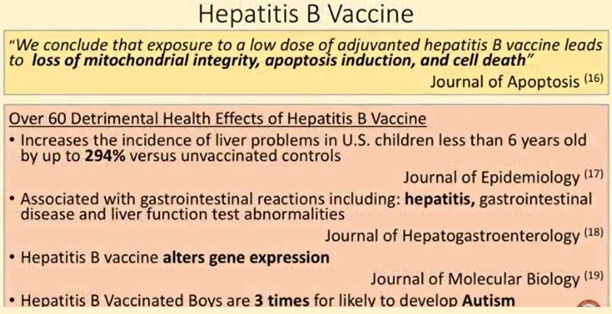

The vaccine companies are already protected. These are just researchers talking about how apoptosis and cell death are result of the hepatitis B vaccine.

Liver problems, 294% increase over unvaccinated controls. Hepatitis, gastro liver dysfunction. Hepatitis B vaccine alters gene expression.

Hepatitis B vaccine, boys three times more likely to develop autism. The data is out there, but the vaccine companies aren't liable and you're forced to get this product. You can't sue them.

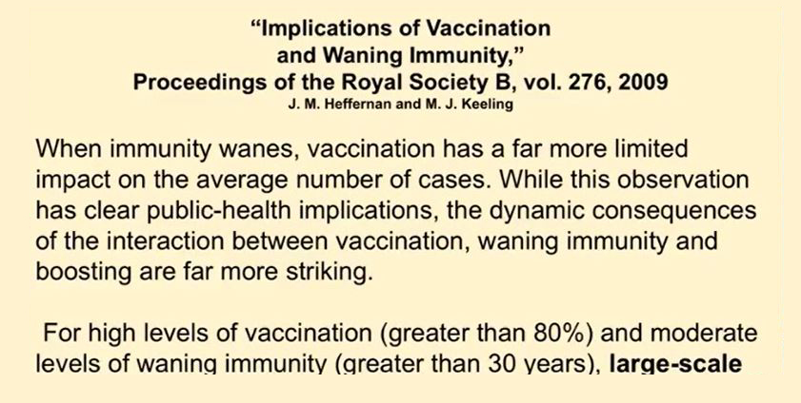

Warnings, implication of vaccination and waning immunity. Turns out the more the population you vaccinate, if it's over 80% and you do it for longer periods of time, like over 30 years, we're going to see massive epidemics coming up. This is going to be the fear factor to force the adults to get the vaccines.

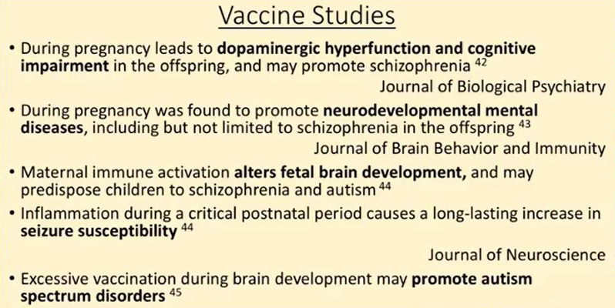

We're looking at vaccine studies on cognitive impairment, neural development, impairment, alters fetal development, increased seizure susceptibility, no kidding. Okay. Promotes autism spectrum disorder.

We're looking at multiple sclerosis, autoimmune conditions, autoimmune diseases, Guillain-Barre syndrome. This isn't just one journal article. This is multiple.

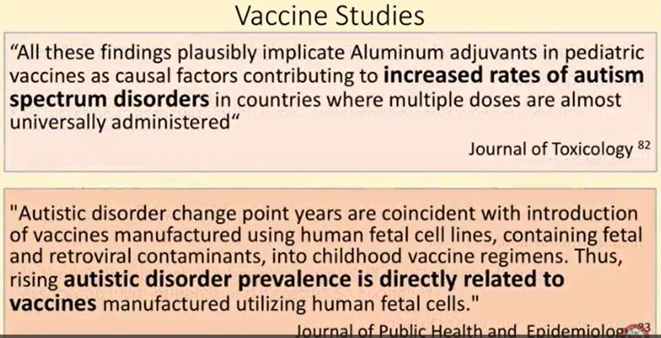

Journal of toxicology increased rates of autism spectrum disorders from the adjuvants. Autistic disorders prevalence is directly related to vaccines manufactured using the human fetal cells and none of them can be gone over this. So, I mean, Thomas Jefferson, if people let the government decide what foods they eat, what medicines they take, their bodies will be as sorry state as the souls who live under tyranny.

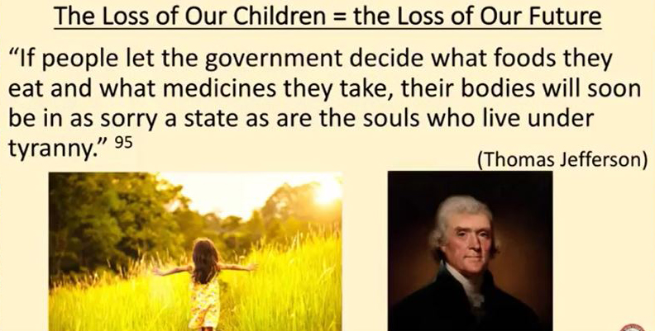

We are living under tyranny. We are forced to take a liability-free product. There is no answer other than changing the law.

And I don't know how to do that. And that's, I mean, that's why I was totally frustrated when it comes to health. I know how to reverse arthritis.

I know how to, I've seen cancer go away. I've seen tumors dropped off. I know, I mean, I've seen this in my day-to-day thing, but how to correct the absolute ignorance and fear of people that thinking that vaccines need to be protected because, you know, our societal go to hell in a handbasket.

Shit, they got to look around us. We're already there. The population is done.

This generation one and two is a chronic illness or disease. Now I put a few references on here for the scum sucking internet trolls that are still blind. Now I put references on here, the ones in the dark number ones, those are for some of the slides, but I also put a whole list of references in this blue that I got off of a brilliant health talk with Barbara Lowe Fisher and Dr. Mercola.

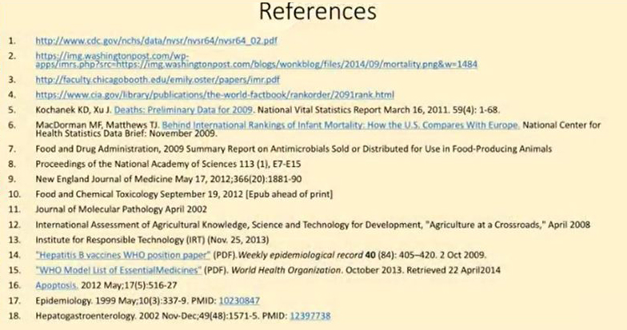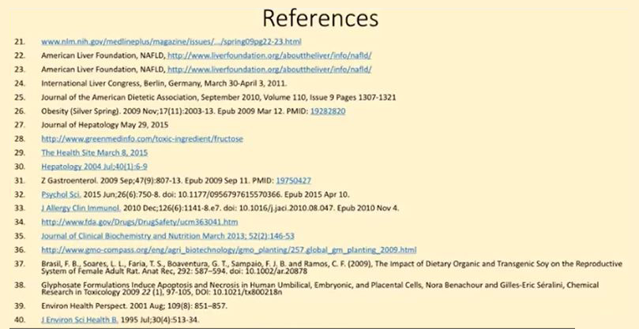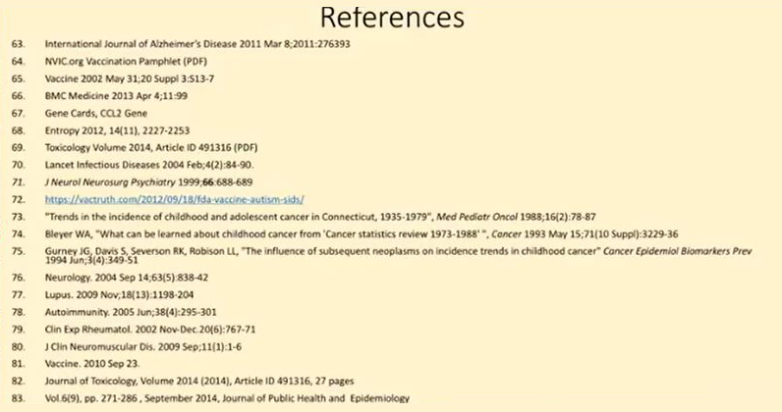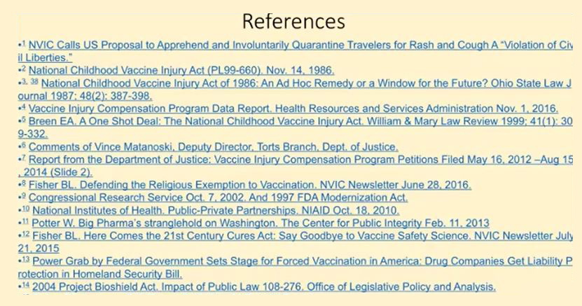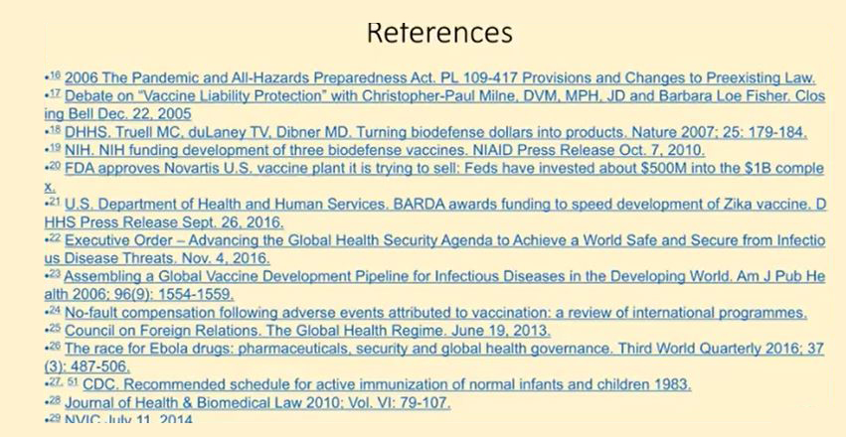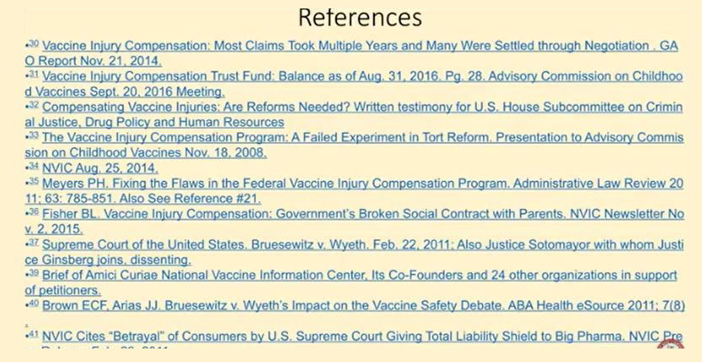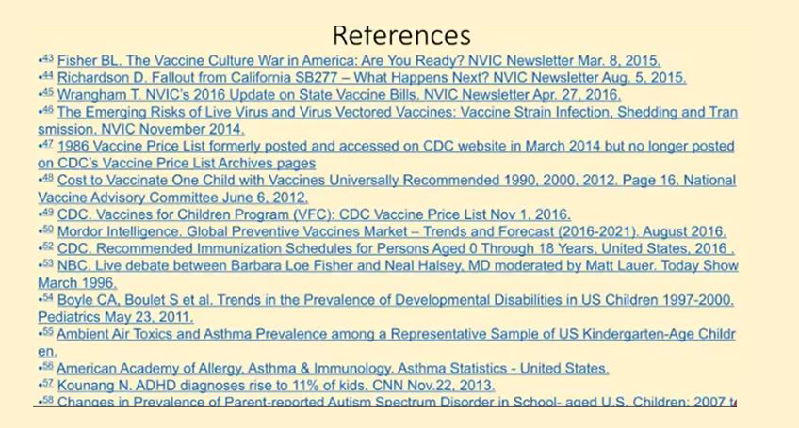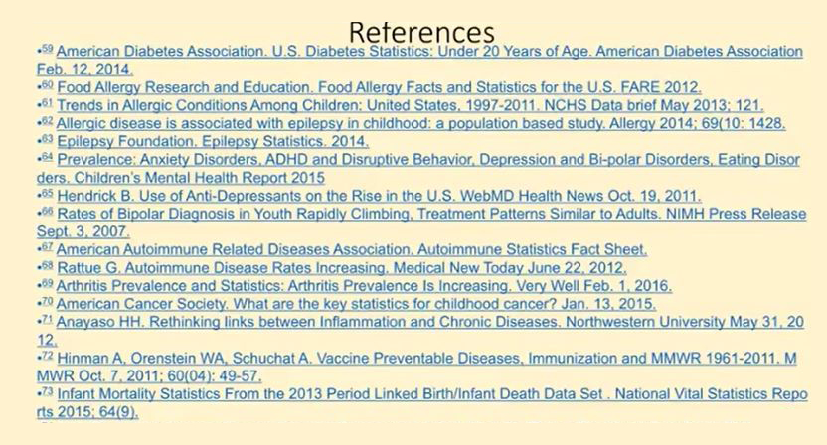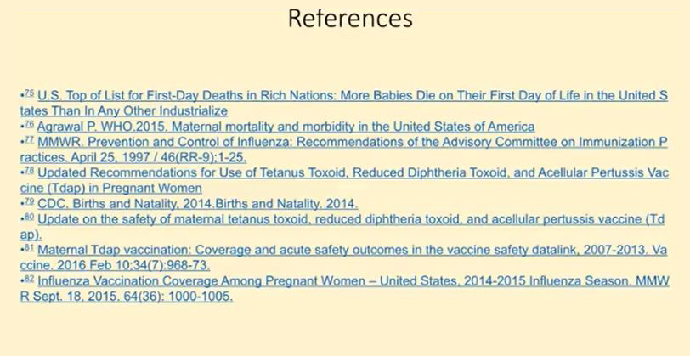

And this is how I do my research. I'll look at it. I'll look at the reference.

I'll follow the reference. And then I'll look at the data on the reference. And so, I mean, just for shits and giggles, if you really want to look at it, reference and reference and reference and reference and reference.

Okay. You know, it's, we have to, we have to take, take charge of this. This is a crime.

Okay. Any questions? That's pretty downer of a talk, isn't it? It was, it was killing me to do it. I was doing this on Sunday and it was a bummer.

Getranscribeerd door TurboScribe.ai. Upgrade naar Onbeperkt om dit bericht te verwijderen.

